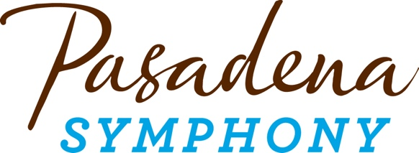
FOR IMMEDIATE RELEASE

Pasadena Symphony Association
Pasadena Symphony & POPS
Contact: Marisa McCarthy
mmccarthy@PasadenaSymphony-Pops.org
(626) 793-7172 ext. 13

September 2, 2026

CLICK HERE FOR HIGH-RES IMAGES

Pasadena Symphony Announces 26/27 Classics Series at Ambassador Auditorium

Highlights of the Season, which opens October 24, 2026, include:

- Five Distinctive Programs, all led by Music Director Brett Mitchell, with matinee and evening performances at Ambassador Auditorium
- Landmark Orchestral Works including Brahms Symphony No. 1, Beethoven Symphony No. 7 and Shostakovich Symphony No. 5, which hasn’t been played by the orchestra in over a decade
- Classical Music’s most beloved concerti including Vivaldi Four Seasons, Barber and Tchaikovsky Violin Concerti, Elgar Cello Concerto and Rachmaninoff’s powerhouse Piano Concerto No. 2
- The Future of Classical Music on Display with works by Joan Tower, Carlos Simon, Jennifer Higdon & Kevin Puts
- Slate of Acclaimed Guest Artists - Violinists Benjamin Beilman, Simone Porter and Paul Huang, Pianist Clayton Stephenson, and the Pasadena Symphony’s Principal Cellist Michael Kaufman
Pasadena, CA – Music Director Brett Mitchell and the Pasadena Symphony announce an exhilarating 2026/27 Classics season featuring five thoughtfully curated programs that celebrate the richness and diversity of classical music through both beloved masterworks and compelling new voices. The season pairs celebrated works from the classical canon with music by some of today’s most distinctive composers, including two works by contemporary female composers Joan Tower and Jennifer Higdon, alongside music by Pulitzer Prize- and Grammy®-winning composer Kevin Puts, and Carlos Simon’s inventive reimagining of musical history. All concerts take place at the orchestra’s home of over a decade - Pasadena’s historic Ambassador Auditorium with matinee and evening performances at 2pm and 8pm.
"I'm so pleased during my third season as Music Director of the Pasadena Symphony to continue this great musical journey we've been sharing. From timeless works by Bach, Beethoven, Brahms, Rachmaninoff, and Tchaikovsky to more contemporary masterpieces by Joan Tower, Carlos Simon, Jennifer Higdon, and Kevin Puts, our 2026/27 season has something for every lover of orchestral music, and the orchestra and I can't wait to share it with you." – Brett Mitchell, Music Director
Mitchell kicks off the season on October 24 with the drama and glory of Joan Tower’s Made in America, inspired by “America the Beautiful” in continuation of the orchestra’s commemoration of America at 250. Barber’s exquisite Violin Concerto follows, performed by the “poised and monstrously talented” (Philadelphia Inquirer) Avery Fisher Career Grant winner, Benjamin Beilman. This grand opening concert culminates in Brahms’ majestic Symphony No. 1, which established the composer as a master of the symphonic tradition and remains one of the most enduring works of the repertoire.
On November 14, the power of the orchestra is on full display for Beethoven Symphony No. 7 with Pasadena Symphony Principal Cellist Michael Kaufman taking center stage to perform Elgar’s heart-wrenching Cello Concerto. February 13 brings romance to the Ambassador as Mitchell conducts Stravinsky’s magical Firebird Suite and 2025 Sphinx Medal of Excellence winner Clayton Stephenson performs Rachmaninoff’s lush Piano Concerto No. 2.
Spring brings the return of audience-favorite Simone Porter performing Vivaldi’s Four Seasons on March 20, alongside Stravinsky’s elegant Dumbarton Oaks and Bach’s beloved Brandenburg 3. Highly acclaimed, multiple award-winning violinist Paul Huang makes his Pasadena debut on May 1 to perform Tchaikovsky’s sumptuous and deeply passionate Violin Concerto, closing the season with the thrilling power and emotional intensity of Shostakovich’s Fifth Symphony—a monumental work making its long-awaited return to the Pasadena Symphony stage.
The Pasadena Symphony provides a quintessential experience specially designed for the music lover, the social butterfly or a date night out. Audiences can enjoy a pre-concert meal at nearby restaurants in Old Town Pasadena or have a drink and a bite on Ambassador Auditorium's beautiful outdoor veranda. The Symphony also offers a pre-concert conversation one hour prior to each performance hosted by KUSC Classical California’s Brian Lauritzen, with Music Director Brett Mitchell and special guests including soloists and composers.
All Pasadena Symphony concerts take place at Ambassador Auditorium, 131 S. St. John Avenue, Pasadena, CA 91105, with performances at 2pm and 8pm. Subscription packages start at $129 with single tickets starting at $55. Both may be purchased online at pasadenasymphony-pops.org or by calling (626) 793-7172.
2026/27 Symphony Season Calendar

Brahms Symphony No. 1
October 24, 2026

Brett Mitchell, conductor
Benjamin Beilman, violin

Joan Tower Made in America
Barber Violin Concerto
Brahms Symphony No. 1

The season opens with quite possibly the greatest first symphony ever written—placing Brahms in his rightful place as one of the world’s most beloved musical geniuses. Joan Tower’s vibrant fantasy on “America the Beautiful” opens the program, with Avery Fisher winner Benjamin Beilman performing Barber’s exquisite Violin Concerto for a grand opening night!
Beethoven Symphony No. 7
November 14, 2026

Brett Mitchell, conductor
Michael Kaufman, cello

Carlos Simon Fate Now Conquers
Elgar Cello Concerto
Beethoven Symphony No. 7
From the infectious energy of Beethoven’s Seventh Symphony and Carlos Simon’s contemporary reimagining of this bold work to the emotional depths of Elgar’s Cello Concerto, this program showcases the orchestra at its most powerful, with Principal Cellist Michael Kaufman taking center stage.
Rachmaninoff Piano Concerto No. 2
February 13, 2027

Brett Mitchell, conductor
Clayton Stephenson, piano

Jennifer Higdon blue cathedral
Stravinsky Suite from The Firebird (1919)
Rachmaninoff Piano Concerto No. 2

Just in time for Valentine’s Day, Stravinsky’s spellbinding Firebird Suite brings the legendary tale to vivid life with its shimmering colors and thrilling rhythms. Jennifer Higdon’s soaring “blue cathedral” sets the tone of the evening, and Rachmaninoff’s lush and deeply romantic Piano Concerto No. 2 will sweep you away with its sumptuous melodies, leaving you breathless and asking for more.

Vivaldi Four Seasons
March 20, 2027

Brett Mitchell, conductor
Simone Porter, violin

Bach Brandenburg Concerto No. 3
Stravinsky Dumbarton Oaks
Vivaldi The Four Seasons

Acclaimed violinist Simone Porter makes her triumphant return, bringing her technical chops and expressive panache to Vivaldi’s most cherished concerti. Modeled after the Brandenberg Concerti, Stravinsky’s “Dumbarton Oaks” offers his intimate nod to the master of counterpoint, alongside one of Bach’s most beloved chamber works, in a performance full of energy and elegance.

Tchaikovsky & Shostakovich
May 1, 2027

Brett Mitchell, conductor
Paul Huang, violin

Kevin Puts Millennium Canons
Tchaikovsky Violin Concerto
Shostakovich Symphony No. 5

The season closes with two monumental masterpieces and a sprightly fanfare – Kevin Put’s “Millennium Canons” offers a bright contrast to Tchaikovsky’s passionate exploration of love and longing and Shostakovich’s powerful Fifth Symphony—a gripping journey from darkness to triumph.

ABOUT THE PASADENA SYMPHONY ASSOCIATION
Formed in 1928, the Pasadena Symphony and POPS is an ensemble of Hollywood’s most talented, sought-after musicians. With extensive credits in film, television, recording and the orchestral industry, the artists of the Pasadena Symphony and POPS are some of the most heard in the world.
Nationally recognized conductor Brett Mitchell assumed the post of Pasadena Symphony Music Director on April 1, 2024. The Summer POPS series is led by Resident Pops Conductor Larry Blank, an award-winning arranger, composer and Broadway conductor. Michael Feinstein, the multi-platinum-selling, Emmy and Grammy Award-nominated entertainer assumed the role of Principal Pops Conductor Emeritus in September 2025, after leading the POPS for 14 years.
The Pasadena Symphony and POPS performs in two of the most extraordinary venues in the United States: Ambassador Auditorium, known as the Carnegie Hall of the West, and the Los Angeles Arboretum & Botanic Garden.
A hallmark of its robust education programs, the Pasadena Symphony Association has served the youth of the region for over five decades through the Pasadena Youth Symphony Orchestras (PYSO). PYSO offers supplemental in-class instruction within the Pasadena Unified School District and eleven performance ensembles, serving over 700 4th-12th grade students from all over Southern California. The PYSO has performed at venues across the globe as well as on the television show GLEE.
The Pasadena Symphony Association provides people from all walks of life with powerful access points to the world of symphonic music. www.pasadenasymphony-pops.org

ABOUT THE ARTISTS
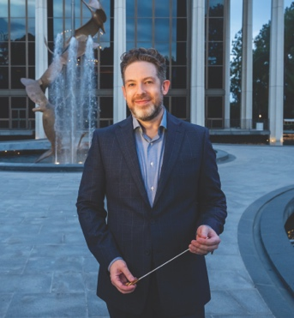
Brett Mitchell
Music Director
Widely recognized as an engaging communicator known for his vivid musical leadership, Brett Mitchell has earned consistent praise for his performances on world-class stages, establishing himself as a leading voice in American classical music.
Mitchell currently serves as Music Director of the Pasadena Symphony and Artistic Director & Conductor of Oregon’s Sunriver Music Festival. He previously held tenures as Music Director of the Colorado Symphony and Associate Conductor of The Cleveland Orchestra, and held conducting positions with the Houston Symphony and the Orchestre National de France.
In May 2025, Mitchell’s versatility was on full display when he stepped in for his New York Philharmonic subscription debut at David Geffen Hall on less than 24 hours' notice. He led three acclaimed performances of Kevin Puts’s The Brightness of Light with Renée Fleming and Rod Gilfry, followed by the complete score of Ravel’s Daphnis et Chloé with the New York Philharmonic Chorus.
A prolific guest conductor, Mitchell’s 2026–27 season features debuts with the Lyric Opera of Chicago and the Virginia Symphony Orchestra, as well as return appearances with The Cleveland Orchestra, Houston Symphony, and San Francisco Symphony. He has also led the Los Angeles Philharmonic at the Hollywood Bowl and the National Symphony Orchestra at the Kennedy Center, part of a domestic and international portfolio that includes the major orchestras of Dallas, Detroit, Indianapolis, Milwaukee, Minnesota, Nashville, and North Carolina, as well as the New Zealand, Vancouver, and Edmonton Symphonies.
Also an accomplished pianist, Mitchell was named a Steinway Artist in 2025. He concertizes regularly at the keyboard and is widely recognized for his original solo transcriptions of iconic film scores, a repertoire he also champions on the podium, having led live-to-picture productions of more than two dozen of the world’s most celebrated films. Through these projects and his digital presence, he has cultivated a devoted global following for his multi-faceted artistry.
Born in Seattle, Mitchell holds degrees from the University of Texas at Austin and Western Washington University. He studied with Leonard Slatkin at the National Conducting Institute and was mentored by Kurt Masur and Lorin Maazel.

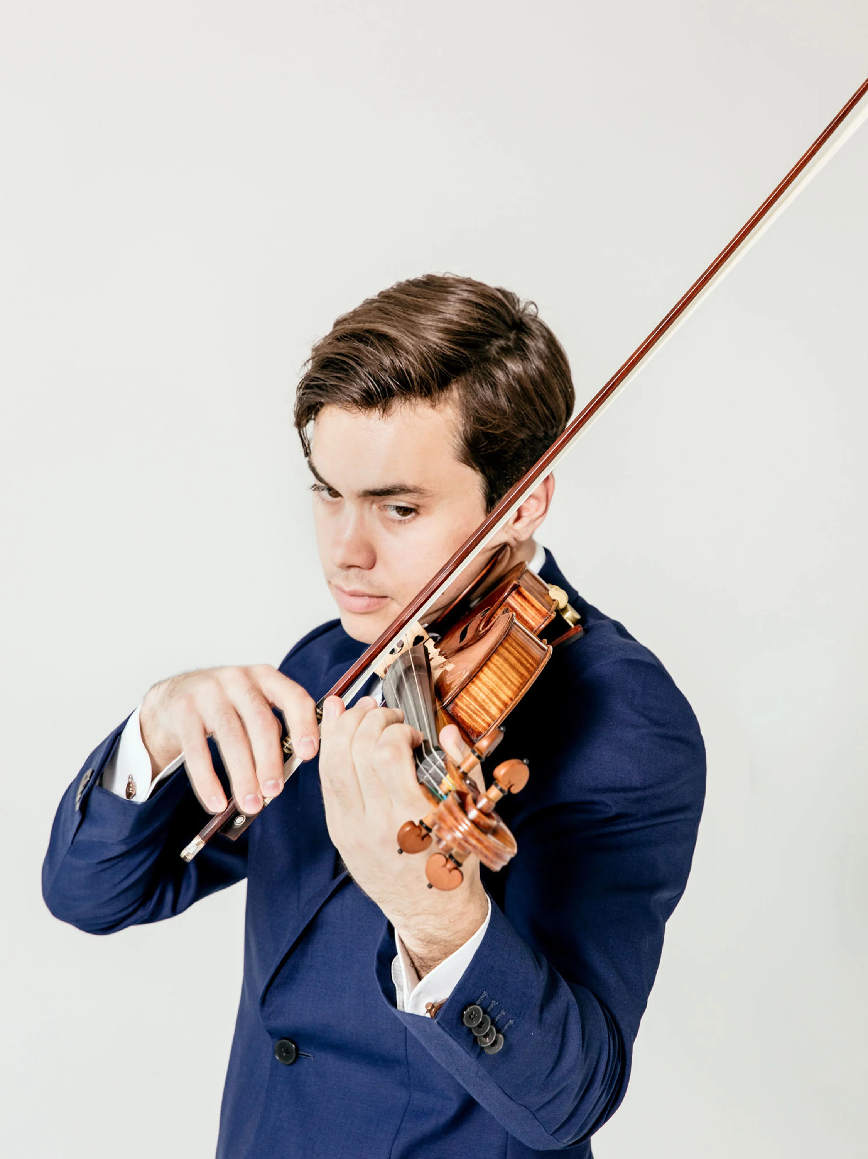
Benjamin Beilman
Violin
Benjamin Beilman has earned international acclaim for his passionate performances and distinctive tone—The New York Times called it “muscular with a glint of violence,” while The Strad praised its “pure poetry.” Praised for his instinctive sense of form and color, he uncovers new depths in familiar works and expands the violin’s expressive range through his commitment to contemporary music.
Recent and upcoming orchestral highlights include his subscription debut with the Berlin Philharmonic—following a 2024 US tour with the orchestra—and appearances with the Minnesota Orchestra, Dresden Philharmonic, Antwerp Symphony, and Nashville Symphony. Beilman records for Warner Classics and has received a Borletti-Buitoni Trust Fellowship, an Avery Fisher Career Grant and a London Music Masters Award. He performs with the ex-Balaković F. X. Tourte bow (c. 1820), and plays the “Ysaÿe” Guarneri del Gesù from 1740, on loan from the Sasakawa Music Foundation.

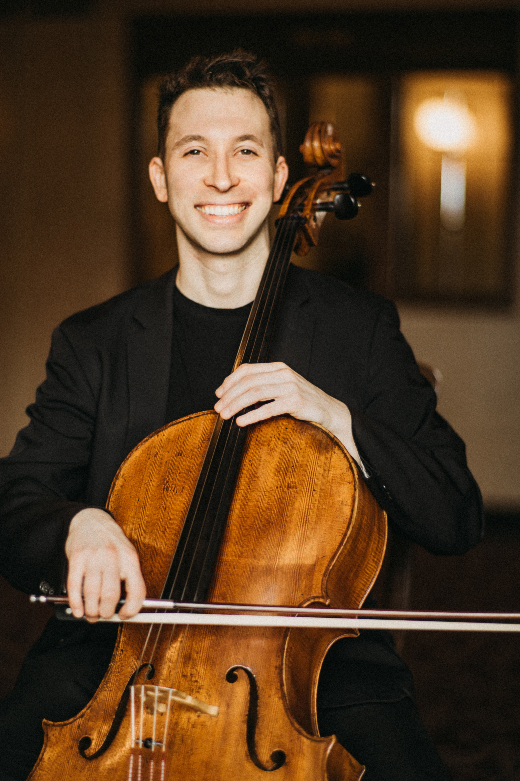
Michael Kaufman
Cello
Dr. Michael Kaufman is an internationally acclaimed cellist whose performances are distinguished by their depth, versatility, and expressive power. Equally at home in solo, chamber, and orchestral settings, Dr. Kaufman is Assistant Professor of Cello, Education and Outreach at the University of Utah, where he brings a passionate commitment to mentorship and artistic exploration.
Celebrated for his dynamic artistry, Dr. Kaufman has appeared at premier venues including Zankel and Weill Hall at Carnegie Hall, and has been featured in major festivals such as Open Chamber Music at Prussia Cove, Yellow Barn, Music@Menlo, and the Verbier Festival. He has collaborated with renowned artists including Midori and Kim Kashkashian and has performed as principal cellist with La Monnaie Opera in Brussels.
His discography includes recordings for ECM Records, notably the works of Tigran Mansurian, and the recent release of Clair de lune with the SAKURA Cello Quintet on the Platoon label. A committed advocate for contemporary music, Dr. Kaufman has premiered numerous new works, including Sean Friar’s concerto with the Eastman Wind Ensemble and Brett Dean’s 12 Angry Men at the Piatigorsky International Cello Festival. As founder and artistic director of Sunset ChamberFest and a founding member of the boundary-pushing cello quintet SAKURA, he curates programs that fuse classical masterpieces with bold, exploratory repertoire.
Dr. Kaufman earned his bachelor’s degree at the Eastman School of Music under Steven Doane, and his master’s and doctoral degrees from the University of Southern California studying with Ralph Kirshbaum. In addition to his role at the University of Utah, he is a faculty member at the Colburn School, a cellist with LA Opera and Principal Cello of the Pasadena Symphony. A dedicated advocate for the music of our time, he continues to inspire audiences and students alike through his visionary approach to performance and education.

Clayton Stephenson
Piano
American pianist Clayton Stephenson’s love for music is immediately apparent in his joyous charisma onstage, expressive power, and natural ease at the instrument. Hailed for interpretations that are “fresh, incisive and characterfully alive” (Gramophone), he is committed to making an impact on the world through his music-making. Growing up in New York City, Clayton found musical inspiration in community programs. As he describes it, the “Third Street Music School jump-started my music education; the Young People’s Choir taught me phrasing and voicing; Juilliard’s Music Advancement Program introduced me to formal and rigorous piano training, which enabled me to get into Juilliard Pre-College; the Morningside Music Bridge validated my talent and elevated my self-confidence; and the Boy’s Club of New York exposed me to jazz.”
He received an Avery Fisher Career Grant in 2024 and is a 2025 Sphinx Medal of Excellence honoree. Recent and upcoming highlights include the New York Philharmonic and Houston and Cincinnati Symphony Orchestras; and Grant Park, Washington Performing Arts at the Kennedy Center, Fondation Louis Vuitton, and 92NY.

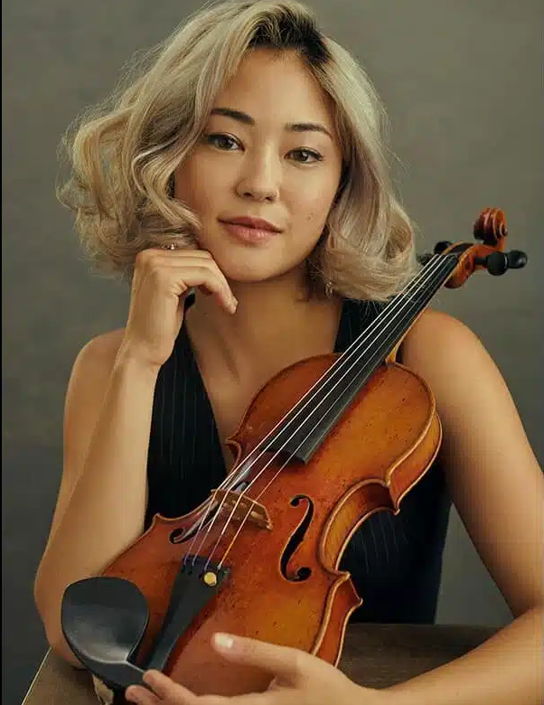
Simone Porter
Violin
Violinist Simone Porter has been recognized as an emerging artist of impassioned energy, interpretive integrity, and vibrant communication. She has debuted with the New York Philharmonic, the Philadelphia Orchestra, the Los Angeles Philharmonic, Seattle and Pittsburgh Symphonies and with a number of renowned conductors, including Stéphane Denève, Gustavo Dudamel, Yannick Nézet-Séguin, Nicholas McGegan, Ludovic Morlot, Donald Runnicles, David Robertson, Esa-Pekka Salonen, Manfred Honeck, Louis Langrée and David Danzmayr. Simone made her professional solo debut at age 10 with the Seattle Symphony and her international debut with the Royal Philharmonic Orchestra in London at age 13. In March 2015, Simone was named a recipient of an Avery Fisher Career Grant.
Porter’s recent seasons include extensive US touring with debuts and return to orchestras such as Colorado, North Carolina, St. Louis, Oregon, Nashville, Baltimore, Hawaii, Grand Rapids, Arkansas, Omaha, Quebec, Jacksonville and Westchester Symphonies, Erie Philharmonic, and Florida Orchestra. The 25/26 season began with her return to the Oregon Symphony, where she will serve as Artist in Residence through the 27/28 season. Internationally, Simone has performed with the Simón Bolívar Symphony Orchestra with Gustavo Dudamel; the Orquestra Sinfônica Brasileira; the National Symphony Orchestra of Costa Rica; the City Chamber Orchestra of Hong Kong; the Royal Northern Sinfonia; the Milton Keynes City Orchestra; Orquesta Clasica Santa Cecilia de la Fundacion Excelentia; the Opera de Marseille and at the Edinburgh Festival under the direction of Stéphane Denève,
Recent recital highlights include a tour in Spain and debuts at Celebrity Series in Boston and NY92. Porter has appeared at festivals such as La Jolla Summerfest, Bay Chamber Music, Moab Music Festival, and Charlottesville Chamber Music Festival. February 2025 marked the release of her highly acclaim first solo album ad tendo on the Bright Shiny Things label.
Raised in Seattle, Washington, Simone studied with Margaret Pressley as a recipient of the Dorothy Richard Starling Scholarship and was then admitted into the studio of the renowned pedagogue Robert Lipsett, with whom she studied at the Colburn Conservatory of Music in Los Angeles.
Simone Porter performs on a 1740 Carlo Bergonzi violin made in Cremona Italy on generous loan from The Master’s University, Santa Clarita, California.
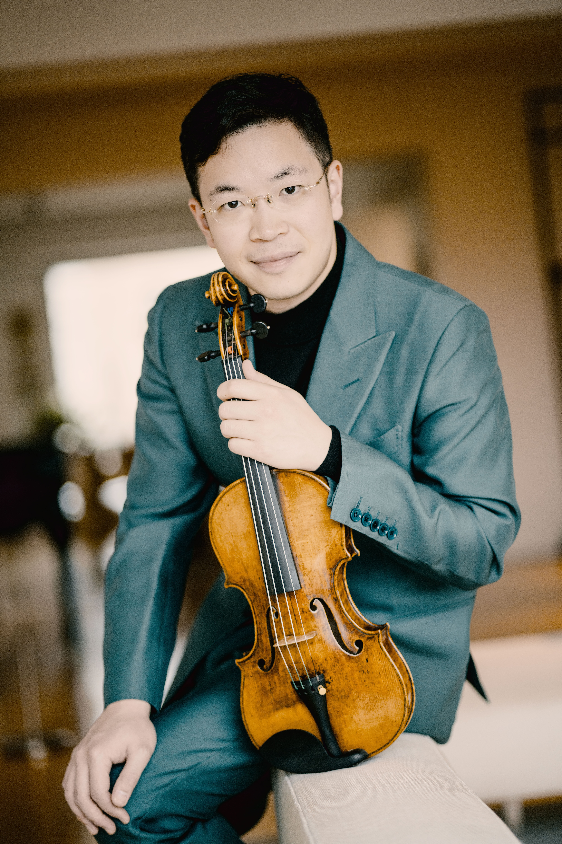
Paul Huang
Violin
Recipient of the prestigious 2015 Avery Fisher Career Grant and the 2017 Lincoln Center Award for Emerging Artists, violinist Paul Huang is considered to be one of the most distinctive artists of his generation. The Washington Post remarked that Mr. Huang "possesses a big, luscious tone, spot-on intonation and a technique that makes the most punishing string phrases feel as natural as breathing," and further proclaimed him as "an artist with the goods for a significant career" following his recital debut at the Kennedy Center.
Known for his "unfailing attractive, golden, and resonant tone" (The Strad), Mr. Huang's recent highlights have included acclaim debut at Bravo!Vail Music Festival, stepping in for violinist Anne-Sophie Mutter in the Mozart’s Violin Concerto No.4 with Chamber Orchestra Vienna-Berlin, Rotterdam Philharmonic with Lahav Shani, BBC Symphony Orchestra with Marie Jacquot, Detroit Symphony with Leonard Slatkin, Houston Symphony with Andres Orozco-Estrada, NHK and Dallas Symphonies with Fabio Luisi, Mariinsky Orchestra with Valery Gergiev, Baltimore Symphony and Seoul Philharmonic with Markus Stenz, San Francisco Symphony with Mei-Ann Chen, and recital debuts at the Lucerne Festival in Switzerland and Aspen Music Festival.
In Fall 2021, Paul became the first classical violinist to perform his own arrangement of the National Anthem for the opening game of the NFL at the Bank of America Stadium in Charlotte, North Carolina to an audience of 75,000. An exclusive recording artist with France's Naïve Records, his second album “Mirrors" was released worldwide to critical acclaim in January of 2025 with Gramophone Magazine remarked as "musical storytelling of such virtuosity and conviction".
A frequent guest artist at music festivals worldwide, he has performed at the Seattle, Music@Menlo, Savannah, Caramoor, La Jolla, Santa Fe, Moritzburg, Kissinger Sommer, Sion, Orford Musique, and the PyeongChang Music Festival in South Korea. His chamber music collaborators have included Gil Shaham, Cho-Liang Lin, Nobuko Imai, Mischa Maisky, Jian Wang, Lynn Harrell, Yefim Bronfman, Kirill Gerstein and Marc-Andre Hamelin.
Winner of the 2011 Young Concert Artists International Auditions, Mr. Huang made critically acclaimed recital debuts in New York at Lincoln Center and in Washington, D.C. at the Kennedy Center. Other honors include First Prize at the 2009 Tibor Varga International Violin Competition Sion-Valais in Switzerland, the 2009 Chi-Mei Cultural Foundation Arts Award for Taiwan’s Most Promising Young Artists, the 2013 Salon de Virtuosi Career Grant, and the 2014 Classical Recording Foundation Young Artist Award.
Born in Taiwan, Mr. Huang began violin lessons at the age of seven. He is a recipient of the inaugural Kovner Fellowship at The Juilliard School, where he earned his bachelor’s and master’s degrees under Hyo Kang and I-Hao Lee. He plays on the legendary 1742 “ex-Wieniawski” Guarneri del Gesù on extended loan through the Stradivari Society of Chicago and is on the faculty of Taipei National University of the Arts. He resides in New York.
-end-

