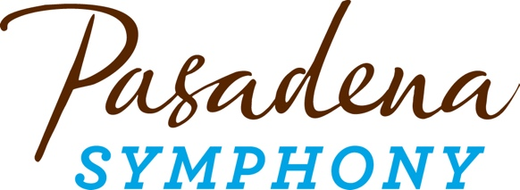

**FOR IMMEDIATE RELEASE**

**Pasadena Symphony Association**

**Pasadena Symphony & POPS**

Contact: Marisa McCarthy

mmccarthy@PasadenaSymphony-Pops.org

(626) 793-7172 ext. 13

October 20, 2025

For artist bios and high res images visit: [pasadenasymphony-pops.org/25-26-symphony-season-announcement](https://pasadenasymphony-pops.org/25-26-symphony-season-announcement)

**Pasadena Symphony Announces 25/26 Season with American Spirit Full of Stellar Classical Masterworks Plus Two Commissions and Premieres**

**Highlights of 98th Season, which opens November 8, 2025, include:**

* Six Distinctive Programs, all led by Music Director Brett Mitchell, with matinee and evening performances at Ambassador Auditorium;
* Landmark Orchestral Works that haven’t been performed by the orchestra in over a decade, including Berlioz Symphonie Fantastique to open the season and Tchaikovsky Symphony No. 6 “Pathétique;"
* Classical Masterworks including Mendelssohn Symphony No. 3, “Scottish,” Beethoven Symphony No. 3, “Eroica” and Dvořák Symphony No. 9 “From the New World;”
* The Future of Classical Music on display with a co-commission of Juan Pablo Contreras’ First Symphony, the west coast premiere of Jennifer Higdon’s Cello Concerto and a co-commission and west coast premiere of Jonathan Leshnoff’s “Rhapsody on America;”
* Slate of Acclaimed Guest Artists performing a mix of old and new concerti - Pianists Orion Weiss (Ravel Piano Concerto in G), Michelle Cann (Mozart Piano Concerto No. 23) and Joyce Yang (Leshnoff Piano Concerto), Violinist Tessa Lark (Meyer Violin Concerto) and Cellist Julian Schwarz (Higdon Cello Concerto)

***Pasadena, CA*** – Music Director Brett Mitchell and the **Pasadena Symphony** announce his sophomore season with an exhilarating schedule of six performances, curated in honor of the rich tradition of American composition. “As we close in on America’s 250th birthday next summer,” says Mitchell, "I’m excited to celebrate the best of American orchestral music, past and present, all season long, pairing new American repertoire with great masterworks of the past.” Alongside astellar program of celebrated Classical works, the Pasadena Symphony cements its commitment to contemporary music by presenting **two co-commissions** – **Juan Pablo Contreras’ Symphony No. 1** and **Jonathan Leshnoff’s “Rhapsody on America,”** and hosting two **west coast premieres** – **Jennifer Higdon’s Cello Concerto** andthe **Leshnoff Piano Concerto**. All concerts take place at the orchestra’s home of over a decade - Pasadena’s historic Ambassador Auditorium with matinee and evening performances at 2pm and 8pm.

Mitchell kicks off the 25/26 season on **November 8th** with **Berlioz’** bold and electrifying **Symphonie Fantastique**, which the orchestra has never before performed at Ambassador Auditorium. Plus, acclaimed pianist **Orion Weiss** performs **Ravel’s Piano Concerto in G Major** and the concert opens with **Principal Tuba Jim Self’s Tour de Force**, on the occasion of his 50th anniversary with the orchestra! The new year brings **Mendelssohn & Meyer** on **January 24, 2026**. Mitchell will take us on a rich musical journey, through Scotland with **Mendelssohn’s Hebrides Overture and Symphony No. 3 “Scottish,”** and then through fields of Kentucky bluegrass with **Edgar Meyer’s Violin Concerto** performed by multiple award-winning phenom **Tessa Lark.**

The orchestra will perform the Ambassador Auditorium debut for another masterwork on **February 21**st, with **Tchaikovsky’s** haunting **Symphony No. 6 “Pathétique."** The program opens with Colorado-based composer **Jeffrey Nytch’s Beacon** and a shimmering performance of **Mozart’s 23rd Piano Concerto** by **Grammy Award-winning pianist Michelle Cann**. **March 21st** brings Mexican-American composer **Juan Pablo Contreras** to the stage to introduce **his first symphony, which the Pasadena Symphony co-commissioned. “My Great Dream”** captures Contreras’ journey to becoming both a composer and US Citizen. **Bernstein’s Dance Variations from *Fancy Free***opens the program, and **Dvořák’s Symphony No. 9 “From the New World”** caps this tribute to the American spirit.

**Beethoven’s Symphony No. 3 “Eroica”** fills the concert hall with revolutionary verve on **March 21st**, accompanied by 2025 ASCAP Young Composer Award-winner **Quinn Mason’s Heroic Overture.** The **west coast premiere** of Grammy-winning composer **Jennifer Higdon’s Cello Concerto** completes the program, performed by cellist **Julian Schwarz**, whom the concerto was written for. The season closes with a celebration of **America @250 on May 30th**, highlighting American composition throughout the last centuryfrom **Copland’s Lincoln Portrait and *Appalachian Spring* Suite** to **John Williams’** **Selections from *American Journey***, commissioned by President Clinton for the 2000 Millennium celebrations. The Pasadena Symphony is also proud to present the **west coast premiere and co-commission of Jonathan Leshnoff’s “Rhapsody on America”** written for and performed by award-winning pianist **Joyce Yang.**

The Pasadena Symphony provides a quintessential experience specially designed for the music lover, the social butterfly or a date night out. Audiences can enjoy a pre-concert meal at nearby restaurants in Old Town Pasadena or have a drink on Ambassador Auditorium's beautiful outdoor plaza. The symphony also offers a pre-concert discussion one hour prior to each performance hosted by KUSC Classical California’s Brian Lauritzen, who interviews Music Director Brett Mitchell and special guests including soloists and composers.

All Pasadena Symphony concerts take place at **Ambassador Auditorium**, 131 S. St. John Avenue, Pasadena, CA 91105, with performances at **2pm and 8pm**. Subscription packages start at $120 with single tickets starting at $55. Both may be purchased online at pasadenasymphony-pops.org or by calling (626) 793-7172.

**2025/26 Symphony Series Calendar**

**Symphonie Fantastique!**

November 8, 2025

**Brett Mitchell,** conductor

**Orion Weiss,** piano

**Jim Self** Tour de Force

**Ravel**  Piano Concerto in G Major

**Berlioz** Symphonie Fantastique

Mitchell kicks off the season in dramatic style with Ravel’s jazz-inspired Piano Concerto and Berlioz’s bold, hallucinatory masterpiece of passion, obsession and vivid orchestral storytelling. Plus Principal Tuba Jim Self’s celebratory orchestral composition *Tour de Force* opens his 50th season with the orchestra!

**Mendelssohn & Meyer**  
January 24, 2026

**Brett Mitchell,** conductor

**Tessa Lark,** violin

**Mendelssohn** The Hebrides Overture

**Edgar Meyer** Violin Concerto

**Mendelssohn** Symphony No. 3, “Scottish”

Embark on a rich musical journey through the misty beauty of the Highlands with Mendelssohn’s evocative Scottish Symphony and acclaimed violinist Tessa Lark brings you through fields of Kentucky bluegrass with fire and finesse for Edgar Meyer’s genre-blending Violin Concerto.

**Tchaikovsky** **Pathétique**

February 21, 2026

**Brett Mitchell,** conductor

**Michelle Cann,** piano

**Jeffrey Nytch**  Beacon

**Mozart**  Piano Concerto No. 23 in A Major, K. 488

**Tchaikovsky** Symphony No. 6, “Pathétique”

Delight in the elegance of Mozart’s 23rd Piano Concerto, shimmering with grace and lyrical beauty at the hands of the electrifying Michelle Cann. Then, plunge into the emotional depths of Tchaikovsky’s haunting *“*Pathétique” Symphony for a gripping journey exploring love, despair and fate.

**From the New World**

March 21, 2026

**Brett Mitchell,** conductor

**Juan Pablo Contreras,** composer & special guest

**Bernstein**  Three Dance Variations from *Fancy Free*

**Contreras**  Symphony No. 1, “My Great Dream” *\*co-commission*

**Dvořák** Symphony No. 9, “From the New World”

Experience the Pasadena debut of Mexican-American composer Juan Pablo Conteras’ first symphony, capturing his journey to becoming a composer and a US citizen, and get lost in one of the most popular symphonies of all time – a tribute to the American spirit.

**Beethoven Eroica**

April 25, 2026

**Brett Mitchell,** conductor

**Julian Schwarz,** cello

**Quinn Mason** Heroic Overture (Overtura Eroica)

**Jennifer Higdon**  Cello Concerto \**west coast premiere*

**Beethoven**  Symphony No. 3, “Eroica”

A grand display of musical innovation across centuries, with the west coast premiere of Grammy-winning composer Jennifer Higdon’s cello concerto, and the bold spirit of Beethoven’s ground-breaking Eroica Symphony—revolutionary, heroic and full of power.

**America @ 250**

May 30, 2026

**Brett Mitchell,** conductor

**Joyce Yang,** piano

**Williams**  Selections from *American Journey*

**Jonathan Leshnoff** Rhapsody on “America” \**co-commission & west coast premiere*

**Copland**  Suite from *Appalachian Spring*

**Copland** Lincoln Portrait

A celebration of the American spirit with a concert work by John Williams and two seminal pieces by Copland – *Lincoln Portrait* and *Appalachian Spring*. Plus award-winning pianist Joyce Yang dazzles on the west coast premiere of a new concerto by Jonathan Leshnoff to top off the season with a bang!

**ABOUT THE PASADENA SYMPHONY ASSOCIATION**  
Formed in 1928, the Pasadena Symphony and POPS is an ensemble of Hollywood’s most talented, sought-after musicians. With extensive credits in film, television, recording and the orchestral industry, the artists of the Pasadena Symphony and POPS are some of the most heard in the world.

Brett Mitchell assumed the post of Pasadena Symphony Music Director on April 1, 2024. The multi-platinum-selling, Emmy and Grammy Award-nominated entertainer dubbed “The Ambassador of the Great American Songbook,” Michael Feinstein, assumed the role of Principal Pops Conductor Emeritus in September 2025, after leading the POPS for 14 years, succeeding Marvin Hamlisch. Resident Pops Conductor Larry Blank will lead the POPS for the 2026 season.

The Pasadena Symphony and POPS performs in two of the most extraordinary venues in the United States: Ambassador Auditorium, known as the Carnegie Hall of the West, and the Los Angeles Arboretum & Botanic Garden.

A hallmark of its robust education programs, the Pasadena Symphony Association has served the youth of the region for over five decades through the Pasadena Youth Symphony Orchestras (PYSO). PYSO offers supplemental in-class instruction within the Pasadena Unified School District and eleven performance ensembles, serving over 700 4th-12th grade students from all over Southern California. The PYSO has performed at venues across the globe as well as on the television show *GLEE*.

The Pasadena Symphony Association provides people from all walks of life with powerful access points to the world of symphonic music. [www.pasadenasymphony-pops.org](http://www.pasadenasymphony-pops.org)

**ABOUT THE ARTISTS**

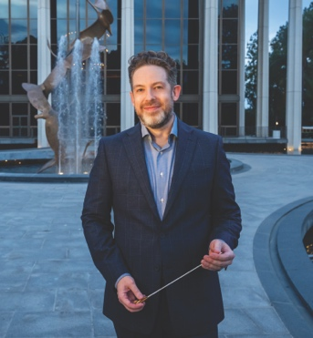**Brett Mitchell**  
**Music Director**

Hailed for presenting engaging, in-depth explorations of thoughtfully curated programs, American conductor **Brett Mitchell** currently serves as Music Director of the Pasadena Symphony and Artistic Director & Conductor of Oregon’s Sunriver Music Festival. He previously served as Music Director of the Colorado Symphony (2017-21), Associate Conductor of The Cleveland Orchestra (2013-17), and Assistant Conductor of the Houston Symphony (2007-11) and Orchestre National de France (2006-09).

In May 2025, with less than 24 hours’ notice, Mr. Mitchell stepped in for his subscription debut with the New York Philharmonic, leading three performances of Kevin Puts’s *The Brightness of Light,* featuring soprano Renée Fleming, followed by the complete score of Ravel’s *Daphnis and Chloé,* featuring the New York Philharmonic Chorus. Working widely as a guest conductor, Mr. Mitchell’s other recent engagements have included appearances with the Dallas, Detroit, Edmonton, Fort Worth, Houston, Indianapolis, Milwaukee, National, North Carolina, Oregon, San Antonio, San Francisco, and Vancouver symphonies; the Los Angeles Philharmonic at the Hollywood Bowl; the Cleveland and Minnesota orchestras; the Rochester Philharmonic Orchestra; the Saint Paul Chamber Orchestra; the Grant Park Festival Orchestra; and a two-week tour with the New Zealand Symphony Orchestra.

Mr. Mitchell also regularly collaborates with the world’s leading soloists, including Yo-Yo Ma, Renée Fleming, Itzhak Perlman, Kirill Gerstein, Conrad Tao, Rudolf Buchbinder, James Ehnes, Augustin Hadelich, Leila Josefowicz, and Alisa Weilerstein. Born in Seattle in 1979, Mr. Mitchell holds degrees in conducting from the University of Texas at Austin and composition from Western Washington University. His two principal professional mentors were Kurt Masur and Lorin Maazel. For more information, please visit [brettmitchellconductor.com](https://brettmitchellconductor.com/).

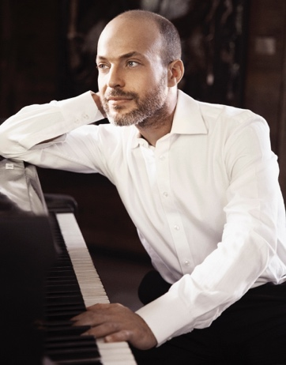**Orion Weiss**

**Piano**

One of the most sought-after soloists and chamber music collaborators today, Orion Weiss is a “brilliant pianist” (*The New York Times*) with “powerful technique and exceptional insight” (*The Washington Post).* He has dazzled audiences worldwide with his “head-spinning range of colors” (*Chicago Tribune*) and has performed with all of the major orchestras of North America, including the Chicago Symphony Orchestra, Boston Symphony Orchestra, Los Angeles Philharmonic and New York Philharmonic.

In 2024 Weiss released *Arc III*, the final album in his Arc recital trilogy (First Hand Records). His live performance schedule includes engagements the Chicago Symphony Orchestra, led by Michael Tilson Thomas, the National Symphony; multiple performances in the United States, Canada and Asia with violinist Augustin Hadelich; and the Kennedy Center, Lincoln Center and Carnegie Hall’s Zankel Hall. Known for his affinity for chamber music, Weiss performs at venues and festivals around the United States with such artists as violinists Augustin Hadelich, William Hagen and James Ehnes; pianists Michael Brown and Shai Wosner; cellist Julie Albers; and the Ariel, Parker, and Pacifica Quartets.

A native of Ohio, Weiss attended the Cleveland Institute of Music and made his Cleveland Orchestra debut performing Liszt’s Piano Concerto No. 1 in 1999. That same year, with less than 24 hours’ notice, Weiss stepped in to replace André Watts for a performance of Shostakovich’s Piano Concerto No. 2 with the Baltimore Symphony Orchestra. Weiss’s awards include the Classical Recording Foundation’s Young Artist of the Year, Gilmore Young Artist Award, an Avery Fisher Career Grant and more. His teachers include Paul Schenly, Jerome Lowenthal and Sergei Babayan. In 2004, he graduated from the Juilliard School, where he studied with Emanuel Ax. Learn more [www.orionweiss.com.](http://www.orionweiss.com./)

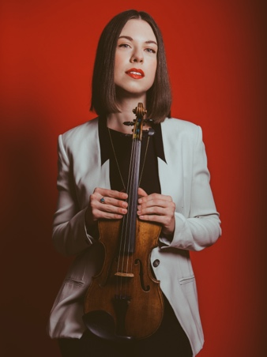**Tessa Lark**   
**Violin**

Increasingly in demand in the classical realm, violinist Tessa Lark was nominated for a Grammy in 2020 in the Best Classical Instrumental Solo category. She is also a highly acclaimed fiddler in the tradition of her native Kentucky, delighting audiences with programming that includes Appalachian and bluegrass music, and inspiring composers to write for her.

Tessa is the newly minted Artistic Director of the Moab Music Festival, and is the Artistic Director of Musical Masterworks, a chamber music series in Old Lyme, Connecticut. Her 2025/26 season features a new concerto written for her by Lisa Biewala, premiering with The Louisville Orchestra.

Tessa has performed with orchestras, recital venues and festivals around the world including the Royal Scottish National Orchestra, BBC Symphony Orchestra, Stuttgart Philharmonic and the Indianapolis, Knoxville and Seattle Symphonies; as well as being presented by Carnegie Hall, Lincoln Center, Amsterdam's Concertgebouw, and other prestigious venues and festivals.

Tessa’s most recent album, *The Stradgrass Sessions*, released in spring 2023, features an all-star roster of collaborators and composers including Edgar Meyer,pianist Jon Batiste, mandolinist Sierra Hull and fiddler Michael Cleveland Tessa’s debut commercial recording was the Grammy-nominated *Sky*, a bluegrass-inspired violin concerto written for her by Michael Torke and performed with the Albany Symphony Orchestra. Her discography also includes *Fantasy* on First Hand Records: *Fantasias* by Schubert, Telemann and Fritz Kreisler; Ravel’s *Tzigane*; and Lark’s own composition *Appalachian Fantasy.*

Lark is a recipient of the Hunt Family Award, one of Lincoln Center’s prestigious Emerging Artist Awards, as well as a 2018 Borletti-Buitoni Trust Fellowship and a 2016 Avery Fisher Career Grant. She was Silver Medalist in the 9th Quadrennial International Violin Competition of Indianapolis and winner of the 2012 Naumburg International Violin Competition. She is a graduate of New England Conservatory and completed her Artist Diploma at The Juilliard School, where she studied with Sylvia Rosenberg, Ida Kavafian, and Daniel Phillips. Her primary mentors include Cathy McGlasson, Kurt Sassmannshaus, Miriam Fried, and Lucy Chapman. She plays a ca. 1600 G.P. Maggini violin on loan from an anonymous donor through the Stradivari Society of Chicago.

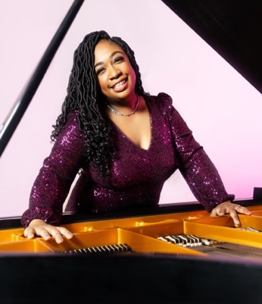**Michelle Cann**  
**Piano**

Lauded as “exquisite” by *The Philadelphia Inquirer* and “a pianist of sterling artistry” by *Gramophone*, GRAMMY Award winning pianist Michelle Cann is one of the most sought-after artists of her generation. Recent engagements include appearances with Chicago Symphony Orchestra, The Cleveland Orchestra, The Philadelphia Orchestra, Los Angeles Philharmonic, National Symphony Orchestra, and Orquestra Sinfônica Municipal de São Paulo. She is a recipient of the Sphinx Medal of Excellence and the Andrew Wolf Chamber Music Award, and she served as the inaugural Christel DeHaan Artistic Partner of the American Piano Awards.

Highlights of Cann’s 2025-26 season include appearances with the Colorado Symphony, New Jersey Symphony, Kansas City Symphony, and Ireland’s National Symphony Orchestra. She also performs the world premiere of a new piano concerto by Valerie Coleman with the National Symphony Orchestra in Washington, D.C. Her recital appearances include Stanford Live, Music Toronto, Chamber Music Detroit, the Isabella Stewart Gardner Museum, Spivey Hall, and a recital tour in China.

Recognized as a leading interpreter of the piano music of Florence Price, Cann performed the New York City premiere of Price’s *Piano Concerto in One Movement* with The Dream Unfinished Orchestra in 2016. Her recording of the concerto with the New York Youth Symphony won a GRAMMY Award in 2023 for Best Orchestral Performance. She won a GRAMMY Award in 2025 for *Beyond the Years: Unpublished Songs* of Florence Price, recorded with soprano Karen Slack, which features 19 unpublished songs composed by Price. Her acclaimed debut solo album *Revival*, featuring music by Price and Margaret Bonds, was released in 2023.

Cann holds bachelor’s and master’s degrees from the Cleveland Institute of Music and an Artist’s Diploma from Curtis Institute of Music. She joined the Curtis piano faculty in 2020 as the inaugural Eleanor Sokoloff Chair in Piano Studies, and she is on the piano faculty of the Manhattan School of Music.

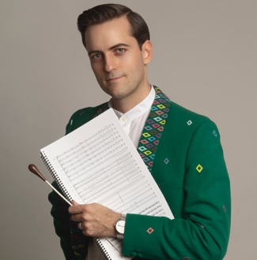**Juan Pablo Contreras  
Composer**

Juan Pablo Contreras is a three-time Latin GRAMMY®-nominated composer and conductor who masterfully weaves Western classical and Mexican folk music into an exhilarating soundscape. His music has been performed by 60 major orchestras across the United States, Mexico, Austria, Slovakia, Colombia, Spain, Argentina, and Venezuela, as well as in prestigious concert halls such as Walt Disney Concert Hall, Carnegie Hall, and Hollywood Bowl. He is renowned as the first Mexican-born composer to sign a record deal with Universal Music, to serve as Sound Investment Composer for Los Angeles Chamber Orchestra, and to win the Vilcek Prize for Creative Promise.

**Julian Schwarz  
Cello**

Schwarz made his concerto debut at the age of 11 with the Seattle Symphony. Since being awarded first prize at the inaugural Schoenfeld International String Competition in Hong Kong, he has led an active career as soloist, performing with prestigious orchestras in the United States and abroad.

As a chamber musician, Mr. Schwarz performs extensively in recital with pianist Marika Bournaki, and the pair was awarded first prize at the inaugural Boulder International Chamber Music Competition’s “The Art of Duo”. Mr. Schwarz is a founding member of the New York based touring ensemble “Frisson” and is also a member of the Olmos Ensemble in San Antonio, TX, the Palladium Chamber Players (St Petersburg FL) and the Alaria Ensemble (New York NY).

Mr. Schwarz is deeply committed to the future of American music and will present the world premiere of Jennifer Higdon’s first Cello Concertro with a large consortium of orchestras in spring 2026. Past commissioning projects include concertos by Lowell Liebermann, Richard Danielpour and Samuel Jones and he has premiered chamber music by Adolphus Hailstork and Dobrinka Tabakova among others. Mr. Schwarz’s commitment to the music of Jewish experience includes projects with the YIVO Institute for Jewish Research, the Defiant Requiem, Central Synagogue, the Milken Archive of American Jewish Music, and a new association with South Florida Public Broadcasting to raise awareness of the history of Jewish music.

Mr. Schwarz serves as Associate Professor of Cello and String Area Coordinator at Shenandoah Conservatory of Shenandoah University (Winchester, VA), and on the artist faculty of NYU’s Steinhardt School of Music. In the summer, he teaches and performs at the Eastern Music Festival and the Josef Gingold Festival.

Born in Seattle, WA in 1991, Mr. Schwarz has studied at the Colburn School in Los Angeles under Ronald Leonard and at The Juilliard School with Joel Krosnick. Julian plays a Neapolitan cello made by Gennaro Gagliano in 1743 and American bows by Paul Martin Siefried.

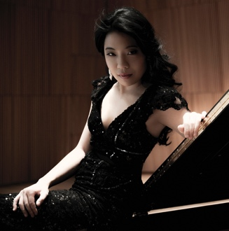**Joyce Yang   
Piano**

Grammy-nominated pianist Joyce Yang first came to international attention in 2005 when she won the silver medal at the 12th Van Cliburn International Piano Competition. The youngest contestant at 19 years old, she took home two additional awards: Best Performance of Chamber Music (with the Takàcs Quartet), and Best Performance of a New Work. In 2006 Yang made her celebrated New York Philharmonic debut alongside Lorin Maazel at Avery Fisher Hall along with the orchestra’s tour of Asia.

Over the last two decades, Yang has blossomed into an “astonishing artist” (Neue Zürcher Zeitung), showcasing her colorful musical personality in solo recitals and collaborations with the world’s top orchestras and chamber musicians through more than 1,000 debuts and re-engagements. She received the 2010 Avery Fisher Career Grant and earned her first Grammy nomination (Best Chamber Music/Small Ensemble Performance) for her recording of Franck, Kurtág, Previn & Schumann with violinist Augustin Hadelich.

Other notable orchestral engagements have included the Chicago Symphony, Los Angeles Philharmonic, Philadelphia Orchestra, San Francisco Symphony, Deutsches Symphonie-Orchester Berlin, Hong Kong Philharmonic, the BBC Philharmonic, as well as the Toronto, Vancouver, Sydney, Melbourne, and New Zealand symphony orchestras. Yang has released 10 recordings, including celebrated solo discs (*Collage* and *Wild Dreams*, Avie Records) and a live-performance recording of Tchaikovsky’s Piano Concerto No. 1 with Denmark’s Odense Symphony Orchestra (Bridge Records).

As a champion of new music, Yang has premiered three piano concerti by Michael Torke, Jonathan Leshnoff and Reinaldo Moya. In recent years, Yang has focused on promoting creative ways to introduce classical music to new audiences as Guest Artistic Director for the Laguna Beach Music Festival and in her collaboration with the Aspen Santa Fe Ballet of Half/Cut/Split, which toured nationwide.

Born in Seoul, South Korea, Yang received her first piano lesson from her aunt at the age of four. By the age of ten, she had entered the School of Music at the Korea National University of Arts and went on to make a number of concerto and recital appearances in Seoul and Daejeon. Yang moved to the United States where she graduated from Juilliard with special honor as the recipient of the school’s 2010 Arthur Rubinstein Prize, and in 2011 she won its 30th Annual William A. Petschek Piano Recital Award. She is a Steinway artist.

*-end-*