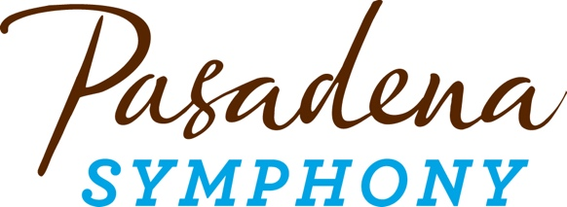
FOR IMMEDIATE RELEASE

Pasadena Symphony Association
Pasadena Symphony & POPS
Contact: Marisa McCarthy
mmccarthy@PasadenaSymphony-Pops.org
(626) 793-7172 ext. 13

March 15, 2023

For full artist bios and high res images visit: https://pasadenasymphony-pops.org/23-24-symphony-season-announcement/

PASADENA SYMPHONY ANNOUNCES STELLAR 23/24 SEASON OF CLASSICAL MUSIC’S GREATEST HITS PAIRED WITH ITS CRITICALLY ACCLAIMED COMPOSER’S SHOWCASE OF VIBRANT CONTEMPORARY MUSIC DELIGHTING AUDIENCES OF ALL AGES

Acclaimed guest conductors Brett Mitchell, Ward Stare, Kensho Watanabe, Kyle Dickson, François López-Ferrer, Linhan Cui and Jenny Wong will serve as Artistic Partners for the 2023/24 season

Pasadena, CA – Pasadena Symphony announces its 2023/24 season with an exhilarating schedule of seven performances, running October 21, 2023 through April 20, 2024. Season highlights include piano powerhouse concertos with Rachmaninoff Rhapsody on a Theme of Paganini, Tchaikovsky Piano Concerto No. 1 and Beethoven “Emperor” alongside stunning violin concertos of Mendelssohn, Beethoven and Vivaldi’s Four Seasons. Experience how simultaneously intimate and Technicolor symphonic music can be at the Ambassador Auditorium with Tchaikovsky Symphony No. 4, Elgar’s Enigma Variations, Sibelius Symphony No. 2 and Stravinsky’s Firebird Suite. The season also includes the annually sold-out Holiday Candlelight Concert on Saturday, December 16, 2023 with 4pm and 7pm performances at All Saints Church.

The season’s impressive line-up of internationally renowned guest artists includes conductor Brett Mitchell, who will return to open the season October 21st for Tchaikovsky 4 with Yehudi Menuhin International Competition winner Diana Adamyan; Grammy-nominated conductor Ward Stare for Rachmaninoff Rhapsody on a Theme of Paganini, performed by award-winning pianist Natasha Paremski; Kensho Watanabe returning to conduct Beethoven “Emperor” with Avery Fisher Career Grant winner George Li; Salonen Conducting Fellow Kyle Dickson for Tchaikovsky Piano Concerto No. 1 performed by Concert Artists Guild International Competition winner Wynona Wang; François López-Ferrer returning to conduct Beethoven Violin Concerto with the "frighteningly awesome" (Buffalo News) talent of violinist Francisco Fullana; and Dudamel Conducting Fellow Linhan Cui for Vivaldi’s Four Seasons with Colburn artist Charlotte Marckx.
The Pasadena Symphony’s fourth annual Composer’s Showcase kicks off with Mason Bates’ Garages of the Valley, inspired by the digital age that was dreamed up in the most low-tech of spaces dotting the landscape of Silicon Valley; followed by Patrick Harlin’s Earthrise, inspired by the iconic and arguably the most important environmental photo taken by astronaut Bill Anders on the first-ever trip around the moon. Harlin’s piece is part of the California Festival: A Celebration of New Music, conceived by LA Phil Music & Artistic Director Gustavo Dudamel, San Diego Symphony Music Director Rafael Payare and San Francisco Symphony Music Director Esa-Pekka Salonen to highlight the collaborative and innovative spirit that thrives in California. The season continues with Jessica Hunt’s Climb inspired by her shared struggle with Beethoven, in overcoming physical adversities; Jessie Montgomery’s Strum, which draws upon American folk idioms and the spirit of dance; Shawn Okpebholo’s Stomp the Dust! which showcases the colorful essence of Kenya and musically depicts the arid terrain, dancing and pleas for rain; and Si’ang Chen’s beautifully sonorous Adagio.
The Pasadena Symphony provides a quintessential experience specially designed for the music lover, the social butterfly or a date night out, and the inner epicurean in us all. Audiences can enjoy a pre-concert meal at nearby restaurants in Old Town Pasadena or have a drink and a bite in the lively outdoor Symphony Lounge. A posh setting at Ambassador Auditorium's beautiful outdoor plaza, the Lounge offers uniquely prepared menus for both lunch and dinner and a full service bar before each concert and during intermission.

All Pasadena Symphony concerts take place at Ambassador Auditorium, 131 S. St. John Avenue, Pasadena, CA 91105, with performances at 2pm and 8pm. Subscription packages start at $99 with single tickets starting at $40. Both may be purchased online at pasadenasymphony-pops.org or by calling (626) 793-7172.

2023/24 Symphony Series Calendar

TCHAIKOVSKY 4
October 21, 2023

Brett Mitchell, conductor
Diana Adamyan, violin

Mason Bates Garages of the Valley
Mendelssohn Violin Concerto
Tchaikovsky Symphony No. 4

RHAPSODY ON A THEME OF PAGANINI
November 18, 2023

Ward Stare, conductor
Natasha Paremski, piano

Patrick Harlin Earthrise
Rachmaninoff Rhapsody on a Theme of Paganini
Elgar Enigma Variations

HOLIDAY CANDLELIGHT
December 16, 2023
Jenny Wong, conductor
Soloist, tba

BEETHOVEN EMPEROR
January 27, 2024

Kensho Watanabe, conductor
George Li, piano

Jessica Hunt Climb
Kodály Dances of Galánta
Beethoven Piano Concerto No. 5 “Emperor”

TCHAIKOVSKY PIANO CONCERTO NO. 1
February 17, 2024

Kyle Dickson, conductor
Wynona Wang, piano

Jessie Montgomery Strum for String Orchestra
Tchaikovsky Piano Concerto No. 1
Sibelius Symphony No. 2

BEETHOVEN VIOLIN CONCERTO
March 23, 2024

François López-Ferrer, conductor
Francisco Fullana, violin

Shawn Okpebholo Kutimbua Kivumbi (Stomp the Dust!)
Beethoven Violin Concerto
Stravinsky The Firebird Suite

VIVALDI FOUR SEASONS
April 20, 2024

Linhan Cui, conductor
Charlotte Marckx, violin

Si’ang Chen Adagio
Bach Brandenburg Concerto No. 3
Puccini Crisantemi
Vivaldi Four Seasons

ABOUT THE ARTISTS

Tchaikovsky 4, October 21, 2023
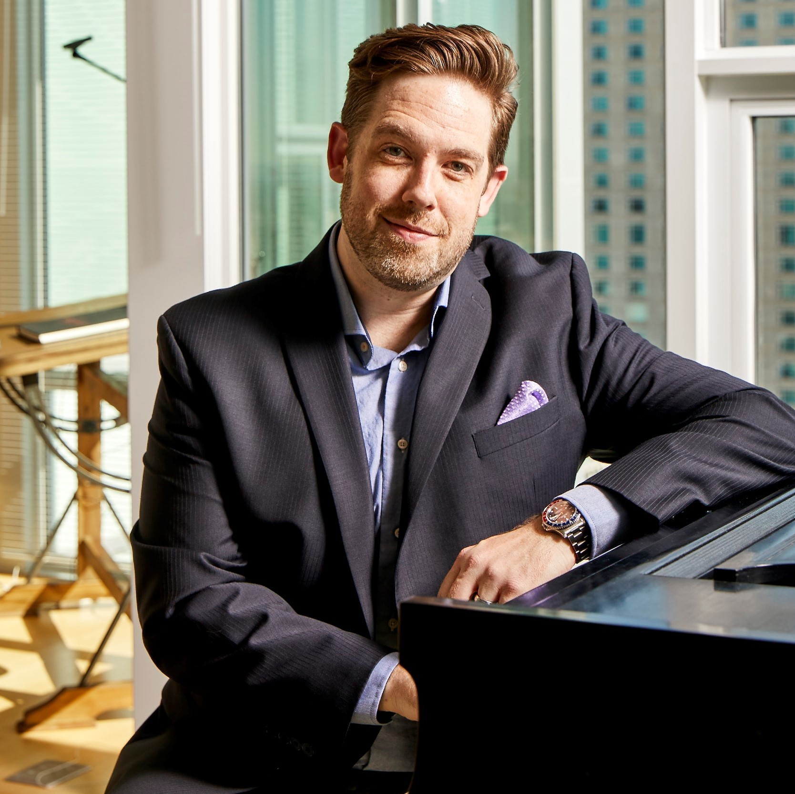
Brett Mitchell
Conductor
Hailed for presenting engaging, in-depth explorations of thoughtfully curated programs, Brett Mitchell concluded his tenure as Music Director of the Colorado Symphony in 2021. Brett is in consistent demand as a guest conductor, making his debut with the San Francisco Symphony in July 2019, and has served as Associate Conductor of The Cleveland Orchestra and Assistant Conductor of the Houston Symphony.
In addition to his work with professional orchestras, Mr. Mitchell is also well known for his affinity for working with and mentoring young musicians. His tenure as Music Director of the Cleveland Orchestra Youth Orchestra was highly praised, and included a four-city tour of China in 2015. Mr. Mitchell holds degrees in conducting from the University of Texas at Austin and composition from Western Washington University, which selected him as its Young Alumnus of the Year in 2014. Mr. Mitchell was also one of five recipients of the League of American Orchestras’ American Conducting Fellowship from 2007 to 2010.
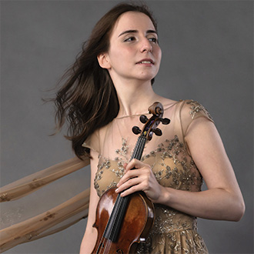
Diana Adamyan
Violin
Diana Adamyan is quickly gaining an international reputation as one of her generation’s most outstanding violinists after winning First Prize at the 2018 Yehudi Menuhin International Competition and First Prize in the 2020 Khachaturian Violin Competition. Born in Yerevan, Armenia into a family of musicians, Ms. Adamyan currently studies at the Munich University of Performing Arts with world-renowned teacher, Professor Ana Chumachenco.

Ms. Adamyan has performed throughout world, and has appeared as soloist alongside Pinchas Zukerman, Itzhak Perlman, Jessica Linnebach and other renowned musicians, including alongside Mr. Zukerman playing the Bach Double Concerto with the Royal Philharmonic in commemoration of the 100th anniversary of the Armenian Genocide. She performs on an instrument made by Nicolò Gagliano in 1760, generously on loan from the Henri Moerel Foundation.
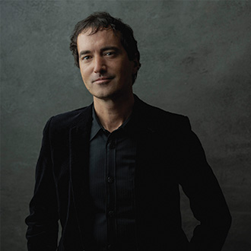
Mason Bates
Composer
Composer of the Grammy-winning opera The (R)evolution of Steve Jobs, Mason Bates is imaginatively transforming the way Classical music is created and experienced as a composer, DJ and curator. As the first composer-in-residence appointed by the Kennedy Center, he presented a diverse array of artists on his series KC Jukebox using immersive production and stagecraft. Championed by legendary conductors from Riccardo Muti and Michael Tilson Thomas to Marin Alsop, Bates has also composed for feature film including Gus Van Sant’s The Sea of Trees starring Matthew McConaughey and Naomi Watts.

Highly informed by his work as a DJ, his curatorial approach integrates adventurous music, ambient information, and social platforms in a fluid and immersive way. Bates developed Mercury Soul, a show combining DJing and Classical music, working under the name DJ Masonic to packed crowds with clubs and orchestras around the country. A diverse artist exploring the ways Classical music integrates into contemporary cultures, he serves on the faculty of the San Francisco Conservatory of Music.

Rhapsody on a Theme of Paganini, November 18, 2023
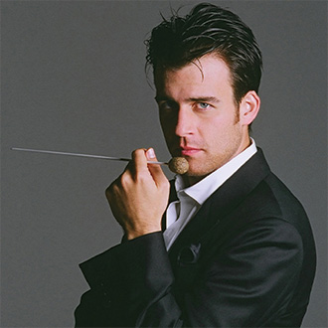
Ward Stare
Conductor
Grammy-nominated conductor Ward Stare, hailed by the Chicago Tribune as “A rising-star in the conducting firmament,” served as Music Director of the Rochester Philharmonic Orchestra from 2014-2021. In demand worldwide, Stare has led symphony and opera orchestras in Atlanta, Pittsburgh, Chicago, Dallas, Detroit, Los Angeles, Toronto, Miami (New World), Rome (Italy), Japan, Oslo (Norway), Sydney (Australia), and the DSO-Berlin. Stare served as resident conductor of the Saint Louis Symphony Orchestra from 2008- 2012 and returns frequently as a guest.

A passionate advocate for arts education, Stare is a Distinguished Artist at the Robert McDuffie Center for Strings. In 2016, he recorded Concerto for Violin, Rock Band and String Orchestra, by R.E.M. bassist/songwriter Mike Mills with the ensemble and its founder, Robert McDuffie. An enthusiastic collaborator and performer of new music, Stare gave the world premiere of Pravda, by Academy Award-winning composer Elliot Goldenthal and the regional premiere of Pulitzer Prize-winning composer Aaron Jay Kernis’ Flute Concerto, featuring Marina Piccinini.

Natasha Paremski
Piano
Awarded several prestigious prizes at a very young age, including the Gilmore Young Artists prize in 2006 at the age of 18, the Prix Montblanc in 2007, the Orpheum Stiftung Prize in Switzerland and the 2010 Classical Recording Foundation’s Young Artist of the Year, Natasha Paremski continues to win over audiences with her musical sensibility and powerful, flawless technique. She has performed with major orchestras in North America including the Dallas Symphony Orchestra, Los Angeles Philharmonic Orchestra and the San Francisco, San Diego, Toronto, Baltimore, Houston and Nashville Symphonies as well as the Royal Philharmonic Orchestra with whom she has performed every year since 2008 in venues including Royal Albert Hall, Royal Festival Hall and Cadogan Hall.

Natasha began her piano studies at the age of 4 with Nina Malikova at Moscow’s Andreyev School of Music. She then studied at San Francisco Conservatory of Music before moving to New York to study with Pavlina Dokovska at Mannes College of Music, from which she graduated in 2007. At the age of 15, Natasha debuted with the Los Angeles Philharmonic and recorded two discs with the Moscow Philharmonic Orchestra.

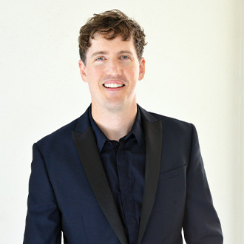
Patrick Harlin
Composer
Patrick Harlin’s music is permeated by classical, jazz, and electronic music traditions, all underpinned with a love and respect for the great outdoors. His works have been performed by the St. Louis Symphony, Kansas City Symphony, the Rochester and Calgary Philharmonic Orchestras, Collegium Cincinnati, and Calidore String Quartet, among others. Patrick was recently chosen as the inaugural composer in residence with the Lansing Symphony Orchestra (2019-2022).

Patrick’s interdisciplinary research in soundscape ecology—a field that aims to better understand ecosystems through sound—has taken him to imperiled regions around the world, including the Amazon rainforest and the Book Cliffs of Utah. His baseline recordings for ecological impact studies are also the fodder for artistic inspiration. These pieces draw parallels between the sounds of the natural world and those of the concert hall, seeking to bring awareness to the importance of sound in our environment. Patrick’s work in this field has been supported by a Graham Sustainability Institute Doctoral Fellowship, Theodore Presser Award, and a University of Michigan Predoctoral Fellowship, resulting in an ongoing body of works called The Wilderness Anthology. Patrick was raised in Seattle, WA, and is currently an adjunct faculty member at the University of Michigan.

Holiday Candlelight, December 16, 2023
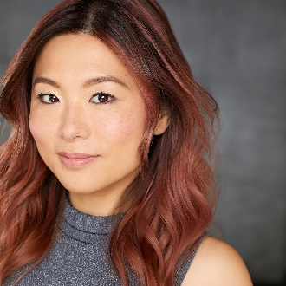
Jenny Wong
Conductor
A native of Hong Kong, Jenny Wong is currently the Associate Artistic Director of the Los Angeles Master Chorale. Conducting highlights include performances of Peter Sellars’ staging of di Lasso’s Lagrime di San Pietro while on tour in Australia, Mexico and throughout the U.S. Wong was one of nine national recipients of OPERA America’s inaugural Opera Grants for Women Stage Directors and Conductors, through which she will be conducting Schoenberg’s Pierrot Lunaire and Kate Soper’s Voices from the Killing Jar with Long Beach Opera in collaboration with WildUp.
Wong has been a conducting fellow for the Oregon Bach Festival, Baltimore Chamber Orchestra, Norfolk Chamber Music Festival, Distinguished Concerts International New York and Hong Kong SingFest. Wong received her Doctor of Musical Arts and Master of Music from the University of Southern California. She earned her undergraduate degree in voice performance from the University of Illinois, Urbana-Champaign.

Beethoven “Emperor,” January 27, 2024

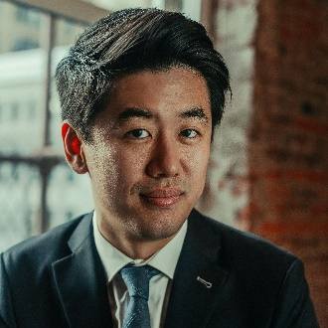
Kensho Watanabe
Conductor

Kensho Watanabe is fast becoming one of the most exciting and versatile young conductors on the international stage. He held the position of Assistant Conductor of The Philadelphia Orchestra from 2016 to 2019 and was previously an inaugural conducting fellow of the Curtis Institute of Music under the mentorship of Yannick Nézet-Séguin. Recent highlights include debuts with the London Philharmonic and Tokyo Philharmonic Orchestras, as well as his Finnish debut with the Jyväskylä Sinfonia. Equally at home in both symphonic and operatic repertoire, Watanabe has led numerous operas with the Curtis Opera Theatre and served as Assistant Conductor on a new production of Strauss’s Elektra at Montreal Opera.
Watanabe was recently recognized with a Career Assistance Award by the Solti Foundation U.S. An accomplished violinist, Mr. Watanabe received his Master of Music degree from the Yale School of Music and is a graduate of the Curtis Institute of Music, where he studied with distinguished conducting pedagogue Otto-Werner Mueller.
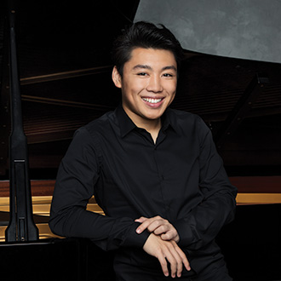
George Li
Piano
Since winning the Silver Medal at the 2015 International Tchaikovsky Competition and being named the recipient of the 2016 Avery Fisher Career Grant, George Li has rapidly established a major international reputation as he performs regularly with the world’s leading orchestras and conductors, including Gustavo Dudamel, James Gaffigan, Valery Gergiev, Andrés Orozco-Estrada, Kirill Petrenko, Leonard Slatkin, Yuri Temirkanov, Michael Tilson Thomas and Xian Zhang. Among his many awards, he was the First Prize winner of the 2010 Young Concert Artists International Auditions, as well as a recipient of the 2012 Gilmore Young Artist Award and the 2018 Arthur Waser Prize.
Li gave his first public performance at the age of 10 at Boston’s Steinert Hall, and at the age of 15, he performed for President Obama at the White House in an evening honoring German Chancellor Angela Merkel. George began his piano studies at age 4, and in 2019 he completed the Harvard/New England Conservatory dual degree program, with a Bachelor’s degree in English Literature and a Master’s degree in Music. He is currently pursuing an Artist Diploma at the New England Conservatory.
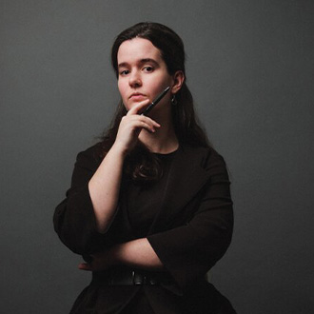
Jessica Hunt
Composer
Jessica Hunt (b. 1987) has been commissioned by major orchestras including the Philadelphia Orchestra (Climb), the Ann Arbor Symphony Orchestra (The Eagle Tree), Detroit Chamber Winds and Strings, and many others. She has served as the Boontling Community Fellow at the Gabriela Lena Frank Creative Academy of Music and as the Young Composer in Residence with the Detroit Chamber Winds and Strings, and was awarded a Regents Fellowship at the University of Michigan, where she completed her doctoral studies in 2019.

In her work as a composer, Hunt’s primary goal is to seek emotional resonance in the rhetorical dialogue between herself, the audience, and the performer by creating eclectic works that explore the aural and syntactical intersections between theatre, narrative, sound, truth and fiction. As such, she has a particular focus on works engaging with the interpretation of text and identity, ranging from her opera-in-progress Thurso’s Landing based on the lengthy narrative poem by Robinson Jeffers, to recently-premiered Climb, which explores Hunt’s physical experiences with disability and chronic illness.

Hunt serves as an Assistant Professor of Music Theory at The Peabody Institute of The Johns Hopkins University.

Tchaikovsky Piano Concerto No. 1, February 17, 2024

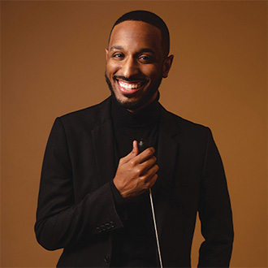
Kyle Dickson
Conductor
Kyle Dickson is quickly building a reputation as an innovative and compelling presence on the podium. Recipient of the 2021 GPMF Advocate for Arts Award, he is a Salonen Conducting Fellow with the San Francisco Symphony under the guidance of Music Director Esa-Pekka Salonen. In 2021 he became the recipient of the Richard S. Weinert Award from Concert Artists Guild.
Dickson is assistant conductor of the Inner City Youth Orchestra of Los Angeles and previously served as Music Director of Chicago’s South Loop Symphony. He was a conducting fellow at the 2021 National Orchestral Institute’s Conducting Academy with Marin Alsop and James Ross, and from 2019 to 2021 was a Project Inclusion Freeman Conducting Fellow with Chicago. In 2020, he was selected as assistant conductor of Spoleto Festival USA for the world premiere of Rhiannon Giddens and Michael Abels’s opera Omar.
Beginning his career as a violinist, Mr. Dickson was a prizewinner at the 2010 NANM National Concerto Competition. In 2021, he earned his master’s degree in orchestral conducting from Northwestern University studying with Victor Yampolsky. He also received degrees in violin performance from Michigan State University and DePaul University.
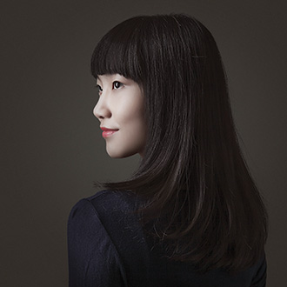
Wynona Wang
Piano
Pianist Wynona Wang was selected as First Prize winner of the 2018 Concert Artists Guild International Competition and of the 2017 Wideman International Piano Competition in Louisiana. Wynona also received the 2019 “Charlotte White” Career Grant awarded by the Salon de Virtuosi in New York City.
An active performer worldwide, Wynona’s recent North American festival performances PianoTexas, Morningside Music Bridge in Calgary, Canada, the International Keyboard Institute & Festival in New York City, and the Chautauqua Institution. Internationally, Wynona has been a featured soloist with the Academic Symphony Orchestra of the National Philharmonic Society of Ukraine, and the Romanian Mihail Jora Philharmonic Orchestra in Italy. She has also given numerous solo piano recitals in Madrid, Jakarta and throughout China in cities including Beijing, Qingdao, Hangzhou, Wuhan and Shenzhen.

Born in Beijing, Wang began playing piano at age 4, and went on to study at the prestigious Central Conservatory of Music (CCOM) in Beijing. She now lives in New York, NY while pursuing her undergraduate degree at The Juilliard School as a student of Dr. Robert McDonald.

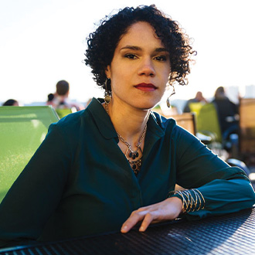
Jessie Montgomery
Composer
Jessie Montgomery is an acclaimed composer, violinist and educator. She is the recipient of the Leonard Bernstein Award from the ASCAP Foundation, and her works are frequently performed around the world. She interweaves classical music with elements of vernacular music, improvisation and social justice, placing her squarely as one of the most relevant interpreters of contemporary American sound.
Her works have been described by the Washington Post as “turbulent, wildly colorful and exploding with life.” Highlights of her growing body of work include Five Slave Songs (2018), Records from a Vanishing City (2016), Caught by the Wind (2016), and Banner (2014), written to mark the 200th anniversary of The Star-Spangled Banner. She holds degrees from the Juilliard School and New York University and is currently a Graduate Fellow in Music Composition at Princeton University.

Beethoven Violin Concerto, March 23, 2024
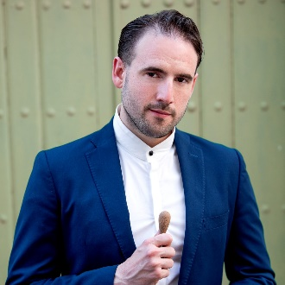
François López-Ferrer
Conductor
Spanish-American conductor François López-Ferrer came to international attention after a critically acclaimed debut at the 2018 Verbier Festival, where he jumped in for Iván Fischer in a shared program with Sir Simon Rattle and Gébor Takécs-Nagy. In demand as a guest conductor, López-Ferrer’s recent and upcoming highlights include debuts with the Los Angeles Philharmonic, Orquesta Nacional de España, Cincinnati Symphony Orchestra and Orquesta Sinfónica de Galicia, among others. López-Ferrer is one of six participants to be featured in the 2022 Bruno Walter National Conductor Preview with the Louisiana Philharmonic Orchestra. He previously served as Associate Conductor of the Orquesta Sinfónica Nacional de Chile (OSNCH), Principal Conductor of the Ballet Nacional Chileno, and was the youngest ever Conductor-in-Residence of the OSNCH's Summer Concert Series.
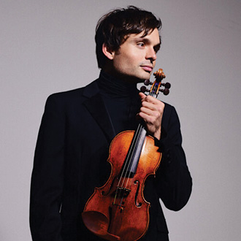
Francisco Fullana
Violin
Spanish-born violinist Francisco Fullana, has been hailed as an "amazing talent" (Gustavo Dudamel) and "frighteningly awesome" (Buffalo News). His versatility as a performer has brought him to perform with ensembles across the artistic spectrum, from major orchestras including Vancouver, Aachen, Pacific and Buffalo Symphony Orchestras, to the baroque ensemble Apollo’s Fire, where he served as artist-in-residence, and the new music driven Metropolis Ensemble. He has won numerous prestigious awards including the 2018 Avery Fisher Career Grant.
Francisco is a committed innovator, leading new institutions of musical education for young people. He is co-founder of San Antonio’s Classical Music Summer Institute, where he currently serves as Chamber Music Director. He also created the Fortissimo Youth Initiative, a series of music seminars and performances with youth orchestras, which aims to deepen young musicians’ understanding of 18th-century music.
Francisco is a graduate of the Royal Conservatory of Madrid, received Bachelor’s and Master’s degrees from The Juilliard School studying with Donald Weilerstein and Masao Kawasaki, and holds an Artist Diploma from the USC Thornton School of Music, where he worked with the renowned violinist Midori. Fullana performs on the 1735 "Mary Portman" ex-Kreisler Guarneri del Gesù violin, kindly on loan from Clement and Karen Arrison through the Stradivari Society of Chicago.

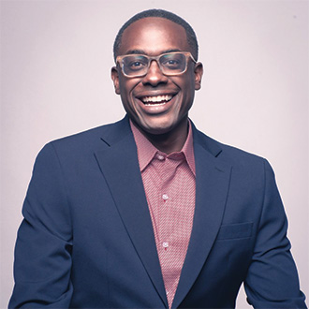
Shawn Okpebholo
Composer
Shawn E. Okpebholo is a Grammy®-nominated, award-winning composer whose music has been described as "devastatingly beautiful" and "fresh and new and fearless" (The Washington Post). Honors include The Academy of Arts and Letters Walter Hinrichsen Award, 2022 Winner of Barlow Endowment for Music Composition and First Place Winner of the 2020 American Prize in Composition. Okpebholo's music has been performed by orchestras throughout the world and he is currently in residence with the Chicago Opera Theater (2021-2023 seasons), culminating with an opera commission with librettist Mark Campbell.
Okpebholo's music has been featured on PBS Newshour, and radio broadcasts nationwide including NPR's All Things Considered, NPR's Morning Edition and SiriusXM's Living American series. NPR selected his art song The Rainas as one of the 100 Best Songs of 2021; only a few classical works to make the ranking.
Okpebholo’s compositional and research interests have been a gateway for ethnomusicological fieldwork in both East and West Africa. He has studied the music of the Esan people in southern Nigeria, the Akambe people in the Machakos region of Kenya, and South Sudanese refugees in northern Uganda, resulting in in two chamber works, two symphonic works, transcriptions, and academic lectures. He is currently Jonathan Blanchard Professor of Music Composition and Theory at Wheaton College-Conservatory of Music (IL).

Vivaldi Four Seasons, April 20, 2024
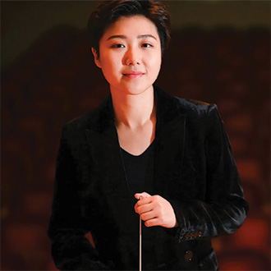
Linhan Cui
Conductor

Conductor Linhan Cui has established herself as a sought-after artist who recently won second prize in the Malko International Conducting Competition. With natural expressivity at the core of her work, her experience includes performances with the Baltimore Symphony Orchestra, Danish National Symphony Orchestra, Korean Symphony Orchestra, and the Xinghai Symphony Orchestra, among others. As an Assistant Conductor, Linhan has worked with many world-renowned maestros including Leon Fleisher and Xian Zhang.
Linhan is Gustavo Dudamel's Conducting Fellow for the 2022-2023 season, performing with the Los Angeles Philharmonic. During the 2019-2020 season, she was appointed Conducting Fellow by the Baltimore Symphony Orchestra where she had the privilege of serving as Marin Alsop’s cover conductor.
Cui was born in Shenyang, China and began her piano study at the age of 4. She started conducting at age 18 when she was the only accepted student at the Xinghai Conservatory, China. She holds a Master of Music degree from the Peabody Conservatory and is currently pursuing doctoral studies in orchestral conducting at the Indiana University Jacobs School of Music, under the guidance of Arthur Fagen.
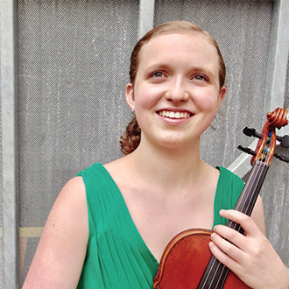
Charlotte Marckx
Violin
Violinist Charlotte Marckx was a 2019 Davidson Fellowship Laureate and is a Jack Kent Cooke College Scholar. She won the Gold Medal and Bach Prize at the 2018 Stulberg International Competition and was a major prizewinner at the 2018 Johansen International Competition. Originally from the Seattle area, Ms. Marckx has won the KING FM Young Artists Awards and the Seattle Young Artists Music Festival Concerto Competition. Ms. Marckx has soloed with many orchestras, including the Seattle Symphony, Burbank Symphony, Baltimore Chamber Orchestra, and Kalamazoo Symphony, and has performed with the Seattle Chamber Music Society, Orcas Island Chamber Music Festival, and Colburn Chamber Music Society. She has also been featured on National Public Radio’s From the Top and in Strings magazine.
Charlotte is currently a student at the Colburn Conservatory, where she studies with renowned pedagogue Robert Lipsett. In the summers, Ms. Marckx continues her studies with Mr. Lipsett at the Aspen Music Festival and Sounding Point Academy.
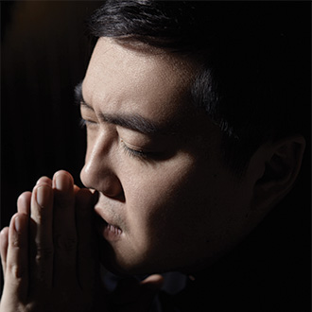
Si’ang Chen
Composer
Chinese composer Si’ang Chen is an associate professor of composition at the Xinghai Conservatory of music. He graduated from the Central Conservatory of music, where he studied under the guidance of Professor Tang Jianping. In his compositions, Chen emphasizes the use of timbre, and the exploration of various compositional approaches. His works have been performed by orchestras worldwide, and has been awarded many prizes.
-end-

