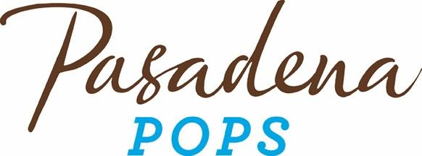
FOR IMMEDIATE RELEASE
Pasadena Symphony Association
Pasadena Symphony & POPS
Contact: Marisa McCarthy
MMcCarthy@PasadenaSymphony-Pops.org
(626) 793-7172 ext. 13
July 20, 2022
Click here for high res images

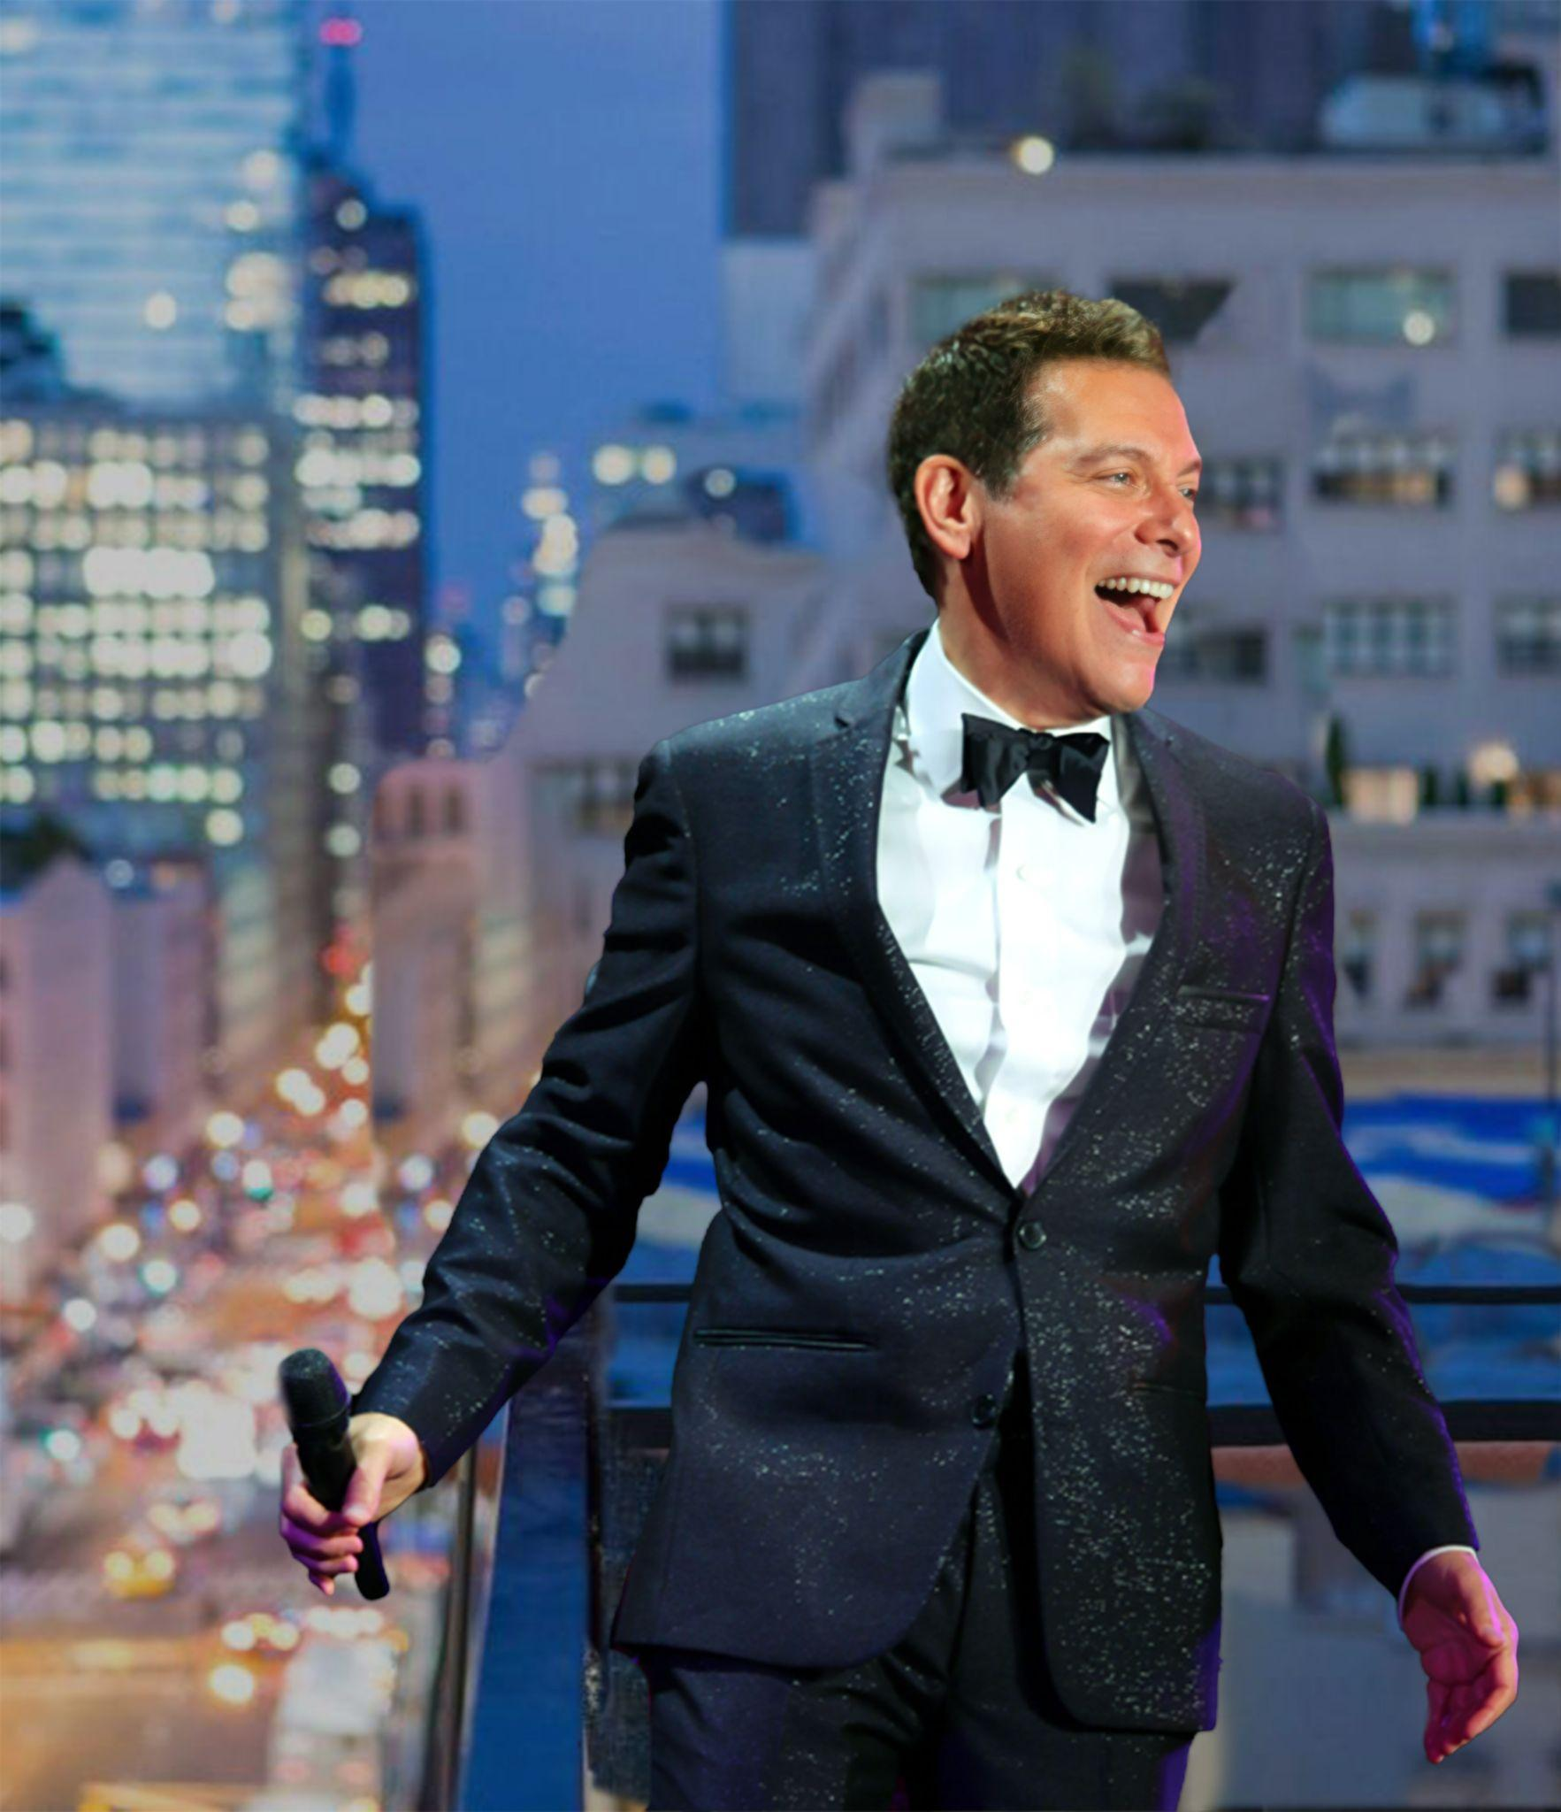
MICHAEL FEINSTEIN AND THE PASADENA POPS CELEBRATE THE CENTENNIALS OF JUDY GARLAND, DORIS DAY AND PEGGY LEE AT THE LA ARBORTUM
Pasadena, CA – Principal Pops Conductor Michael Feinstein and the Pasadena POPS continue their one-of-a kind, outdoor concert series with American Icons: Judy Garland & Friends on Saturday, August 13 at the LA County Arboretum. The program will celebrate the centennials of iconic songstresses Judy Garland, Doris Day and Peggy Lee, and give a nod to Liza Minnelli and Garland’s legacy. Audiences will delight in hearing Feinstein’s firsthand accounts and intimate stories as Melissa Manchester, Nicole Henry and Maddie Baillio sing timeless songs such as “Big Spender,” “Cabaret,” “Come Rain or Come Shine,” “Lady Be Good,” “Lover,” “The Trolley Song,” the original film arrangement for “Over The Rainbow” and so much more.

“Even though I never met Judy Garland, I know her family very well and they have made available her entire library of her arrangements. Some of these have never been played publicly before, or were only heard once on her TV show. Speaking of Garland’s family, we will have a special tribute to Judy's beloved daughter and my close friend for decades, Liza Minnelli. Liza has generously loaned us some of her personal orchestrations as well to pay tribute to her, so it’s going to be quite a show.”
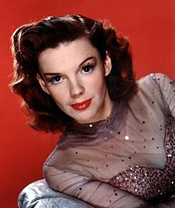
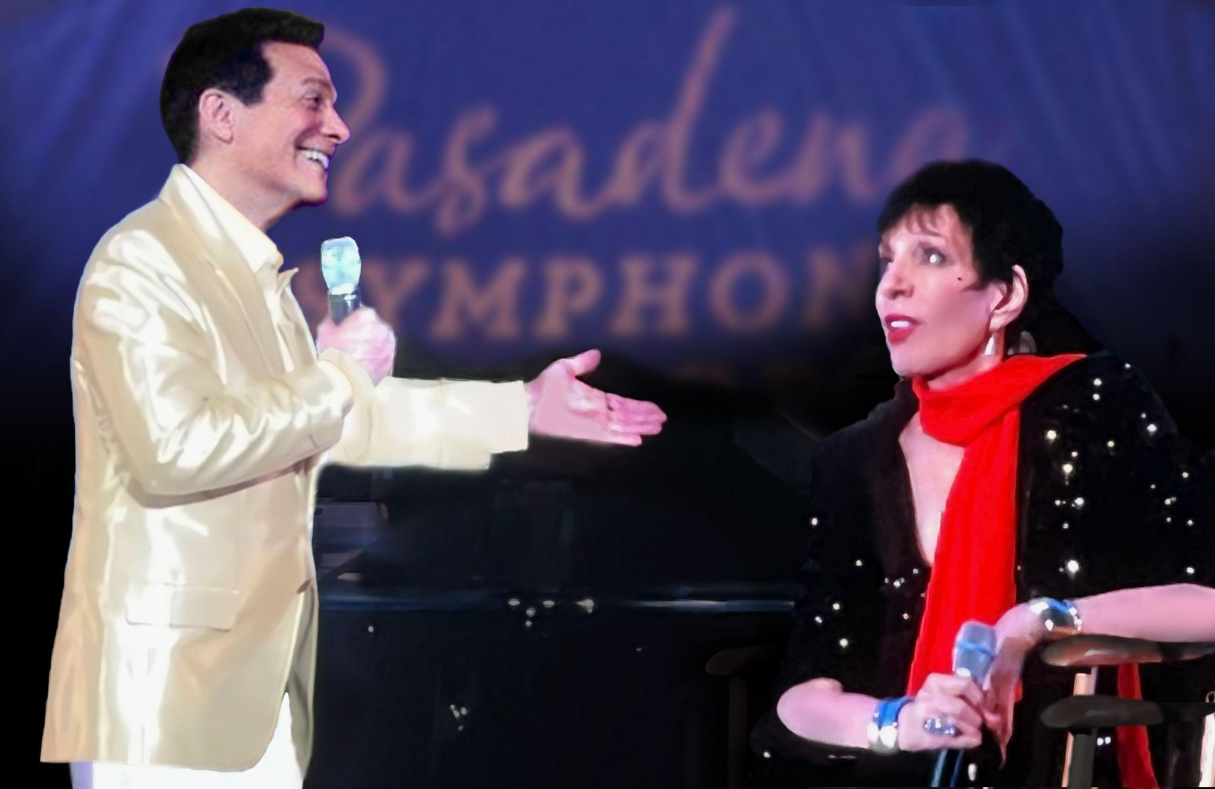
– Michael Feinsten

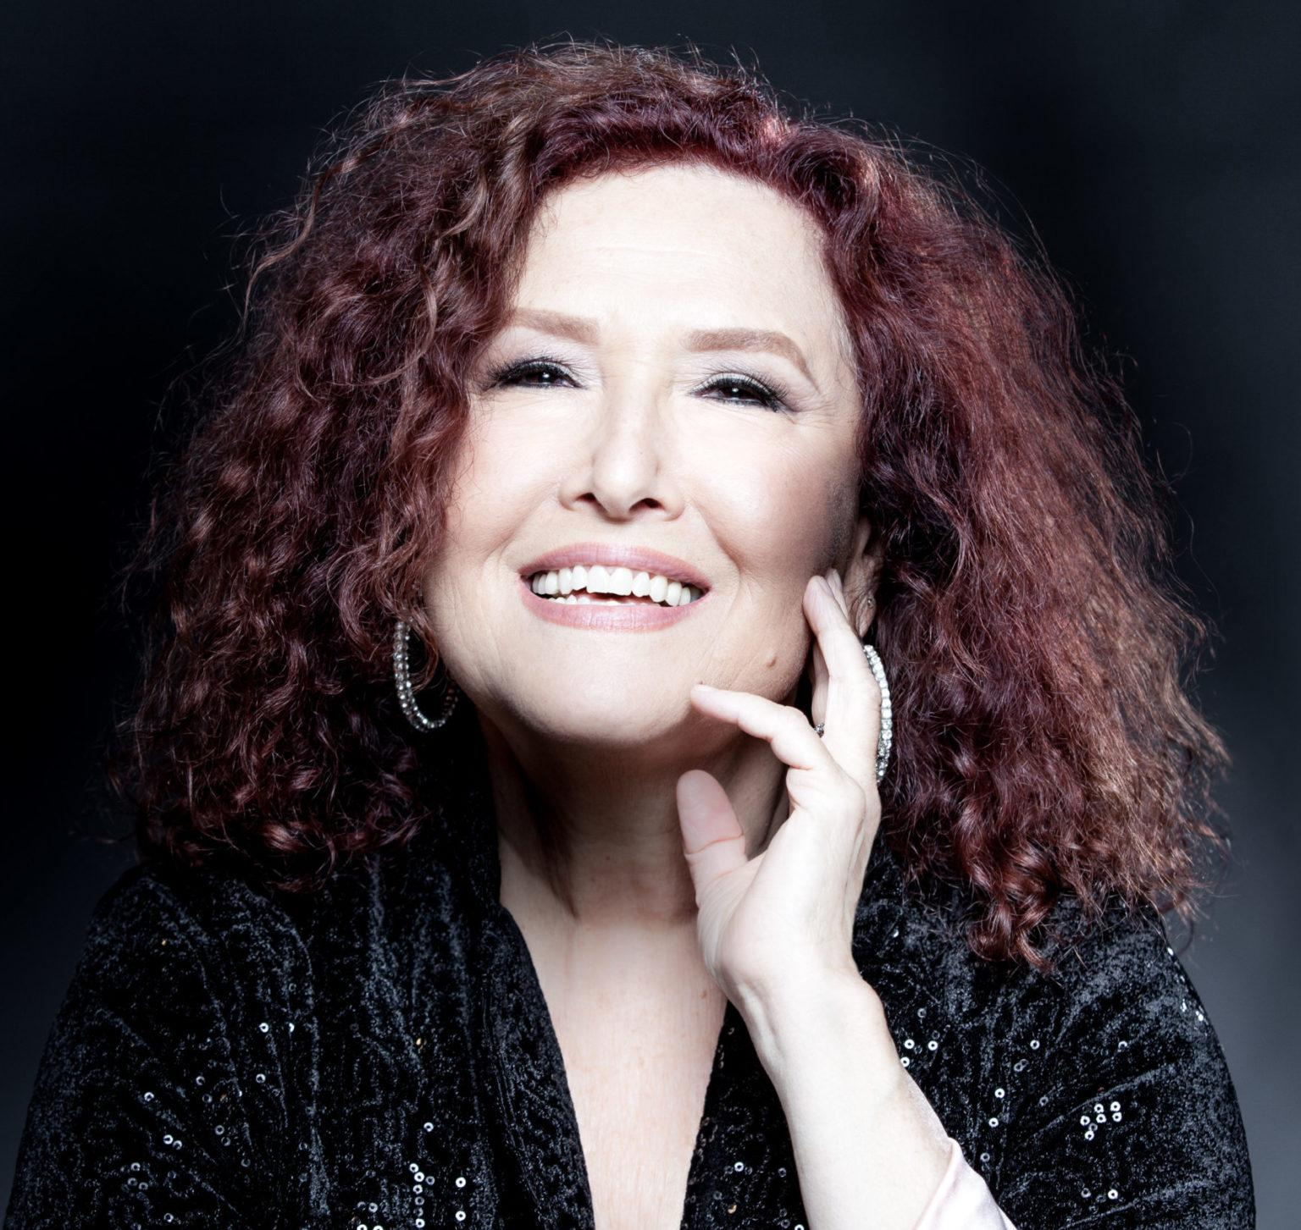
To musically celebrate the legacies of these women, Feinstein welcomes three soloists to the stage including icon, “Grammy Award Winner”, singer and songwriter, Melissa Manchester, whose hits include, “Don't Cry Out Loud", "You Should Hear How She Talks About You", "Midnight Blue” and "Just Too Many People". Manchester will be singing selections from her album Legends, where she pays tribute to Judy Garland, Peggy Lee and Doris Day, as well as songs from her own collection like “Come in from the Rain.” Manchester will share the stage with two generations of icons-in-the-making with Award-winning Jazz performer, Nicole Henry and Songbook Youth Ambassador and Hairspray Live’s Maddie Baillio.
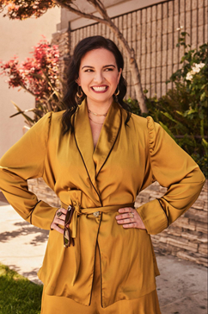

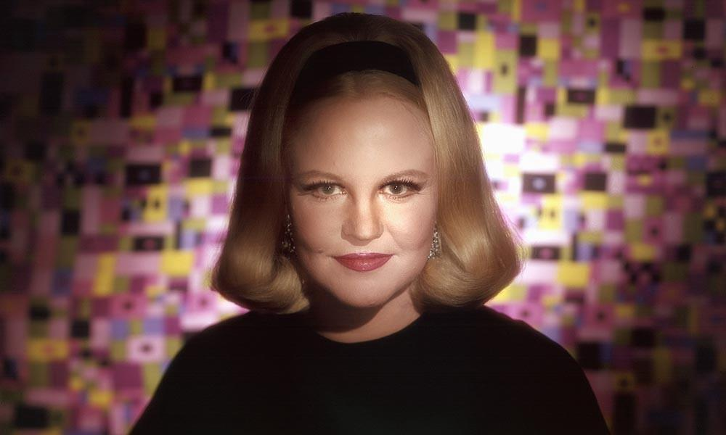
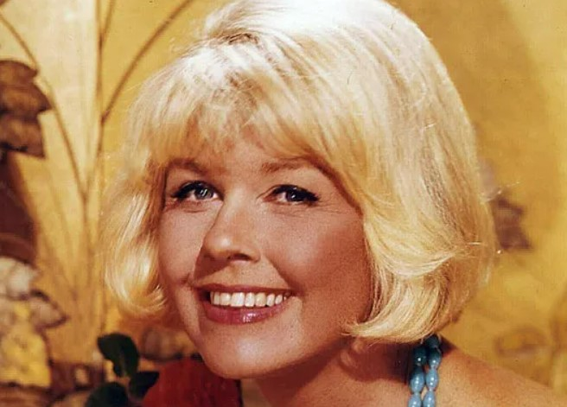
Grammy Award winner Doris Day, who like Peggy Lee, began her career as a big band singer brought great music to film including the timeless, Academy Award Winner, “Que Sera Sera.” Lee’s fever has influenced generation after generation since its 1940 debut, to thousands of covers and platinum tributes from artists as diverse as Chaka Khan and Madonna.

All concerts are held at the Los Angeles County Arboretum and Botanic Gardens. Grounds open for picnicking and dining at 5:30pm and performances begin at 7:30pm. Don’t miss the best outdoor dinner party in town with spacious circular table seating with fine linens, gourmet cuisine and fine wines are available for table side service or lawn seating for those who want to bring a blanket – each option carries on the tradition of picnic-dining with your family and friends listening to Michael Feinstein and Pasadena’s premier orchestra! Among many venue amenities, concert goers can enjoy pre-ordered gourmet box dinners for on-site pickup just steps from their table or a variety of food truck options.
The Arboretum is located at 301 North Baldwin Ave., Arcadia, CA. Subscribers may purchase pre-paid onsite parking at the Arboretum, and all concertgoers can purchase guaranteed and convenient parking at Santa Anita Park, with complimentary, non-stop shuttle service to the Arboretum’s main entrance.
Tickets start at $25, and are available by calling the box office at (626) 793-7172, online at PasadenaSymphony-Pops.org or at the Arboretum on concert days.
IF YOU GO:
- What: The Pasadena POPS presents American Icons: Judy Garland & Friends
Michael Feinstein, Principal Pops Conductor
Melissa Manchester, soloist
Nicole Henry, soloist
Maddie Baillio, soloist
- When: Saturday, August 13, 2022. Concert starts at 7:30pm. Gates open at 5:30pm.
- Where: The LA County Arboretum | 301 N Baldwin Ave., Arcadia, CA 91007
- Cost: Tickets start at $25.00
- Dining: Gates open at 5:30pm for picnicking. Guests are welcome to bring their own food and drink or pre-order from onsite food vendors.
- Parking: Subscribers have the opportunity to purchase onsite Arboretum parking. Single ticket holders may purchase guaranteed and convenient parking at Santa Anita Park, located just across Baldwin Ave., with non-stop shuttle service to the Arboretum’s main entrance for $10. Available for pre-purchase or cash only on-site.
ABOUT THE ARTISTS
Michael Feinstein
Principal Pops Conductor
In addition to his recognition as one of the leading musical entertainers and piano virtuosi of recent decades, Michael Feinstein’s work as an educator, archivist, interpreter, and Ambassador of the Great American Songbook have established the popular and honored musician as a pre-eminent force in contemporary music. His dazzling career as a top-selling and critically acclaimed recording artist and a star performer on Broadway, and the world’s great concert stages has earned him five GRAMMY® Award nominations, two Emmy nominations of his PBS-TV specials and acclaim for is NPR series. His live concerts have spanned the globe including such iconic venues such as The White House, Buckingham Palace, Hollywood Bowl, Carnegie Hall, and the Sydney Opera House.
As one of cabaret’s most famous champions has forged a collaboration with New York’s renowned room and storied venues, Café Carlyle.
In 2022, Feinstein released to rave reviews, Gershwin Country, an album of standards in duet with some of the biggest names in Country Music from Dolly Parton and Alison Krauss to Brad Paisley and Amy Grant. Gershwin Country charted at Number 7 on the Billboard’s Country Charts.
In 2007, as an extension of his work as a legendary performer and passionate guardian of his nation’s greatest musical traditions, Mr. Feinstein founded the Great American Songbook Foundation. The Foundation works to preserve and elevate America’s rich musical legacy by curating physical artifacts of its creators and performers; offering programs for the public and research opportunities for scholars, historians, and performers; and providing educational opportunities for student musicians, including the annual high school Songbook Academy®. For over a decade, Michael served as a Founding Member on the Library of Congress’ National Recording Preservation Board; an organization dedicated to ensuring the survival, conservation and increased public availability of America’s sound recording heritage.
Feinstein earned his fifth Grammy Award nomination in 2009 for The Sinatra Project, his CD celebrating the music of “Ol’ Blue Eyes.” The Sinatra Project, Volume II: The Good Life was released in 2011. He released the CDs The Power Of Two – collaborating with “Glee” and “30 Rock” star Cheyenne Jackson – and Cheek To Cheek, recorded with Broadway legend Barbara Cook. For Feinstein’s CD We Dreamed These Days, he co-wrote the title song with Dr. Maya Angelou.
His Emmy Award-nominated TV special Michael Feinstein – The Sinatra Legacy, which was taped live at the Palladium in Carmel, IN, aired across the country in 2011. The PBS series “Michael Feinstein’s American Songbook,” the recipient of the ASCAP Deems-Taylor Television Broadcast Award, was broadcast for three seasons and is available on DVD. His most recent primetime PBS-TV Special, “New Year’s Eve at The Rainbow Room” – written and directed by “Desperate Housewives” creator Marc Cherry – aired in 2014. For his nationally syndicated public radio program “Song Travels,” Michael interviewed and performed alongside of music luminaries such as Bette Midler, Neil Sedaka, Liza Minnelli, Rickie Lee Jones, David Hyde Pierce and more.
Feinstein was named Principal Pops Conductor for the Pasadena Symphony in 2012 and made his conducting debut in June 2013 to celebrated critical acclaim. Under Feinstein’s leadership, the Pasadena Pops has quickly become a premier orchestral presenter of the Great American Songbook with definitive performances of rare orchestrations and classic arrangements. He launched an additional Pops series at the Kravis Center for the Performing Arts in Palm Beach, Florida in 2014.
Michael’s book The Gershwins and Me – the Los Angeles Times best-seller from Simon & Schuster – features a new CD of Gershwin standards performed with Cyrus Chestnut at the piano.
Feinstein serves as Artistic Director of the Center for the Performing Arts, a $170 million, three-theatre venue in Carmel, Indiana, which opened in January 2011. The theater is home to diverse live programming and a museum for his rare memorabilia and manuscripts. Since 1999, he has served as Artistic Director for Carnegie Hall’s “Standard Time with Michael Feinstein” in conjunction with ASCAP. In 2010 he became the director of the Jazz and Popular Song Series at New York’s Jazz at Lincoln Center.
Feinstein’s at the Nikko, Michael’s nightclub at San Francisco’s Nikko Hotel, has presented the top talents of pop and jazz since 2013. He debuted at Feinstein’s/54 Below, his new club in New York, late in 2015. His first venue in New York, Feinstein’s at the Regency, featured major entertainers such as Rosemary Clooney, Glen Campbell, Barbara Cook, Diahann Carroll, Jane Krakowski, Lea Michele, Cyndi Lauper, Jason Mraz, and Alan Cumming from 1999 to 2012. Most recently, Feinstein opened his first Los Angeles location, Feinstein’s at Vitello’s in June of 2019.
He has designed a new piano for Steinway called “The First Ladies,” inspired by the White House piano and signed by several former First Ladies. It was first played to commemorate the Ronald Regan centennial on February 6, 2011.
In 2013 Michael released Change Of Heart: The Songs of Andre Previn in collaboration with four time Oscar and eleven time Grammy Award-winning composer-conductor-pianist Andre Previn. The album celebrates Previn’s pop songs and motion picture classics. Earlier album highlights include Hopeless Romantics, a songbook of classics by Michael’s late friend Harry Warren, recording with legendary jazz pianist George Shearing. His album with songwriting icon Jimmy Webb, Only One Life – The Songs of Jimmy Webb, was named one of “10 Best CDs of the Year” by USA Today.
Feinstein received his fourth Grammy nomination for Michael Feinstein with the Israel Philharmonic Orchestra, his first recording with a symphony orchestra. The year before, Rhino/Elektra Music released The Michael Feinstein Anthology, a two-disc compilation spanning 1987 to 1996 and featuring old favorites and previously unreleased tracks.
Michael was born and raised in Columbus, Ohio, where he started playing piano by ear as a 5-year-old. After graduating from high school, he moved to Los Angeles when he was 20. The widow of legendary concert pianist-actor Oscar Levant introduced him to Ira Gershwin in July 1977. Feinstein became Gershwin’s assistant for six years, which earned him access to numerous unpublished Gershwin songs, many of which he has since performed and recorded.
Gershwin’s influence provided a solid base upon which Feinstein evolved into a captivating performer, composer, and arranger of his own original music. He also has become an unparalleled interpreter of music legends such as Irving Berlin, Jerome Kern, Johnny Mercer, Duke Ellington, and Harry Warren. Feinstein has received three honorary doctorates.
Through his live performances, recordings, film and television appearances, and his songwriting (in collaboration with Alan and Marilyn Bergman, Lindy Robbins, Bob Merrill, and Marshall Barer), Feinstein is an all-star force in American music.
For more information, please visit www.MichaelFeinstein.com.
Melissa Manchester
Soloist
In 1980, Melissa Manchester became the first recording artist in the history of the Academy Awards to have two nominated movie themes in a single year, “Through The Eyes Of Love” from Ice Castles and “I’ll Never Say Goodbye” from The Promise, and to perform them both on the Oscar telecast. Melissa starred in the national tours of Andrew Lloyd Webber’s Music Of The Night and Song And Dance, and created the role of Maddy, the title character’s mother, on the NBC hit TV series Blossom.
Nominated for a Grammy in 1980 for “Don’t Cry Out Loud,” she won the Grammy Award for best female vocalist in 1982 singing “You Should Hear How She Talks About You.” Melissa has composed music for the animated features The Great Mouse Detective and Lady And The Tramp II, the sequel to the Disney classic. In addition to composing the scores for the theatrical musicals I Sent A Letter To My Love and Sweet Potato Queens, Melissa also cowrote the radio mainstays “Midnight Blue”, “Come In From The Rain” and “Whenever I Call You Friend.”
Melissa celebrated her forty-five-year career with the release of her 21th album, The Fellas, a tribute to the iconic male singers who set the platinum standard for the music of the great American songbook. Her new album, RE:VIEW, rolling out song by song in 2021, features previously unreleased songs as well as fresh takes on several of Melissa’s enduring classic hits.
Nicole Henry
Soloist
Since her debut, Nicole Henry has established herself among the jazz world’s most acclaimed performers, possessing a potent combination of dynamic vocal abilities, impeccable phrasing, and powerful emotional resonance.
Her passionate, soulful voice and heartfelt charisma have earned her a Soul Train Award for “Best Traditional Jazz Performance,” and three Top-10 U.S. Billboard and HMV Japan jazz albums. Heralded by The New York Times, Wall Street Journal, The Japan Times, El Pais, Jazz Times, Essence and more, Ms. Henry tells real stories through peerless interpretations of repertoire from the American Songbook, classic and contemporary jazz, popular standards, blues and originals.
She has captivated audiences in over 20 countries, headlining at venues in cities including New York, Tokyo, Madrid, Moscow, Paris, Shanghai, Los Angeles, Chicago, Boston, San Francisco and Miami. Ms. Henry has also performed in more than 30 music festivals worldwide and in some of the world’s most famous venues including Blue Note; Jazz at Lincoln Center; Blues Alley; Arsht Center; Feinstein’s; Green Mill; Jazz St. Louis; Madrid Jazz Festival; the Regattabar; and Catalina Jazz.
She has recorded with some of today’s musical greats including Kirk Whalum, Julian Lage, Gerald Clayton and Gil Goldstein and has performed with the Duke Ellington Orchestra, the Henry Mancini Institute Orchestra and Michael Feinstein.
In late 2019, Ms. Henry returned to the theatrical stage and garnered critical praise in the musical version of The Bodyguard, and in 2021 will be in the world premiere of the new musical A Wonderful World, on the life of Louis Armstrong.
Growing up in a musical family in Bucks County, PA, Ms. Henry immersed herself in the arts early on, singing in school and church, and studying cello and ballet. After graduating from the University of Miami with a degree in Communications and Theatre, she launched a successful acting career, appearing in national commercial roles as well as a series of voiceover assignments. However, she directed her strongest passion toward the development of her full-time singing career which was quickly rewarded when the Miami New Times named Nicole “Best Solo Musician.”
Through Nicole Henry’s career accomplishments and active commitment to supporting community non-profits such as Miami Children’s Initiative, YoungArts and Miami Music Project, she has been recognized by the City of Miami Beach and Miami-Dade County with proclamations of “Nicole Henry Days” in 2011, 2016 and 2017. She also served two terms on the Board of Governors of the Florida Chapter of the Recording Academy.
Maddie Baillio
Soloist
Madelyn Baillio, from League City, Texas, served as the 2014 Songbook Youth Ambassador. A sophomore at Marymount Manhattan College in New York City, she recently starred as Dracula in Dracula, the Musical and Winnifred in Once Upon a Mattress at the York Theatre. Madelyn has performed to capacity audiences at venues such as the Kennedy Center, the Grand 1894 Opera House, Carnegie Hall, Lincoln Center, and Birdland Jazz Club with Michael Feinstein.
Madelyn was selected to perform the role of Tracy Turnblad in NBC’s Hair Spray Live! (2016) and played Millie Mitchellchuck in the Netflix comedy film Dumplin’ in 2018. More recent credits include her role as Malvolia in Amazon Prime Original movie Cinderella (2021).
ABOUT THE PASADENA SYMPHONY ASSOCIATION
Formed in 1928, the Pasadena Symphony and POPS is an ensemble of Hollywood’s most talented, sought after musicians. With extensive credits in the film, television, recording and orchestral industry, the artists of Pasadena Symphony and POPS are the most heard in the world.
The Pasadena Symphony and POPS performs in two of the most extraordinary venues in the United States: Ambassador Auditorium, known as the Carnegie Hall of the West, and the luxuriant Los Angeles Arboretum & Botanic Garden. The multi-platinum-selling, two-time Emmy and five-time Grammy Award-nominated entertainer dubbed “The Ambassador of the Great American Songbook,” Michael Feinstein, leads the POPS as Principal Pops Conductor, succeeding Marvin Hamlisch.
A hallmark of its robust education programs, the Pasadena Symphony Association has served the youth of the region for over five decades through the Pasadena Youth Symphony Orchestras (PYSO) comprised of seven performing ensembles, with over 700 gifted 4th-12th grade students from 85 schools all over Southern California. The PYSO Symphony has performed at venues across the globe as well as on the television show GLEE.
The PSA provides people from all walks of life with powerful access points to the world of symphonic music.
- end -

