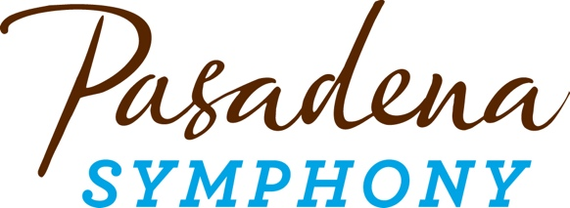
FOR IMMEDIATE RELEASE

Pasadena Symphony Association
Pasadena Symphony & POPS
Contact: Lora Unger
Lunger@PasadenaSymphony-Pops.org
(626) 793-7172 ext. 12

February 8, 2022

For full artist bios and high res images visit: https://pasadenasymphony-pops.org/22-23-symphony-season-announcement/

PASADENA SYMPHONY ANNOUNCES 2022/23 SEASON TOGETHER WITH MUSIC DIRECTOR SEARCH
Acclaimed guest conductors François López-Ferrer, Lina Gonzáles-Granados, Vinay Parameswaran, Rebecca Tong, Kensho Watanabe, Jenny Wong and Joseph Young will serve as Artistic Partners for the 2022/23 season

Third annual Composers Showcase will feature works by composers who are shaping the future of classical music with Unsuk Chin, Anna Clyne, Valerie Coleman, Nokuthula Ngwenyama, Huang Ruo and Carlos Simon

Pasadena, CA – Pasadena Symphony announces its 95th season with an exhilarating schedule of seven concerts, running October 22, 2022 through April 29, 2023. The 2022/23 season will be presented under the batons of seven guest conductors serving as Artistic Partners, each bringing a new and diverse voice to the podium while the orchestra embarks on a search for its new Music Director. Alongside a stellar season of celebrated works and world-renowned guest artists, the orchestra’s commitment to contemporary music remains a top priority with its third annual Composers Showcase, featuring works at each concert by both emerging and established composers who are shaping the future of classical music. Concerts take place at Pasadena’s Ambassador Auditorium with both matinee and evening performances at 2pm and 8pm. The season also includes the annually sold-out Holiday Candlelight Concert on Saturday, December 17, 2022 with 4pm and 7pm performances at All Saints Church.

"Everyone at the Pasadena Symphony is excited to embark on the journey of selecting a new Music Director. We have formed a team of musicians, board members and staff to work collaboratively in selecting a conductor with passionate musical ideas, who inspires the orchestra to perform at the highest technical and artistic level, and who will thrill and attract audiences of all ages,” says Lora Unger, CEO adding "we’re looking for our next Music Director to bring a set of skills and values that will shape how we communicate, invite and engage the diversity of our community to ensure access for all.”

Conductor Vinay Parameswaran opens the 2022/23 season on October 22 with Mozart’s Symphony No. 39 and the Saint-Saëns’ Piano Concerto No. 2 with Grammy-nominated pianist Terrence Wilson; 2021 Sphinx Medal of Excellence recipient Lina Gonzáles-Granados leads the orchestra on November 12 with Tchaikovsky’s Symphony No. 5 and the Sibelius Violin Concerto with award-winning violinist Alexandra Conunova; and back by popular demand, conductor Jenny Wong returns to ring in the holidays with the orchestra’s annual Holiday Candlelight Concert on December 17. Conductor Joseph Young greets the New Year on January 21 with Mendelssohn’s Symphony No. 4 “Italian” and Mozart’s Piano Concerto No. 20 with Colburn young artist Vijay Venkatesh; François López-Ferrer conducts Rimsky-Korsakov’s Scheherazade and Elgar’s Cello Concerto with internationally renowned, Grammy Award-winning cellist Zuill Bailey on February 11; Rebecca Tong takes the podium on March 18 for Beethoven’s Symphony No. 3 “Eroica” with Russian prodigy Alexander Malofeev and Rachmaninoff’s Piano Concerto No. 2; and the season closes April 29 with Gershwin’s An American in Paris and Rachmaninoff’s Symphonic Dances led by Kensho Watanabe, with Avery Fisher Winner Tai Murray and the Barber Violin Concerto. This season’s Composer’s Showcase features Nokuthula Ngwenyama’s Primal Message (October 22), Valerie Coleman’s Seven O’Clock Shout (November 12), Anna Clyne’s Sound and Fury (January 21), Unsuk Chin’s Subito con forza (February 11), Huang Ruo’s Folk Songs for Orchestra (March 18) and Carlos Simon’s The Block (April 29).

The Pasadena Symphony provides a quintessential experience specially designed for the music lover, the social butterfly or a date night out, and the inner epicurean in us all. Audiences can enjoy a drink or a bite in the lively outdoor Symphony Lounge, yet another addition to the carefree and elegant concert experience the Pasadena Symphony offers. A posh setting at Ambassador Auditorium's beautiful outdoor plaza, the Lounge offers uniquely prepared menus for both lunch and dinner and a full service bar before the concert and during intermission.

All Symphony series concerts take place at Ambassador Auditorium, 131 S. St. John Avenue, Pasadena, CA 91105, with performances at 2pm and 8pm. Subscription packages start at $99 with single tickets starting at $35. Both may be purchased online at pasadenasymphony-pops.org or by calling (626) 793-7172.

The Pasadena Symphony is committed to providing the safest possible setting for the community and requires all concertgoers to be fully vaccinated to attend concerts at Ambassador Auditorium. For the most up to date safety protocols, visit: pasadenasymphony-pops.org/symphony-covid-safety/.

2022/23 Symphony Series Calendar

MOZART SYMPHONY NO. 39
October 22, 2022
Vinay Parameswarn, conductor
Terrence Wilson, piano

Nokuthula Ngwenyama Primal Message for String Orchestra, Harp, and Percussion
Saint-Saëns Piano Concerto No. 2
Rossini Overture to La Scala di Seta
Mozart Symphony No. 397

TCHAIKOVSKY & SIBELIUS
November 12, 2022
Lina Gonzáles-Granados, conductor
Alexandra Conunova, violin

Valerie Coleman Seven O’ Clock Shout
Sibelius Violin Concerto
Tchaikovsky Symphony No. 5

HOLIDAY CANDLELIGHT
December 17, 2022
Jenny Wong, conductor
Soloist, tba

MENDELSSOHN & MOZART
January 21, 2023
Joseph Young, conductor
Vijay Venkatesh, piano

Anna Clyne Sound and Fury
Mozart Piano Concerto No. 20
Mendelssohn Symphony No. 4

SCHEHERAZADE
February 11, 2023
François López-Ferrer, conductor
Zuill Bailey, cello

Unsuk Chin Subito con forza
Elgar Cello Concerto
Rimsky-Korsakov Scheherazade

BEETHOVEN & RACHMANINOFF
March 18, 2023
Rebecca Tong, conductor
Alexander Malofeev, piano

Huang Ruo Folk Songs for Orchestra: Flower Drum Song from Feng Yang, Love Song from Kang Ding
Rachmaninoff Piano Concerto No. 2
Beethoven Symphony No. 3

AMERICAN IN PARIS
April 29, 2023
Kensho Watanabe, conductor
Tai Murray, violin

Gershwin An American in Paris
Barber Violin Concerto
Carlos Simon The Block
Rachmaninoff Symphonic Dances

ABOUT THE ARTISTS

Mozart & Symphony No. 39, October 22, 2022

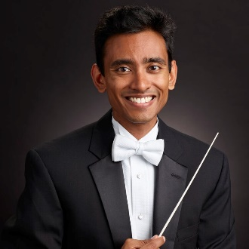
Vinay Parameswaran
Conductor
Internationally recognized for his energetic presence, imaginative programming and compelling musicianship, Vinay Parameswaran is one of the most exciting and versatile young conductors on the podium today. American born and of Indian descent, Parameswaran is the Associate Conductor of The Cleveland Orchestra and also serves as Music Director of the Cleveland Youth Orchestra. He came to Cleveland following three seasons as Associate Conductor of the Nashville Symphony, and has also been a Conducting Fellow at the Tanglewood Music Center. A native of the San Francisco Bay Area, Parameswaran holds a Bachelor of Arts degree from Brown and an Artist Diploma in conducting from the Curtis Institute of Music, where he studied under Otto-Werner Mueller as the Albert M. Greenfield Fellow.

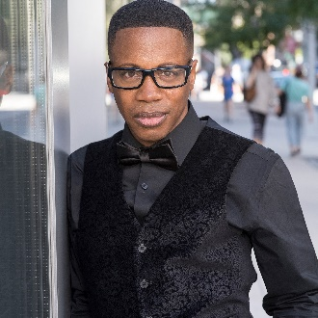
Terrence Wilson
Piano
Acclaimed by the Baltimore Sun as “one of the biggest pianistic talents to have emerged in this country in the last 25 years” pianist Terrence Wilson has performed with orchestras around the globe. Wilson has received numerous awards and prizes, including the SONY ES Award for Musical Excellence, an Avery Fisher Career Grant and the Juilliard Petschek Award. He has also been featured on several radio and television broadcasts, including NPR’s Performance Today, WQXR radio in New York, and programs on the BRAVO Network, A&E, public television, and as a guest on late night network television. In 2011, Wilson was nominated for a Grammy in the category of “Best Instrumental Soloist With an Orchestra” for his world premiere recording of Michael Daugherty’s Deus ex Machina with the Nashville Symphony.

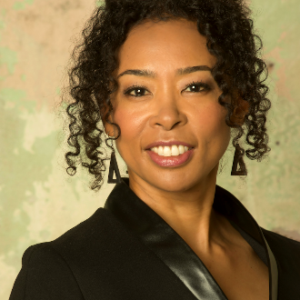
Noluthula Ngwenyama
Composer
Born in Los Angeles of Zimbabwean-Japanese parentage, Nokuthula Endo Ngwenyama is a highly acclaimed composer and violist who she has performed with orchestras worldwide. At age 16 she won the International Viola Competition, followed by the Young Concert Artists International Auditions, and the Avery Fisher Career Grant. She has performed at the White House and testified before Congress on behalf of the National Endowment for the Arts (NEA). She currently performs as violist with the group Umama Womama with fellow performer-composers Valerie Coleman and Hannah Lash.

Ngwenyama is past president of the American Viola Society and has served as visiting professor at the University of Notre Dame and Indiana University Jacobs School of Music, as well as Director of the Primrose International Viola Competition. She is the first composer in residence of the Phoenix Chamber Music Society and curates Composer’s Choice, a co-production of ASU/Kerr Cultural Center, Phoenix Chamber Music Society, and Peace Mama Productions, which features 21st century music and its creators in a chamber setting. She is an alumna of the Colburn School for the Performing Arts and the Curtis Institute of Music. As a Fulbright Scholar she attended the Conservatoire National Supérieur de Musique et de Danse de Paris and received a Master of Theological Studies degree from Harvard University.

Tchaikovsky & Sibelius, November 12, 2022
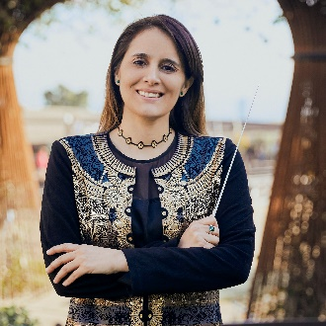
Lina- Gonzáles-Granados
Conductor
Colombian-American Lina González-Granados has distinguished herself as a talented young conductor of symphonic and operatic repertoire, having earned international recognition, most recently as the recipient of the 2021 Sphinx Medal of Excellence. She has also been awarded Third Prize and the ECHO Special Award (European Concert Hall Organization) of La Maestra Competition, the 2020 and 2021 Solti Foundation US Career Assistance Award, and won the Fourth Chicago Symphony Orchestra Sir Georg Solti International Conducting Competition, serving as Solti Conducting Apprentice under the guidance of Riccardo Muti through June 2022. She has held positions as Conducting Fellow of the Philadelphia Orchestra and Seattle Symphony, and was recently appointed Resident Conductor by the LA Opera.
Lina is a fervent proponent for the inclusion and development of new works for chamber and large orchestra, especially music from Latin-American composers. She is the Founder and Artistic Director of Unitas Ensemble, a chamber orchestra that performs works of Latinx composers, and provides access to free community performances for underserved communities. Her work with Unitas has earned her numerous community awards, most recently a Spark Boston award from the City of Boston.

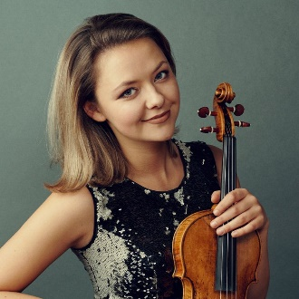
Alexandra Conunova
Violin
Born in 1988 in Moldavia, Alexandra Conunova regularly performs as a soloist with major orchestras across the globe. She has been hailed by her virtuosity, warm tone, impressive range of color and flawless technique. She has earned international accolades, winning First Prize at the Joseph Joachim Violin Competition in Hanover, Third Prize at the Tchaikovsky Violin Competition in Moscow, and was awarded by the Singapore International Competition. In 2016 she also received the prestigious Fellowship by the Borletti-Buittoni Trust in London.
Nominated “Maître ès Arts” by the Moldavian President, she founded a charity Foundation “ArtaVie” in her home town Chisinau to support disadvantaged children and social programs. For the last 3 years Alexandra has studied in Geneva under the guidance of Edouard Wulfson. Alexandra currently plays on Giovanni Batistta Guadagnini, ca. 1785 ex. “Ida Levin,” on generous loan from a music lover.

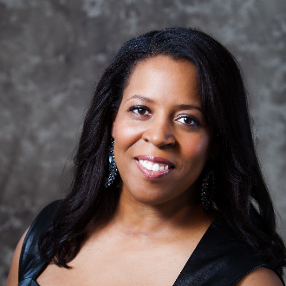
Valerie Coleman
Composer
GRAMMY®-nominated flutist and composer Valerie Coleman was named Performance Today’s 2020 “Classical Woman of the Year,” and one of the “Top 35 Women Composers” by The Washington Post. Her works have garnered awards including the MAPFund, ASCAP Honors Award, Herb Alpert Ragdale Residency Award, and nominations from The American Academy of Arts and Letters and United States Artists. Her piece Umoja, Anthem for Unity was chosen by Chamber Music America as one of the “Top 101 Great American Ensemble Works” and is now a staple of woodwind literature.

Coleman is the founder of the acclaimed ensemble Imani Winds, whose 24-year legacy is documented and featured in an exhibit at the Smithsonian National Museum of African American History and Culture. She also co-founded and currently performs as flutist for the performer-composer trio Umama Womama along with harpist Hannah Lash and violist Nokuthula Ngwenyama.

Coleman recently joined the Mannes School of Music Flute and Composition faculty as the Clara Mannes Fellow for Music Leadership, and previously served on the faculty of The Frost School of Music at the University of Miami. In 2021/22, she leads a year-long residency at The Juilliard School in their Music Advancement Program through American Composers Forum and has also been named to the Metropolitan Opera/Lincoln Center Theater New Works dual commissioning program.

Holiday Candlelight, December 17, 2022
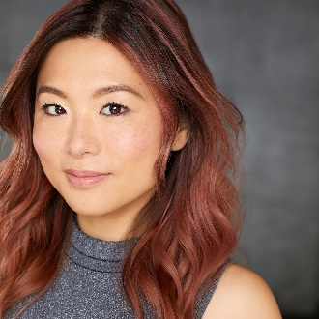
Jenny Wong
Conductor
A native of Hong Kong, Jenny Wong is currently the Associate Artistic Director of the Los Angeles Master Chorale. Conducting highlights include performances of Peter Sellars’ staging of di Lasso’s Lagrime di San Pietro while on tour in Australia, Mexico and throughout the U.S. Wong was one of nine national recipients of OPERA America’s inaugural Opera Grants for Women Stage Directors and Conductors, through which she will be conducting Schoenberg’s Pierrot Lunaire and Kate Soper’s Voices from the Killing Jar with Long Beach Opera in collaboration with WildUp.
Wong has been a conducting fellow for the Oregon Bach Festival, Baltimore Chamber Orchestra, Norfolk Chamber Music Festival, Distinguished Concerts International New York and Hong Kong SingFest. Wong received her Doctor of Musical Arts and Master of Music from the University of Southern California. She earned her undergraduate degree in voice performance from the University of Illinois, Urbana-Champaign.

Mendelssohn & Mozart, January 21, 2023

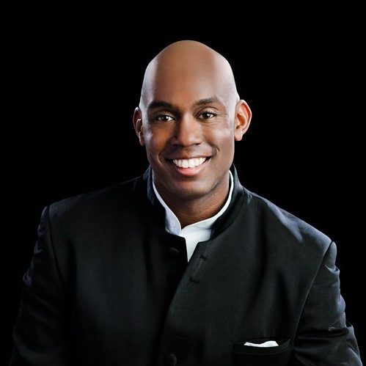
Joseph Young
Conductor
Praised for his suavely adventurous programming, Joseph Young is widely recognized as one of the most gifted conductors of his generation. He currently serves as Music Director of the Berkeley Symphony, Artistic Director of Ensembles for the Peabody Conservatory, and Resident Conductor of the National Youth Orchestra–USA at Carnegie Hall.
Recent tenures include Assistant Conductor of the Atlanta Symphony, Resident Conductor of the Phoenix Symphony and Joseph was a featured conductor at the League of American Orchestras' prestigious Bruno Walter National Conductor Preview. Joseph is a recipient of the 2015 Solti Foundation U.S. Career Assistance Award for young conductors, an award he also won in 2008 and 2014.

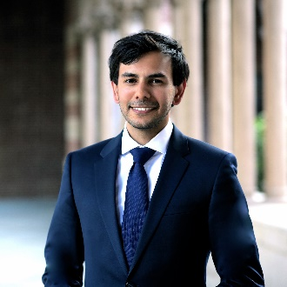
Vijay Venkatesh
Piano
Hailed by the Herald-Tribune for his “dazzling pianism verging on the impossible, effortless technical command and authority with a sense of poetry and refinement that belies his years,” Indian-American pianist Vijay Venkatesh has rapidly established a major international reputation, performing extensively across the United States and Europe. A top prizewinner at the San Jose, Seattle, Zimmerli, World Piano and Waring International Piano Competitions, he has also been named a Davidson Fellow Laureate at the Library of Congress, USC Thornton's Discovery Scholar, Grand Prize Winner of the Los Angeles Music Center’s Spotlight Awards and was featured on NPR’s From the Top.
An active chamber musician, Venkatesh tours as the Vieness Piano Duo with his wife and pianist, Eva Schaumkell, and as pianist in the Aristeia Trio, who won Gold at the Frances Walton International Chamber Music Competition. He currently pursues an Artist Diploma at the Colburn School in Los Angeles and holds degrees from USC Thornton and IU Jacobs School of Music, where he was a recipient of the Barbara and David Jacobs Fellowship under the tutelage of Norman Krieger and André Watts.
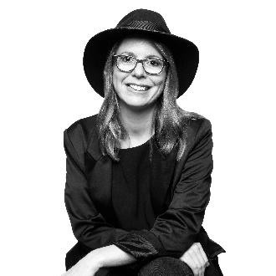
Anna Clyne
Composer
London-born Anna Clyne is a Grammy-nominated composer of acoustic and electro-acoustic music. Described as a “composer of uncommon gifts and unusual methods” by the New York Times, Clyne is one of the most acclaimed and in-demand composers of her generation, often embarking on collaborations with innovative choreographers, visual artists, filmmakers and musicians.

Clyne has served as Composer-in-Residence for the Chicago Symphony Orchestra, Baltimore Symphony Orchestra, L’Orchestre national d’Île-de-France and Berkeley Symphony. She is currently the Scottish Chamber Orchestra’s Associate Composer through the 2021-22 season and a mentor composer for Orchestra of St. Luke's.

Scheherazade, February 11, 2023

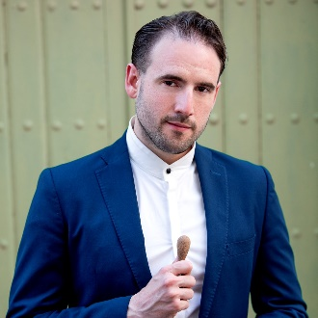
François López-Ferrer
Conductor
Spanish-American conductor François López-Ferrer came to international attention after a critically acclaimed debut at the 2018 Verbier Festival, where he jumped in for Iván Fischer in a shared program with Sir Simon Rattle and Gébor Takécs-Nagy. In demand as a guest conductor, López-Ferrer’s recent and upcoming highlights include debuts with the Los Angeles Philharmonic, Orquesta Nacional de España, Cincinnati Symphony Orchestra and Orquesta Sinfónica de Galicia, among others. López-Ferrer is one of six participants to be featured in the 2022 Bruno Walter National Conductor Preview with the Louisiana Philharmonic Orchestra. He previously served as Associate Conductor of the Orquesta Sinfónica Nacional de Chile (OSNCH), Principal Conductor of the Ballet Nacional Chileno, and was the youngest ever Conductor-in-Residence of the OSNCH's Summer Concert Series.
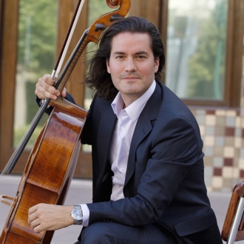
Zuill Bailey
Cello
Grammy Award-winning cellist Zuill Bailey has secured his place as one of the most sought after artists today, collaborating with orchestras worldwide. A prolific recording artist, he has produced more than 30 chart-topping titles including his live performances of the Elgar and Dvorak Cello Concertos, described by Gramophone as the new “reference” recording and one that “sweeps the board.” He was awarded the Classical Recording Foundation Award for Beethoven’s complete works for Cello and Piano and named to the 2014 Johns Hopkins University Distinguished Alumni.
Network television appearances include a recurring role on the HBO series Oz, NBC’s Homicide and a live broadcast of the Beethoven Triple Concerto performed with Itzhak Perlman and the Israel Philharmonic, among others. He has been heard on numerous radio broadcasts including NPR’s Morning Edition, Tiny Desk Concert and Performance Today, BBC’s In Tune, XM Radio’s Live from Studio II, Sirius Satellite Radio’s Virtuoso Voices, KUSC and RTHK Radio Hong Kong. Bailey performs on the "rosette" 1693 Matteo Gofriller Cello, formerly owned by Mischa Schneider of the Budapest String Quartet. In addition to his extensive solo touring engagements, he serves as artistic director of several music festivals, including the Northwest Bach Festival in Spokane, WA and is Director of the Center for Arts Entrepreneurship and Professor of Cello at the University of Texas at El Paso.

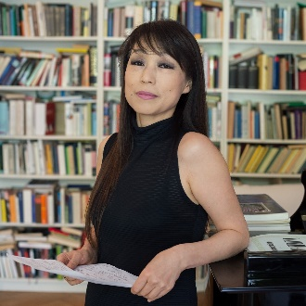
Unsuk Chin
Composer
Unsuk Chin was born in 1961 in Seoul, South Korea and has lived in Berlin since 1988. Her music has attracted the attention of international conductors with its modern language, but lyrical and non-doctrinaire communicative power. Chin has received many honors, including the Arnold Schoenberg Prize, the Prince Pierre Foundation Music Award, the Wihuri Sibelius Prize, the Hamburg Bach Prize, the Kravis Prize and the 2021 Leonie Sonning Music Prize. She has been commissioned by leading performing organizations worldwide, and has also been active in writing electronic music, receiving commissions from IRCAM and other electronic music studios.

Chin has been Composer-in-Residence of festivals around the globe including the Seoul Philharmonic Orchestra, overseeing its contemporary music series, which she founded. She served as Artistic Director of the ‘Music of Today’ series of the Philharmonia Orchestra in London and in 2022 she starts a five year tenure as Artistic Director of the Tongyeong International Festival in South Korea and her Artistic Directorship of the Weiwuying International Music Festival in Taiwan.

Beethoven & Rachmaninoff, March 18, 2023
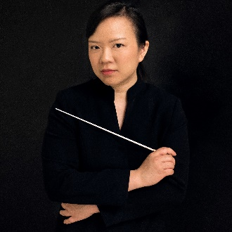
Rebecca Tong
Conductor
Rebecca Tong is Resident Conductor of Jakarta Simfonia Orchestra and Artistic Director and Music Director of Ensemble Kontemporer in Jakarta, her hometown. She is actively involved in the artistic programming of both, her aim being to educate Indonesian audiences about both classical and contemporary orchestral works. Rebecca also founded the Jakarta Christian Youth Orchestra in 2011, and served as Music Faculty of the International Reformed Evangelical Seminary.
Rebecca was the First Prize Winner of the inaugural La Maestra 2020 competition, where she was also awarded the ARTE Prize and the French Concert Halls & Orchestras Prize. She served as Junior Fellow in Conducting at the Royal Northern College of Music, and received the Taki Award for the Taki Concordia Conducting Fellowship, where she worked closely with Marin Alsop. She was also a Conducting Fellow at the Cabrillo Festival of Contemporary Music and was awarded the David Effron Conducting Fellowship at the Chautauqua Institution.

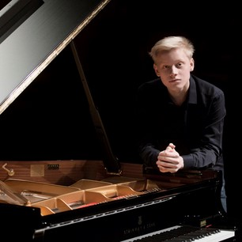
Alex Malofeev
Piano
Russian piano prodigy Alexander Malofeev came to prominence when he won the International Tchaikovsky Competition for Young Musicians at age thirteen. He has since won numerous awards including the Grand Prix of the International Competition for Young Pianists Grand Piano Competition, the Premio Giovane Talento Musicale dell’anno, and Best Young Musician of 2017, when he also became the first Young Yamaha Artist.
He has performed with the most preeminent orchestras around the world, including with the New World Symphony with Michael Tilson Thomas, La Scala Orchestra and Lucerne Festival Orchestra with Riccardo Chailly, the Philadelphia Orchestra, Russian National Orchestra and the Concertgebouw Amsterdam, where he opened the 30th anniversary concert of the renowned Meester Pianists series.

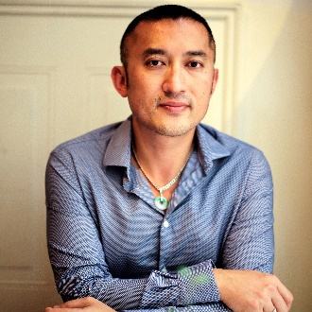
Huang Ruo
Composer
Lauded by the New Yorker as “one of the world’s leading young composers,” Huang Ruo’s vibrant and inventive musical voice draws equal inspiration from Chinese ancient and folk music, Western avant-garde, experimental, noise, natural and processed sound, rock and jazz. His music has been premiered by orchestras worldwide, with his diverse compositional works spanning from orchestra, chamber music, opera, theater and dance, to cross-genre, sound installation, multi-media, experimental improvisation, folk rock and film.

Huang Ruo is composer-in-residence at the National Symphony Orchestra of Taiwan and was the first composer-in-residence of the Concertgebouw Amsterdam. He is currently on the composition faculty at the Mannes College of Music at the New School in New York. He is the artistic director and conductor of Ensemble FIRE (Future In REverse), and was selected as a Young Leader Fellow by the National Committee on United States-China Relations.

American in Paris, April 29, 2023

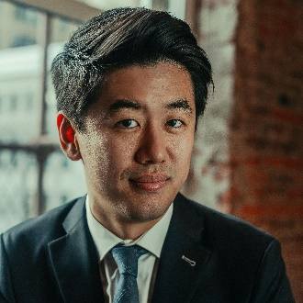
Kensho Watanabe
Conductor

Kensho Watanabe is fast becoming one of the most exciting and versatile young conductors on the international stage. He held the position of Assistant Conductor of The Philadelphia Orchestra from 2016 to 2019 and was previously an inaugural conducting fellow of the Curtis Institute of Music under the mentorship of Yannick Nézet-Séguin. Recent highlights include debuts with the London Philharmonic and Tokyo Philharmonic Orchestras, as well as his Finnish debut with the Jyväskylä Sinfonia. Equally at home in both symphonic and operatic repertoire, Watanabe has led numerous operas with the Curtis Opera Theatre and served as Assistant Conductor on a new production of Strauss’s Elektra at Montreal Opera.
Watanabe was recently recognized with a Career Assistance Award by the Solti Foundation U.S. An accomplished violinist, Mr. Watanabe received his Master of Music degree from the Yale School of Music is a graduate of the Curtis Institute of Music, where he studied with distinguished conducting pedagogue Otto-Werner Mueller.
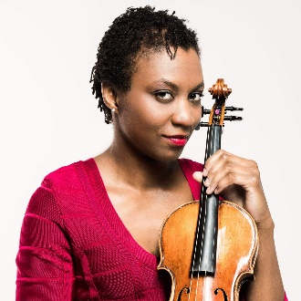
Tai Murray
Violin
Described as “superb” by The New York Times, violinist Tai Murray has established herself as a musical voice of a generation. Appreciated for her elegance and effortless ability, Murray creates a special bond with listeners through her personal phrasing and subtle sweetness. She is a dedicated advocate of contemporary works and among others, performed the world premiere of Malcolm Hayes’ violin concerto at the BBC PROMS in the Royal Albert Hall.
As a chamber musician, Murray has performed as soloist on main stages worldwide and was a member of Lincoln Center’s Chamber Music Society II. She is the recipient of an Avery Fisher Career Grant and was named a BBC New Generation Artist from2008-2010. Tai Murray plays a violin by Tomaso Balestrieri fecit Mantua ca. 1765, on generous loan from a private collection.
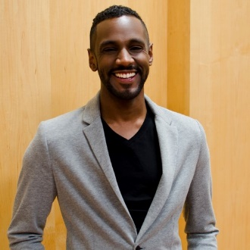
Carlos Simon
Composer
Hailing from Atlanta, Georgia, Carlos Simon’s music ranges from concert music for large and small ensembles to film scores with influences of jazz, gospel and neo-romanticism. Simon is Music Director and keyboardist for Grammy Award-winning singer Jennifer Holliday and has also served as a contributing arranger for Rachel Barton Pine Foundation’s Music by Black Composers series for violin. His string quartet, Elegy, honoring the lives of Trayvon Martin, Michael Brown and Eric Garner was recently performed at the Kennedy Center for the Mason Bates JFK Jukebox Series.
Recent accolades include winning the prestigious Marvin Hamlisch Film Scoring Award, the Underwood Emerging Composer Commission from the American Composers Orchestra, the Presser Award from the Theodore Presser Foundation, and being named as a Sundance/Time Warner Composer Fellow. He has served on the music faculty at Spelman and Morehouse Colleges in Atlanta and currently serves as Assistant Professor at Georgetown University.

-end-

