FOR IMMEDIATE RELEASE

Pasadena Symphony Association Pasadena Symphony & POPS Contact: Lora Unger
Lunger@PasadenaSymphony-Pops.org (626) 793-7172 ext. 12

November 11, 2021

PASADENA SYMPHONY & POPS ELECTS NEW DIRECTORS STEPHEN MIYABE, STEVEN ROSEN AND VICTORIA SCHWARTZ AND BOB MICHERO AS PRESIDENT OF THE BOARD OF DIRECTORS

Pasadena, CA – The Pasadena Symphony and POPS proudly welcomes respected community leaders to its 30-member Board of Directors and announces the appointment of Bob Michero as its Board President commencing with the 21/22 Season. Stephen Miyabe, Pasadena Market President for Northern Trust’s Wealth Management Team, Steven Rosen, Provost & Chief Scientific Officer for City of Hope and Victoria Schwartz, Attorney and President/Founder of the La Cañada Flintridge Sister Cities Association join the vibrant roster of Board members who are passionate about furthering the mission of the Pasadena Symphony and POPS.

These new Board appointments signal growing community support in conjunction with the orchestra’s stellar reopening. The Pasadena POPS made a roaring comeback this summer at the LA Arboretum to capacity audiences of more than 5,000 per concert, and continued its successful re-opening with the 21/22 Symphony season kick-off at Pasadena’s Ambassador Auditorium in October.

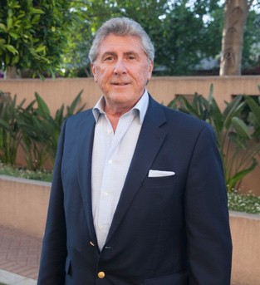
Robert Michero President

Robert Michero was born and raised in South Pasadena, California and has been a longtime Pasadena community volunteer. From an early age, Robert took to music after sharing a love for the arts with his mother. In his adolescence, Bob continued exploring his passion for music, while also nurturing a love for sports.

Robert attended California State University of Los Angeles, University of Arizona, and graduated from UCLA. Early in his career, Robert was Vice-President General Manager-Wine Division of Young’s Market Company in Los Angeles. In 1983, he discovered a desire to have his own business and created Contemporary Marketing Ltd.—a sales, marketing, and vintner company specializing in the Wine and Spirits Industry.

Robert is currently Vice President of Riboli Family of San Antonio Winery of Los Angeles. He previously served as Managing Director of San Antonio Winery-Maddalena Brands and as Vice President-Partner of Dreyfus, Ashby & Company, a national wine and spirits importer and marketing company based in New York, New York.

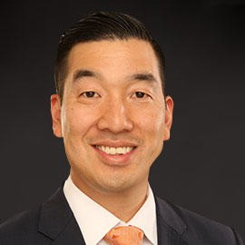
Stephen Miyabe
Early in his career, Miyabe practiced law gearing his practice towards assisting families and business owners with the legal needs of their companies as well as his clients’ trust and estate needs. He is also a featured speaker at events and symposiums throughout the West Region on various topics.

As Pasadena Market President for Northern Trust’s Wealth Management Team, Miyabe leads an organization of experienced professionals for Northern Trust in its banking, investment management and fiduciary services
practices in the greater Los Angeles basin. Northern Trust is a mainstay of the region's financial sector serving affluent and influential families and individuals in the region. Miyabe is also responsible for the overall execution of Northern Trust’s strategic priorities to serve high net worth families and business owners in Los Angeles County with a focus on Pasadena and the surrounding Southern California communities.

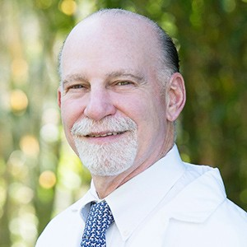
Steven T. Rosen
Steven T. Rosen, MD, FACP, FASCO, is the provost, chief scientific officer, and director of the Comprehensive Cancer Center and the Beckman Research Institute, Irell & Manella Cancer Center Director's Distinguished Chair for the City of Hope in Duarte, California. He served as the Director of the Robert H. Lurie Comprehensive Cancer Center at Northwestern University Feinberg School of Medicine from 1989-2014.

Dr. Rosen's laboratory research focuses on experimental therapeutics and hematologic malignancies. He has received funding from the National Cancer Institute (NCI), American Cancer Society, Leukemia and Lymphoma Society (LLS), Multiple Myeloma Research Foundation, and Rising Tide Foundation. Dr. Rosen has received numerous grant awards and contracts, and has published more than 400 scientific papers. He is editor-in-chief of Cancer Treatment and Research. Dr. Rosen is the chair of the Medical Science Committee of the LLS and serves on its Board. He also serves on the Board of American Society of Clinical Oncology's Conquer Cancer Foundation. Dr Rosen has been an advisor to more than two dozen NCI Comprehensive Cancer Centers.

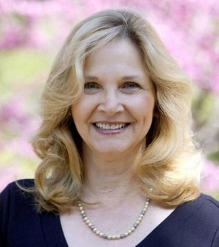
Vicki Schwartz
President and founder of the La Cañada Flintridge Sister Cities Association.

A graduate of the University of San Diego and Loyola Law School, Victoria practiced law focusing on corporate securities and corporate governance. She is devoted to her family, community and philanthropic endeavors. She is a staunch supporter of City of Hope and is a member of their Speakers Bureau, representing the hospital to the California legislature. She serves on a board
that evaluates early-stage cancer research project proposals to determine which projects are awarded funding. She is the founder and president of the La Cañada Flintridge Sister Cities Association where she works very closely with the La Cañada Flintridge City Council, public and private schools, as well as many other community associations. She and her husband have 25 year old twins, and have lived in La Cañada Flintridge for over 30 years.

View the full list of Pasadena Symphony Association Board of Directors

ABOUT THE PASADENA SYMPHONY ASSOCIATION
Formed in 1928, the Pasadena Symphony and POPS is an ensemble of Hollywood’s most talented, sought after musicians. With extensive credits in the film, television, recording and orchestral industry, the artists of Pasadena Symphony and POPS are the most heard in the world.

The Pasadena Symphony and POPS performs in two of the most extraordinary venues in the United States: Ambassador Auditorium, known as the Carnegie Hall of the West, and the luxuriant Los Angeles Arboretum & Botanic Garden. The multi-platinum-selling, two-time Emmy and five-time Grammy Award-nominated entertainer dubbed “The Ambassador of the Great American Songbook,” Michael Feinstein, leads the POPS as Principal Pops Conductor, succeeding Marvin Hamlisch.
A hallmark of its robust education programs, the Pasadena Symphony Association has served the youth of the region for over five decades through the Pasadena Youth Symphony Orchestras (PYSO) comprised of seven performing ensembles, with over 400 gifted 4th-12th grade students from all over Southern California. The PYSO Symphony has performed at venues across the globe as well as on the television show GLEE.
The PSA provides people from all walks of life with powerful access points to the world of symphonic music.

- end -

