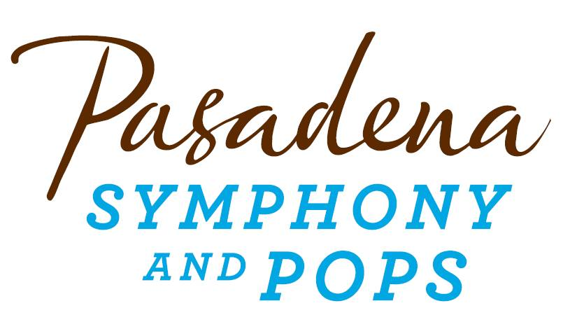
FOR IMMEDIATE RELEASE

Pasadena Symphony Association
Pasadena Symphony & POPS
Contact: Marisa McCarthy
mmccarthy@PasadenaSymphony-Pops.org
(626) 793-7172 ext. 13

For full artist bios and high res images visit: https://pasadenasymphony-pops.org/press-release-holiday-candlelight-2021/

November 17, 2021

PASADENA Symphony’s Beloved Holiday Candlelight Returns to All Saints Church

Pasadena, CA – The Pasadena Symphony’s annual Holiday Candlelight concert returns to All Saints Church on Saturday, December 18, 2021 with two performances at 4:00pm & 7:00pm. Pasadena’s most sought-after concert of the season has become a cherished community holiday tradition and sells out quickly. The architecturally exquisite and acoustically sonorous All Saints Church, Pasadena’s equivalent of a European cathedral, provides the perfect setting to immerse yourself in a Holiday wonderland among an array of hand bells and choruses, with Pasadena’s premiere orchestra.

Artistic Partner Jenny Wong, Associate Director of the Los Angeles Master Chorale, will take the podium to lead the orchestra and returning favorites L.A. Bronze Handbell Ensemble, the Los Angeles Children’s Chorus, the Donald Brinegar Singers and JPL Chorus. Special guest vocalist Allie Feder, heard on movie and TV soundtracks from Frozen 2 and Mulan to Modern Family, will charm audiences on holiday classics including Silent Night, Let it Snow, Have Yourself a Merry Little Christmas, Hallelujah! and many more favorites sprinkled throughout the performance.

Seating is available to purchase throughout the lavish All Saints Church, specially fitted with festive floral and decorations, all under the glow of candlelight. Tickets to Holiday Candlelight are limited and will sell out. Tickets start at $25 and may be purchased either at pasadenasymphony-pops.org or by calling the box office at 626.793.7172.

In order to provide the safest possible experience for all concertgoers, entry to all Pasadena Symphony concerts will require proof of full Covid-19 vaccination. For a list of accepted forms of proof and the most up to date venue safety protocols, please visit https://pasadenasymphony-pops.org/symphony-covid-safety/.

IF YOU GO:

- What: Holiday Candlelight with the Pasadena Symphony
Jenny Wong, conductor
Allie Feder, soloist
Los Angeles Children’s Chorus
Donald Brinegar Singers and the JPL Chorus
L.A. Bronze Handbell Ensemble

- When: Saturday, December 18 at 4:00pm. and 7:00pm

- Where: All Saints Church | 132 N Euclid Ave, Pasadena, CA 91101

- Cost: Tickets: $25.00 - $155.00

- Parking: Parking structures are nearby at the Westin Hotel (enter on Los Robles, south of Walnut) or 330 E Union. Metered parking is also available on Euclid and nearby streets.

      - Proof of Vaccination: The Pasadena Symphony is committed to providing the safest possible setting for the community and will require all concertgoers to be fully vaccinated to attend all concerts. For protocols, visit: pasadenasymphony-pops.org/symphony-covid-safety/

ABOUT THE ARTISTS

Jenny Wong
Conductor

A native of Hong Kong, Jenny Wong is currently the Associate Artistic Director of the Los Angeles Master Chorale. In addition to the regular season, Wong has conducted performances of Peter Sellars’ staging of di Lasso’s Lagrime di San Pietro at the Melbourne International Arts Festival in Australia, the Festival Internacionale Cervantino and the Palacio de Bellas Artes in Mexico, and in the United States. As chorus master, Wong has prepared choruses for Gustavo Dudamel and the LA Philharmonic, Susanna Mälkki, Eric Whitacre, María Guinand, and Music Academy of the West, including the U.S. premier of Tan Dun’s Buddha Passion and the LA Philharmonic’s recent release of Mahler’s Symphony No. 8 with Deutsche Grammophon. Most recently, Wong was Assistant Producer of the Master Chorale’s latest album, Eric Whitacre’s The Sacred Veil with Signum Classics.

This season, Wong was one of nine national recipients of OPERA America’s inaugural Opera Grants for Women Stage Directors and Conductors, through which she will be conducting Schoenberg’s Pierrot Lunaire and Kate Soper’s Voices from the Killing Jar with Long Beach Opera, in collaboration with WildUp. This season also includes an engagement with the Pasadena Symphony. Other recent engagements and positions have included opera Sweet Land by Du Yun and Raven Chacon with opera company The Industry, directed by Yuval Sharon and Cannupa Hanska-Luger, the Grammy-winning ensemble Phoenix Chorale in Phoenix, Arizona, the Gay Men’s Chorus of Los Angeles, as well as the University of the Pacific Conservatory of Music and All Saints Church Pasadena, California.

Wong won two consecutive World Champion titles at the World Choir Games (China, 2010) and the International Johannes Brahms Choral Competition (Germany, 2011), conducting the Diocesan Girls’ School Choir from Hong Kong. She has been a conducting fellow for the Oregon Bach Festival, Baltimore Chamber Orchestra, Norfolk Chamber Music Festival, Distinguished Concerts International New York and Hong Kong SingFest, by which she conducted the Hong Kong Sinfonietta and Hong Kong City Chamber Orchestra.

Wong received her Doctor of Musical Arts and Master of Music from the University of Southern California, when she was also assistant conductor of the Donald Brinegar Singers. She earned her undergraduate degree in voice performance from the University of Illinois, Urbana-Champaign. She has given lectures on Chinese choral music and is an active clinician for choirs. As a singer, Wong sang back-up for Elton John at the 2013 Emmy Awards and for Barry Manilow.

Allie Feder
Soloist

Allie Feder is a seasoned performer and studio singer based in Los Angeles. Her versatile skills in pop, rock, jazz, classical, and character voiceover have given her the opportunity to sing on film scores, TV shows, and concerts around the world. With credits both on-screen and off, Allie appeared in the hit musical comedy film Pitch Perfect 2, playing a member of the German villain group “Das Sound Machine,” and has sung on countless film scores including Frozen 2, Mulan, The Grinch, Ready Player One, The LEGO Movie 2, Birds of Prey, The Call of the Wild, Doctor Sleep, The Nun, War for the Planet of the Apes, Suicide Squad, and Rogue One: A Star Wars Story. TV recording work includes: The Simpsons, Modern Family, Centaurworld, American Dad, Fuller House, Disney’s Descendants, Charmed, American Housewife, Jane the Virgin and many more, and her voice can be heard on albums by Paul McCartney, Harry Styles, Pentatonix, Richard Carpenter, and Michael Bublé.

Allie is incredibly grateful to have shared the stage with artists including Billie Eilish, Jennifer Hudson, Pharrell Williams, Demi Lovato, Alessia Cara, and Ben Folds, and to have joined film composer Hans Zimmer for the Hans Zimmer Revealed: Live Tour in 2017. She has performed live on the Grammy Awards, The Ellen Degeneres Show, The Late Late Show with James Corden, The Sing-Off, and on six seasons of NBC’s hit show The Voice. Her vocals can be heard in theme parks around the world including Tokyo Disney, Universal Studios Japan, and most recently, she co-wrote and recorded two songs currently featured at Disneyland’s Star Wars: Galaxy’s Edge.

As a soloist, Allie recently had the chance to perform as Elsa in a live-to-picture concert of Disney’s Frozen and as Belle in Beauty and the Beast, both in Taiwan with renowned conductor Tim Davies and the Taiwanese National Symphony Orchestra. Back home in Los Angeles, she performs regularly in various singing groups and choirs, including chamber choir LA Choral Lab. In addition to singing, Allie is also a songwriter, and has theme songs currently airing for Disney’s The Ghost and Molly McGee and Netflix’s A Tale Dark and Grimm.

Originally from the Bay Area, Allie was trained in musical theatre as a child before moving to LA to study Theatre and Music at the University of Southern California. She feels so fortunate to make music for a living, is always striving to channel sincerity and passion into every performance, session, and song. For more information, please visit www.alliefeder.com.

Los Angeles Children’s Chorus

Under Artistic Director Fernando Malvar-Ruiz, the Los Angeles Children’s Chorus provides choral music
education of the highest quality to young people who represent richly diverse racial, economic, and cultural backgrounds. The program ignites a love of singing and nurtures the full expression of each individual’s potential for artistic and personal excellence through the collaborative experience of choral music performance. Through the beauty of inspired and joyful singing, Los Angeles Children’s Chorus brings the transformative power of music to communities throughout Southern California, the nation and the world. Now in its 34th season, LACC serves over 400 young singers from more than 50 communities throughout greater Los Angeles, reflecting in its membership the cultural and economic diversity of the region.

Donald Brinegar Singers

Donald Brinegar is Professor of Music and Director of Choral Studies at Pasadena City College, Adjunct Professor of Choral Music and Voice at USC, and Associate Director of the Three-Summer Masters in Choral Conducting at CSULA. As Director of Choruses for PSO he works with the JPL Chorus and provides choruses for the summer pops programs. Internationally recognized as a tenor soloist and conductor, Brinegar has sung as soloist and prepared choruses for The LA Philharmonic, LA Chamber Orchestra, LA Microfest, Hollywood Bowl and Disney Concert Hall. His international appearances include 30 countries most recently teaching and performing in Costa Rica. A noted champion of the music of Morten Lauridsen he has two compact discs dedicated to the composers’ music.

L.A. Bronze Handbell Ensemble

Under the artistic direction of Alex Guebert, L.A. Bronze is an auditioned handbell concert choir creating performances of the highest caliber for the community. Their music making is exciting and uplifting, and audiences around Southern California have praised their concerts. The group is comprised of accomplished handbell musicians who are seeking challenging opportunities for making music, while providing educational opportunities for the handbell community. Our members come from all over the L. A. basin and include musicians, educators, administrators and other professionals.

ABOUT THE PASADENA SYMPHONY ASSOCIATION
Formed in 1928, the Pasadena Symphony and POPS is an ensemble of Hollywood’s most talented, sought after musicians. With extensive credits in the film, television, recording and orchestral industry, the artists of Pasadena Symphony and POPS are the most heard in the world.
The Pasadena Symphony and POPS performs in two of the most extraordinary venues in the United States: Ambassador Auditorium, known as the Carnegie Hall of the West, and the luxuriant Los Angeles Arboretum & Botanic Garden. The multi-platinum-selling, two-time Emmy and five-time Grammy Award-nominated entertainer dubbed “The Ambassador of the Great American Songbook,” Michael Feinstein, leads the POPS as Principal Pops Conductor, succeeding Marvin Hamlisch.
A hallmark of its robust education programs, the Pasadena Symphony Association has served the youth of the region for over five decades through the Pasadena Youth Symphony Orchestras (PYSO) comprised of seven performing ensembles, with over 400 gifted 4th-12th grade students from all over Southern California. The PYSO Symphony has performed at venues across the globe as well as on the television show GLEE.
The PSA provides people from all walks of life with powerful access points to the world of symphonic music.

-end-

