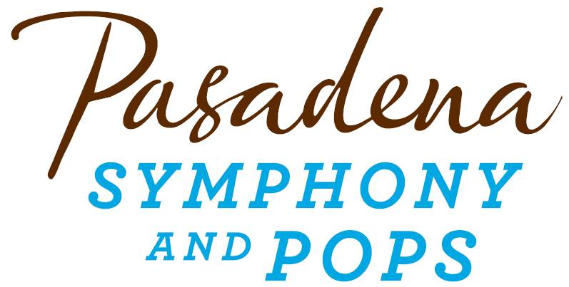
FOR IMMEDIATE RELEASE

Pasadena Symphony Association
Pasadena Symphony & POPS
Contact: Marisa McCarthy
mmccarthy@PasadenaSymphony-Pops.org
(626) 793-7172 ext. 13

September 9, 2021

For artist images, please visit: https://pasadenasymphony-pops.org/press-release-moonlight-sonata-2021/

PASADENA SYMPHONY AND POPS HOST DAZZLING ANNAUL GALA
AT PASADENA CITY HALL

Pasadena, CA – Join the Pasadena Symphony Association for an evening of celebration and reconnection on Saturday, September 25, 2021 as they host their annual Moonlight Sonata Gala, back live and-in person surrounded by the beauty of Pasadena City Hall. The festivities will kick off with an elegant courtyard reception, followed by a luxe dinner, auction and program filled with music and dancing under a starry sky in Centennial Square.

Music from the Pasadena Youth Symphony Orchestras will usher guests into Centennial Square with a warm welcome, and iconic Los Angeles meteorologist Dallas Raines and his wife Dannie will host the evening’s program as guests enjoy a sumptuous dinner courtesy of Parkway Grill. To top off the elegant affair, legendary songstress Melissa Manchester will perform an intimate set of standards in an exclusive performance befitting this enchanted night of music and community.

The event will honor two longtime Pasadena Symphony Association supporters as outstanding luminaries - Community Luminary Robert Michero and Artistic Luminary Polly Sweeney. Michero will be recognized for his longtime Board service to the Pasadena Symphony Association and his charitable contributions to the Pasadena community. Polly Sweeney will be honored for her contributions to the orchestral community of Los Angeles, and visionary work for the Pasadena Symphony and POPS.

Tickets to the Moonlight Sonata Gala are limited. Individual tickets start at $275 and may be purchased by visiting PasadenaSymphony-Pops.org or by contacting Zoë Jones, Development Associate at zjones@PasadenaSymphony-Pops.org or 626.793.7172 x27.

IF YOU GO:

What: The Pasadena Symphony and POPS 2021 Moonlight Sonata Gala

When: Saturday, September 25, 2021, 5:30pm – 10pm

Where: Centennial Square | 100 N. Garfield Avenue, Pasadena, CA 91101
Parking: Complimentary valet parking available onsite.

Cost: Individual tickets $275 each; Patron level: $1,500 includes two VIP tickets and listing in the event program book. Sponsorship and underwriting opportunities are also available at bit.ly/moonlightsonata2021

ABOUT THE PASADENA SYMPHONY ASSOCIATION

Formed in 1928, the Pasadena Symphony and POPS is an ensemble of Hollywood’s most talented, sought after musicians. With extensive credits in the film, television, recording and orchestral industry, the artists of Pasadena Symphony and POPS are some of the most heard in the world.
The Pasadena Symphony and POPS performs in two of the most extraordinary venues in the United States: Ambassador Auditorium, known as the Carnegie Hall of the West and the luxuriant Los Angeles Arboretum & Botanic Garden.
A hallmark of its robust education programs, the Pasadena Symphony Association has served the youth of the region for five decades through the Pasadena Youth Symphony Orchestras (PYSO), comprised of five performing ensembles with 600 gifted 4th-12th grade students from more than 50 schools all over the Southern California region. The PYSO has toured internationally at prestigious venues in New York, Vienna, and most recently San Jose, Costa Rica.
The PSA provides people from all walks of life with powerful access points to the world of symphonic music.

ABOUT ROBERT MICHERO

Robert Michero was born and raised in South Pasadena, California and has been a longtime Pasadena community volunteer. From an early age, Robert took to music after sharing a love for the arts with his mother. In his adolescence, Bob continued exploring his passion for music, while also nurturing a love for sports.

Robert attended California State University of Los Angeles, University of Arizona, and graduated from UCLA. Early in his career, Robert was Vice-President General Manager-Wine Division of Young’s Market Company in Los Angeles. In 1983, he discovered a desire to have his own business and created Contemporary Marketing Ltd.—a sales, marketing, and vintner company specializing in the Wine and Spirits Industry.

Robert is currently Vice President of Riboli Family of San Antonio Winery of Los Angeles. He previously served as Managing Director of San Antonio Winery-Maddalena Brands and as Vice President-Partner of Dreyfus, Ashby & Company, a national wine and spirits importer and marketing company based in New York, New York.

Robert currently sits on the Board of Directors of the Pasadena Symphony Association and for the last ten years has held the position of Vice-President of Finance & Treasurer. Robert has also been the Wine Chair of the Huntington Hospital-Parkway Grill “Fall Food and Wine Festival” for the past 36 years. Bob is a lifelong resident of Pasadena, residing there with his wife of 22 years, Kim, and their daughter, Darcy.

ABOUT POLLY SWEENEY
Polly Sweeney was born in Rochester, New York. Early on, she exhibited an extraordinary talent for music, In addition to her love for music, Polly is an accomplished equestrian, having trained since the age of 12. After attending Oberlin Conservatory and serving as concert master from 1960-1964, she attended the Julliard School in New York City. During her time at Julliard, Polly was musical peers and classmates with legendary musicians such as Itzhak Perlman and Pinchas Zukerman.

Polly and her husband Stender settled in Los Angeles, California in the late 1960s. During this time, Polly established her career among prominent composers and musicians working in the field. She built one of the most enviable and enduring careers in the business, beloved and selected to collaborate by the great artists in the industry. During her studio recording career, Polly has played for 782 films and TV shows, including Titanic, Somewhere in Time, and the television show Murder, She Wrote.

Polly’s work has been instrumental in building the classical music scene of Los Angeles, not only in studio work but also in full symphony and chamber music. She has shape the sound of the Pasadena Symphony and helped establish it as one of the finest orchestras in California building its membership with the best and brightest studio players–all who had a passion for playing classical music, live in the concert hall.

Polly and her husband, Stender, reside in Pasadena, California and have three children: Stender Jr., Alison, and Ryan, along with a host of loving grandchildren.

ABOUT MELISSA MANCHESTER
MOR singer/songwriter Melissa Manchester, whose father was a bassoonist for the New York Metropolitan Opera, began singing commercial jingles at age 15 and went on to become a staff writer for Chappell Music while attending the High School of Performing Arts. After taking a songwriting class at New York University taught by Paul Simon, Manchester took her talents to the Manhattan club scene, where she was discovered by Bette Midler and Barry Manilow; the two hired her as a backup singer in 1971. She recorded her debut album, Home to Myself, in 1973, co-writing many of the songs with Carole Bayer Sager.

Released in 1975, Melissa produced her first Top Ten hit, “Midnight Blue,” and set the tone for most of her career with its direct, slickly produced MOR pop sound. She and Kenny Loggins co-wrote the latter’s 1978 duet hit with Stevie Nicks, “Whenever I Call You Friend,” and the following year, Manchester returned to the Top Ten with “Don’t Cry Out Loud.” In 1980, Manchester became the first singer to have two movie themes nominated for Academy Awards (Ice Castles and The Promise); two years later she achieved her highest Billboard singles chart placement with the number five hit “You Should Hear How She Talks About You,” which won a Grammy for Best Female Vocal Performance. Throughout the ’80s and ’90s, Manchester alternated occasional recording with script writing and acting, appearing with Bette Midler in For the Boys and on the television series Blossom as the title character’s birth mother. In spring 2004, Manchester returned with her first album in ten years. When I Look Down That Road, which included collaborations with Beth Nielsen Chapman and Keb’ Mo’ and marked her first proper release with Koch. In 2017, Manchester released Fellas, a nod to the male vocalists who influenced her, and a sort of sequel to her 1989 release Tribute, which saw her paying homage to the great female singers.

ABOUT DALLAS RAINES
Dallas Raines is the chief meteorologist for ABC7 Eyewitness News, providing weekday evening weather reports.

Dallas joined ABC7 in 1984 and received his Bachelor of Science degree from Florida State University, where he studied broadcast journalism and earth science with an emphasis on meteorology. Dallas is a Certified Broadcast Meteorologist, an elite designation for individuals who have undergone rigorous examination by the American Meteorological Society.

Among his many awards, Dallas won the Daily News People's Choice Award for Best Weatherperson in Los Angeles. He was named Man of the Year by the American Cancer Society. He was voted Best Weather Presenter/World competition level in Paris, France. He received a Golden Mike Award for Best Weathercast in Southern California in the 4 p.m. to 11 p.m. division. He has received the Associated Press Award for Best Weather Segment. The Greater Los Angeles Press Club awarded him with Overall Excellence in a 60 Minute Newscast. KIIS Radio voted Dallas the Most Popular On-Air Newscaster in Los Angeles. He was also voted the Most Popular On-Air Personality at CNN by ON CABLE magazine. His coverage of Hurricane Frederic earned him the National Oceanic and Atmosphere Association (NOAA) Outstanding Coverage Award.

When not on television, Dallas has been a meteorology professor at Cal State University, Northridge, staying actively involved in multiple community service and fundraising projects. Dallas, and his wife, Dannie, are longtime supporters of the Pasadena Symphony and POPS.

- end -

