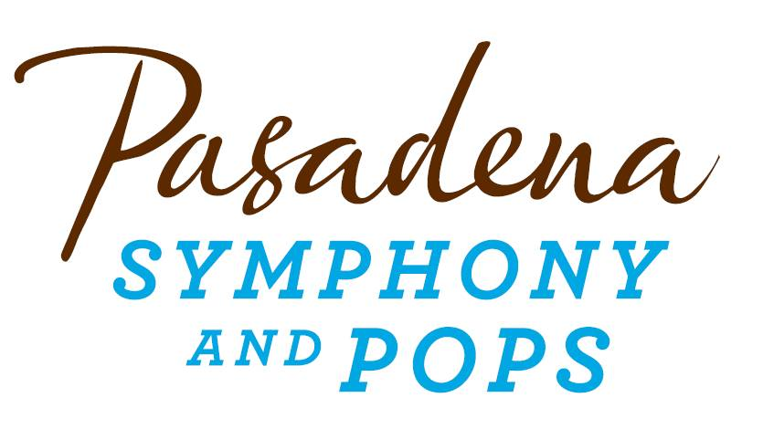
FOR IMMEDIATE RELEASE

Pasadena Symphony Association
Pasadena Symphony & POPS
Contact: Marisa McCarthy
mmccarthy@PasadenaSymphony-Pops.org
(626) 793-7172 ext. 13

For Bios and Images: https://pasadenasymphony-pops.org/press-release-moonlight-sonata-2018/

August 17, 2018

PASADENA SYMPHONY AND POPS HOST AN ENCHANTED EVENING
AT CENTENNIAL SQUARE FOR ANNUAL MOONLIGHT SONATA GALA

Pasadena, CA – Join the Pasadena Symphony Association for an unforgettable evening of enchantment and romance on Saturday, September 22, 2018 as they host the annual Moonlight Sonata Gala. This year’s elegant soiree will light up Centennial Square, set against the iconic rotunda of Pasadena City Hall. The evening’s festivities will kick off with libations around the Baroque fountain in the cloistered courtyard, followed by a luxe dinner under a moonlit sky at the steps of City Hall, and will conclude with dancing into the night under the stars. The program offers something for everyone – with an awards ceremony honoring two prominent community figures, an exciting live and silent auction, and live music performances by distinguished musicians.

True to the organization’s mission, a variety of musical experiences will weave throughout the evening. Guests will be surrounded by live performances from PSA musicians, the Pasadena Youth Symphony Orchestra, and the soulful melodies of Nina Lares and her jazz ensemble. Music Director David Lockington will host the evening’s program as guests enjoy a succulent four-course meal courtesy of Claud & Co. Throughout dinner, David and members of the Pasadena Symphony orchestra will showcase a sampling of chamber music selections that highlight the artistic mission of both the Symphony and the POPS - including a world premiere work by PYSO musician Sydney Wang, a 2017 BMI Student Composer Award winner.
The Pasadena Symphony Association is thrilled to honor this year’s two outstanding luminaries. Barbara Mann Steinwedell will be recognized as Philanthropist Luminary for her long, charitable history with the Pasadena Symphony Association. Steinwedell has been a major force within the organization for decades, donating and raising funds as well as guiding the PSA to reach its highest potential. The gala will also honor Seyfarth Shaw as Corporate Luminary for their generous charitable contributions to the arts, which have encouraged the Pasadena Symphony and POPS to flourish as the region’s premiere source for live symphonic music.

Tickets to the Moonlight Sonata Gala are limited. Individual tickets start at $275 and may be purchased by visiting PasadeanSymphony-Pops.org or by contacting Scott Vandrick, Chief Development Officer at svandrick@PasadenaSymphony-Pops.org or 626.793.7172 x 45.

IF YOU GO:

What: The Pasadena Symphony and POPS 2018 Moonlight Sonata Gala

When: Saturday, September 22, 2018, 5:00pm – 10:00pm

Where: Centennial Square | 100 N. Garfield Avenue, Pasadena, CA 91101
Parking: Complimentary valet parking available onsite.

Cost: Individual tickets $275 each; Patron level: $1500 includes two individual tickets and listing in the event program book. Sponsorship and underwriting opportunity are available.

ABOUT BARBARA STEINWEDELL
Barbara Mann Steinwedell joined the Pasadena Symphony Board of Directors in the mid-1990s, and led the organization through a period of great growth as its Board President. Barbara is dedicated to community service, and has served on the Board of Directors of the Pasadena Senior Center and Planned Parenthood, and was a founding member of the ArtCenter 100.
Serving on the Pasadena Symphony Association Board brings Barbara closer to one of her passions – the beauty of great music. “Listening to musicians of the Pasadena Symphony soar through Schubert or masterfully interpret Dvořák is a joy which you simply must experience – it is beyond words,” Barbara said. Together with her husband William Steinwedell, Barbara has been a major force within the Pasadena Symphony Association for decades, donating and raising funds as well as guiding the organization to reach its highest potential. The Pasadena Symphony Association is thrilled to present Barbara Mann Steinwedell with its Philanthropist Luminary Award at its annual Moonlight Sonata Gala on Saturday, September 22, 2018.

ABOUT SEYFARTH SHAW
Seyfarth Shaw has more than 850 attorneys in 15 offices providing a broad range of legal services in the areas of labor and employment, employee benefits, litigation, corporate and real estate. Seyfarth’s clients include over 300 of the Fortune 500 companies and reflect virtually every industry and segment of the economy. A recognized leader in delivering value and innovation for legal services, Seyfarth has earned numerous accolades from a variety of highly respected industry associations, consulting firms and media.

Seyfarth Shaw strongly encourages all of their attorneys and staff to donate their time to help those in the community, whether as volunteers, fundraisers, board members or participants in service projects. Their people mentor underserved students, build houses for those who otherwise would not have shelter, serve food to the hungry, raise awareness about important causes, collect everything from food to toys to clothing to school supplies, and participate -- sometimes by the hundreds -- in events to raise money and awareness for their charity partners.

ABOUT THE PASADENA SYMPHONY ASSOCIATION:

Recent Acclaim for the Pasadena Symphony and POPS:
“The Pasadena Symphony signals a new direction…teeming with vitality...dripping with opulent, sexy emotion.” – Los Angeles Times.
“In his five years leading the PSO, Lockington has taken an ensemble that was already quite good and elevated it into one where excellence is the byword.” – Pasadena Star News.
Formed in 1928, the Pasadena Symphony and POPS is an ensemble of Hollywood’s most talented, sought after musicians. With extensive credits in the film, television, recording and orchestral industry, the artists of Pasadena Symphony and POPS are the most heard in the world.
The Pasadena Symphony and POPS performs in two of the most extraordinary venues in the United States: Ambassador Auditorium, known as the Carnegie Hall of the West, and the luxuriant Los Angeles Arboretum & Botanic Garden. Internationally recognized, Grammy-nominated conductor, David Lockington, serves as the Pasadena Symphony Association’s Music Director, with performance-practice specialist Nicholas McGegan serving as Principal Guest Conductor. The multi-platinum-selling, two-time Emmy and five-time Grammy Award-nominated entertainer dubbed “The Ambassador of the Great American Songbook,” Michael Feinstein, is the Principal Pops Conductor, who succeeded Marvin Hamlisch in the newly created Marvin Hamlisch Chair.
A hallmark of its robust education programs, the Pasadena Symphony Association has served the youth of the region for over five decades through the Pasadena Youth Symphony Orchestras (PYSO), comprised of five performing ensembles with 300 gifted 4th-12th grade students from more than 50 schools all over the Southern California region. The PYSO has toured internationally at prestigious venues in New York, Vienna, and most recently San Jose, Costa Rica. They regularly perform throughout Southern California and have appeared on the popular television show GLEE.
The PSA provides people from all walks of life with powerful access points to the world of symphonic music.
- end -

