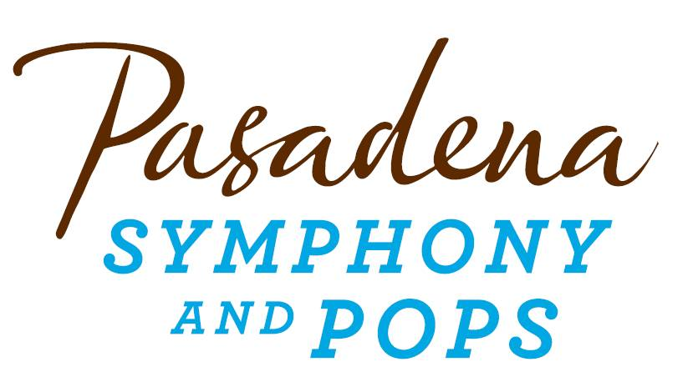
FOR IMMEDIATE RELEASE

Pasadena Symphony Association
Pasadena Symphony & POPS
Contact: Marisa McCarthy
mmccarthy@PasadenaSymphony-Pops.org
(626) 793-7172 ext. 13

July 16, 2018
For artist images and bios visit: https://pasadenasymphony-pops.org/classical-mystery-tour-2018
RELIVE THE BEATLES’ GREATEST HITS WITH CLASSICAL MYSTERY TOUR AND THE PASADENA POPS
Concert Features Dozens of Beatles Songs Performed Exactly as They Were Recorded
Pasadena, CA – The Pasadena POPS celebrates the best of The Beatles with Classical Mystery Tour on Saturday, August 4 at the Los Angeles County Arboretum. Back by popular demand, Classical Mystery Tour: A Tribute to the Beatles brings the timeless hits of the Fab Four to life with a fresh set list of favorites from the early years to Sgt. Pepper’s through their solo careers, with a special tribute to the 50th anniversary of the White Album. Spanning The Beatles’ vast catalog, tracks include “Can’t Buy Me Love,” “Here Comes the Sun,” “While My Guitar Gently Weeps,” “Hey Jude,” “Imagine,” plus many more.
Classical Mystery Tour performers include Jim Owen (John Lennon), Tony Kishman (Paul McCartney), Tom Teeley (George Harrison) and Doug Cox (Ringo Starr). The quartet looks and sounds just like The Beatles, with unforgettable music and costumes, but Classical Mystery Tour is more than just a rock concert. The show presents more than two dozen Beatles tunes transcribed note-for-note and performed with a full orchestra – like you've never heard them before. You might say it’s the best show the Beatles never did!
“The orchestral score is exact, right down to every note and instrument that was on the original recording,” explains Jim Owens, one of the founders and performers of Classical Mystery Tour. “It’s always been our goal to play Beatles music as close as possible to the way they did it, because really, they did it the best.” The Los Angeles Times raved that Classical Mystery Tour was “more than just an incredible simulation......the crowd stood and bellowed for more."
Tickets to Classical Mystery Tour start at $25 and are on sale now along with all other concerts in the Pasadena POPS Sierra Summer Concert Series. All Pasadena POPS concerts are held at the Los Angeles County Arboretum and Botanic Garden. Grounds open for picnicking and dining at 5:30pm and performances begin at 7:30pm. Don’t miss the best outdoor dinner party in town with spacious circular table seating with fine linens, or lawn seating for those who want to bring a blanket – each option carries on the tradition of picnic-dining with your family and friends with Pasadena’s premier orchestra! Among many venue amenities, concert goers can enjoy pre-ordered gourmet dining packages for on-site pickup just steps from their table from Julienne, Marston’s and Claud & Co. The venue also hosts mouth-watering food trucks and the convenience of two full beverage centers serving fine wines, beer, coffee and soft drinks.
Audiences get the ultimate outdoor concert experience with large LED video screens to see the orchestra up close, superior sound and the high-quality production value that is a signature of the Pasadena POPS. Patrons may also visit the Pasadena Humane Society's Mobile Adoption Unit, which will be on-site prior to each concert with deserving animals in need of a forever home as part of the Pups for POPS program. For those who want to make a night of it, exclusive hotel packages are available for POPS patrons at Pasadena’s landmark Hotel Constance.
The Arboretum is located at 301 North Baldwin Ave., Arcadia, CA. Subscribers may pre-purchase parking on-site at the Arboretum, and all concertgoers enjoy free parking at the adjacent Westfield Santa Anita shopping center with complimentary non-stop shuttle service to the Arboretum’s main entrance. Tickets are available by calling the box office at (626)-793-7172, online at PasadenaSymphony-Pops.org, or at the Arboretum on the day of the concert.

IF YOU GO:
- What: The Pasadena POPS presents Classical Mystery Tour with Larry Blank, conductor
- When: Saturday, August 4, 2018 at 7:30 p.m.
- Where: The LA County Arboretum | 301 N Baldwin Ave., Arcadia, CA 91007
- Cost: Tickets start at $25.00
- Dining: Gates open at 5:30pm. Guests are welcome to bring their own food and drink or visit one of the many onsite gourmet food vendors.
- Parking: Subscribers have the opportunity to purchase onsite Arboretum parking. Single ticket holders may park for free at the Westfield Santa Anita shopping center with free non-stop shuttles to the main gate.

ABOUT CLASSICAL MYSTERY TOUR
Since its initial show at the Orange County Performing Arts Center (now renamed the Segerstrom Center for the Arts) in 1996, Classical Mystery Tour has performed with more than 100 orchestras across the United States and around the world, receiving accolades from fans and the media. The Los Angeles Times called the show "more than just an incredible simulation...the swelling strings and soaring French horn lines gave the live performance a high goose-bump quotient...the crowd stood and bellowed for more."
"We really make an effort to sound exactly like the originals," explains James Owen, the founder of Classical Mystery Tour who also portrays John Lennon in the show. "The orchestra score is exact, right down to every note and instrument that was on the original recording. On 'Got to Get You Into My Life,' we have two tenor saxes and three trumpets. That's what it was written for, and that's what we use. And on 'A Day in the Life,' that final big orchestra crescendo sounds amazing when it’s played live."
The release of The Beatles music on ITunes, plus the popularity of The Beatles Box Set and Beatles Rock Band, set off a new wave of Beatlemania and proved that The Beatles are more popular than ever. Because many Beatles fans never had the opportunity to experience a live Beatles show, Classical Mystery Tour offers that live experience—with a symphony orchestra.
"We have some real show-stopping numbers," says Owen. "I wish I could actually be in the audience to see and hear this show, because the power of the emotional and nostalgic connection this music has with audiences is hard to put into words."
ABOUT THE PASADENA SYMPHONY ASSOCIATION
Recent Acclaim for the Pasadena Symphony and POPS
“The Pasadena Symphony signals a new direction…teeming with vitality...dripping with opulent, sexy emotion.” Los Angeles Times.
“...full of pulsating energy from first note to last... the strings were lushly resonant, the wind principals were at the top of their games, and the brass rang out with gleaming vigor.” –Pasadena Star News.
Formed in 1928, the Pasadena Symphony and POPS is an ensemble of Hollywood’s most talented, sought after musicians. With extensive credits in the film, television, recording and orchestral industry, the artists of Pasadena Symphony and POPS are the most heard in the world.
The Pasadena Symphony and POPS performs in two of the most extraordinary venues in the United States: Ambassador Auditorium, known as the Carnegie Hall of the West, and the luxuriant Los Angeles Arboretum & Botanic Garden. Internationally recognized, Grammy-nominated conductor, David Lockington, serves as the Pasadena Symphony Association’s Music Director, with performance-practice specialist Nicholas McGegan serving as Principal Guest Conductor. The multi-platinum-selling, two-time Emmy and five-time Grammy Award-nominated entertainer dubbed “The Ambassador of the Great American Songbook,” Michael Feinstein, is the Principal Pops Conductor, who succeeded Marvin Hamlisch in the newly created Marvin Hamlisch Chair.
A hallmark of its robust education programs, the Pasadena Symphony Association has served the youth of the region for over five decades through the Pasadena Youth Symphony Orchestras (PYSO), comprised of five performing ensembles with 300 gifted 4th-12th grade students from more than 50 schools all over the Southern California region. The PYSO has toured internationally at prestigious venues in New York, Vienna, and most recently San Jose, Costa Rica. They regularly perform throughout Southern California and have appeared on the popular television show GLEE.
The PSA provides people from all walks of life with powerful access points to the world of symphonic music.
-end-

