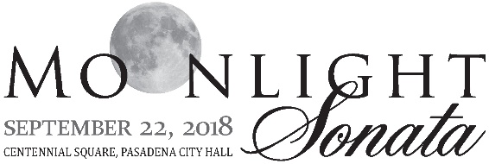
PSA NAME/AFFILIATION: Click or tap here to enter text.

EVENT SPONSORSHIP

Yes! I/We would like to SPONSOR the Moonlight Sonata 2018 at the following
level (see Sponsor Level Descriptions Sheet for more information):

 ☐SUPERMOON AT $10,000  ☐CRESCENT MOON AT $7,500
 ☐MOONBEAM AT $5,000  ☐STARBURST AT $3,000

SPONSORSHIP

Yes! I/We would like to be an UNDERWRITER for the Moonlight Sonata 2018 as the

(name of underwriting opportunity) Click or tap here to enter text.
(see Underwriter Description Sheet for more information) at the $ Click or tap here to enter text. level.

PATRON LEVEL DONORS

I/We would like to be PATRON LEVEL DONOR to the Moonlight Sonata 2018 (which includes two event tickets and listing in the event program booklet):  ☐$1,500

GENERAL EVENT DONATIONS

I/We would like to DONATE to the Moonlight Sonata and listed in the event program booklet:

☐$100 ☐$250 ☐$500 ☐$1,000 ☐$2,500 ☐Other $:Click or tap here to enter text.

PAYMENT INFORMATION Please respond by Friday, July 16, 2018 for inclusion on the invitation

DONOR NAME: Click or tap here to enter text.
☐ We wish to remain anonymous; please do not list our names.

DONOR ADDRESS: Click or tap here to enter text. Street City State Zip
DONOR PHONE: Click or tap here to enter text.

DONOR EMAIL: Click or tap here to enter text.
CHECK ENCLOSED [PAYABLE TO THE PASADENA SYMPHONY ASSOCIATION]
CHARGE MY: ☐ MASTERCARD ☐ VISA ☐ AMERICAN EXPRESS
CARD NUMBER: Click or tap here to enter text.
EXP DATE: Click or tap here to enter text.
3/4-DIGIT CODE: Click or tap here to enter text.

RETURN COMPLETED FORM

501c(3) nonprofit,
TAX ID #95-6002375.
A portion of your Sponsorship/Donation is
tax deductible contribution.

MAIL: Pasadena Symphony Association, 2 N Lake Ave., 91101
FAX: (626) 793-7180
SCAN & EMAIL: svandrick@pasadenasymphony-pops.org
COMPLETE ONLINE: Pasadenasymphony-Pops.org/special-events/moonlight-sonata-gala/

QUESTIONS? For more information, please email Scott Vandrick at svandrick@pasadenasymphony-pops.org or call (626) 793-7172, Ext. 45. Thank you for your interest in the PSA’s Moonlight Sonata Gala 2018.

