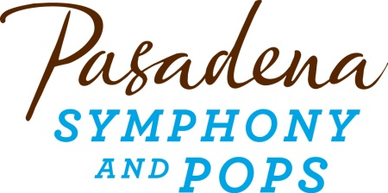

Sample Bequest Language

How to do get started? Below for your convenience is sample bequest language that can easily be added to your estate plan in collaboration with your estate attorney.

Unrestricted Bequest:
I give [ __ percent of my estate, or description of asset, or ____ dollars] to Pasadena Symphony Association, a California nonprofit corporation, 2 N. Lake Ave., Suite 1080, Pasadena, CA 91101 (Pasadena Symphony Association Tax ID 95-6002375) for its general use.

Restricted Bequest:
I give [ __ percent of my estate, or description of asset, or ___ dollars] to Pasadena Symphony Association, a California nonprofit corporation, 2 N. Lake Ave., Suite 1080, Pasadena, CA 91101 (Pasadena Symphony Association Tax ID 95-6002375), for the restricted purpose of [_______]. If, in the future, Pasadena Symphony Association determines that the restriction placed herein would result in an impracticable use of the bequest, it may designate another purpose for its use that most nearly accomplishes my wishes.

Pasadena Symphony Association
Tax ID 95-6002375
2 N. Lake Ave., Suite 1080
Pasadena, CA 91101

