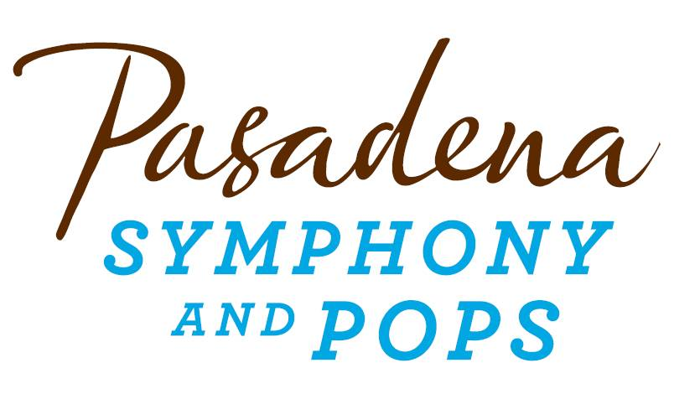
FOR IMMEDIATE RELEASE

Pasadena Symphony Association
Pasadena Symphony & POPS
Contact: Marisa McCarthy
MMcCarthy@PasadenaSymphony-Pops.org
(626) 793-7172 ext. 13

For artist images, click HERE.

June 22, 2016

TONY AND GRAMMY NOMINATED STAR OF BROADWAY’S MOVIN’ OUT BRINGS THE THE MUSIC OF BILLY JOEL TO THE ARBORETUM

Pasadena, CA - The Pasadena POPS continues their one of a kind, popular outdoor summer concert series with Michael Cavanaugh and the Music of Billy Joel on Saturday, July 9 at the LA County Arboretum. Hand-picked by Billy Joel himself to star in the lead role of his Broadway musical Movin’ Out, Cavanaugh’s distinctive flair evokes a style rivaling the Piano Man. Acclaimed for his highly energized piano and lead vocals, Cavanaugh received both Grammy and Tony award nominations for the role in 2003, appearing in more than 1,200 performances over a three-year run. He now brings this electrifying performance to the Arboretum stage for one night only with the Pasadena POPS.
Get in a “New York State of Mind” with “Piano Man,” "Uptown Girl,” “Longest Time,” “You May Be Right,” and other hit songs by the artist Billboard called “the new voice of the American Rock and Roll songbook.”
“[Cavanaugh] has reinvented these songs into something that dare I say sometimes improves upon the originals.” – MD Theatre Guide
Hear the charismatic Cavanaugh breathe new life into these nouveau American standards for a night of sing-along favorites with the POPS Orchestra and a full back-up band. Cavanaugh’s bandmates include saxophonist John Scarpola, who played lead sax in the Tony award-winning Movin' Out, and has recently toured with Billy Joel for the historic Last Stay at Shea shows. "Michael's show is hands down the best contemporary symphony pops show we have had the honor to present,” commented Chief Executive Officer Lora Unger. “The combination of popular songs, his talent as a superb showman and the excellent charts make this a must-have for both the Orchestra and the audience."
All Pasadena POPS concerts are held at the Los Angeles County Arboretum and Botanic Garden. Grounds open for picnicking and dining at 5:30 p.m. and performances begin at 7:30 p.m. Don’t miss the best outdoor dinner party in town with spacious circular table seating with fine linens, or lawn seating for those who want to bring a blanket – each option carries on the tradition of picnic-dining with your family and friends with Pasadena’s premier POPS orchestra! Among many venue amenities, concert goers can enjoy pre-ordered gourmet dining packages for on-site pickup just steps from their table from Julienne, Marston’s and Claud & Co. The food court hosts mouth-watering food trucks plus specialty ice creams by Choctál, and the venue now offers the convenience of two full beverage centers serving fine wines, beer, coffee and soft drinks.
Audiences get the ultimate outdoor concert experience with large LED video screens to see Michael Cavanaugh and the orchestra up close, superior sound and the high-quality production value that is a signature of the Pasadena POPS. Patrons may also visit the Pasadena Humane Society's Mobile Adoption Unit, which will be on-site prior to each concert with deserving animals in need of a forever home as part of the Pups for POPS program. For those who want to make a night of it, exclusive hotel packages are available for POPS patrons at Pasadena’s landmark Hotel Constance.
The Arboretum is located at 301 North Baldwin Ave., Arcadia, CA. Subscribers may pre-purchase parking on-site at the Arboretum, and all concertgoers enjoy free parking at the adjacent Westfield Santa Anita shopping center with complimentary non-stop shuttle service to the Arboretum’s main entrance.
Single tickets start at $25 and are available by calling the box office at (626)-793-7172, online at PasadenaSymphony-Pops.org, or at the Arboretum on the day of the concert.

IF YOU GO:
- What: The Pasadena POPS presents the Music of Billy Joel
Larry Blank, Resident Pops Conductor
Tom & Erika Girardi Chair
Michael Cavanaugh, soloist

- When: July 9, 2016 at 7:30 p.m.
- Where: The LA County Arboretum | 301 N Baldwin Ave., Arcadia, CA 91007
- Cost: Tickets start at $25.00
- Dining: Gates open at 5:30pm for picnicking. Guests are welcome to bring their own food and drink or visit one of the many onsite gourmet food vendors.
- Parking: Subscribers have the opportunity to purchase onsite Arboretum parking. Single ticket holders may park for free at the Westfield Santa Anita shopping center with free non-stop shuttles to the main gate.
###

ABOUT THE PASADENA SYMPHONY ASSOCIATION
Recent Acclaim for the Pasadena Symphony and POPS
“The Pasadena Symphony signals a new direction…teeming with vitality...dripping with opulent, sexy emotion.” Los Angeles Times.
“...full of pulsating energy from first note to last... the strings were lushly resonant, the wind principals were at the top of their games, and the brass rang out with gleaming vigor.” – Pasadena Star News.
Formed in 1928, the Pasadena Symphony and POPS is an ensemble of Hollywood’s most talented, sought after musicians. With extensive credits in the film, television, recording and orchestral industry, the artists of Pasadena Symphony and POPS are the most heard in the world.
The Pasadena Symphony and POPS performs in two of the most extraordinary venues in the United States: Ambassador Auditorium, known as the Carnegie Hall of the West, and the luxuriant Los Angeles Arboretum & Botanic Garden. Internationally recognized, Grammy-nominated conductor, David Lockington, serves as the Pasadena Symphony Association’s Music Director, with performance-practice specialist Nicholas McGegan serving as Principal Guest Conductor. The multi-platinum-selling, two-time Emmy and five-time Grammy Award-nominated entertainer dubbed “The Ambassador of the Great American Songbook,” Michael Feinstein, is the Principal Pops Conductor, who succeeded Marvin Hamlisch.
A hallmark of its robust education programs, the Pasadena Symphony Association has served the youth of the region for over five decades through the Pasadena Youth Symphony Orchestras (PYSO) comprised of five performing ensembles, with over 250 gifted 4th-12th grade students from more than 50 schools all over the Southern California region. The PYSO Symphony often performs on the popular television show GLEE.
The PSA provides people from all walks of life with powerful access points to the world of symphonic music.

ABOUT MICHAEL CAVANAUGH
Michael Cavanaugh is the New Voice of the American Rock & Roll Songbook. A charismatic performer, musician and actor, made famous for his piano/lead vocals in the Broadway Musical Movin’ Out.
Michael Cavanaugh was handpicked by Billy Joel to star in title role and evokes a style rivaling the Piano Man. Michael appeared in the show for 3 years and over 1200 performances, receiving accolade after accolade, which culminated in 2003 with both Grammy and Tony award nominations.
Michael began playing at age 7, when his parents bought their first piano. Encouraged by family and friends, and inspired by his hero Billy Joel, Michael formed his first band at age 10 and began playing local functions, fine-tuning the craft that would become his chosen career. His first full time gig as a musician was an extended engagement in Orlando Florida at a piano bar called Blazing Pianos. In January of 1999, Michael received an offer that would unknowingly change his life, with an opportunity to play Las Vegas at the famed “New York, New York Hotel and Casino.” It was there that Billy Joel spotted Michael and joined him on stage one fateful night of February 2001. It only took 2 songs before Billy was convinced that he had found his new Piano Man, Michael Cavanaugh. Michael closed up shop at New York, New York and moved to New York City to work alongside Billy Joel and Twyla Tharp, to shape the Broadway Musical that would be called Movin’ Out.
With the close of Movin’ Out at the end of 2005, Michael began touring in his own right, creating a show that reinterprets the modern pop/rock songbook. Michael soon became one of the hottest artist’s in the corporate/events market. He continues to perform worldwide for company and charity events as well as sporting events including PGA tour events, the US Open, the Indy 500. It wasn’t long before Symphony Orchestras discovered Michael’s talents and audience appeal. He accepted his first orchestral booking, Michael Cavanaugh – The Songs of Billy Joel and more which debuted in April of 2008 with the Indianapolis Symphony and continues to tour. In October 2 008, he signed with Warner/ADA to distribute his first CD titled In Color. In June, 2010, Michael debuted his second symphony show in the Generations of Rock series entitled Michael Cavanaugh: The Songs of Elton John and more and then debuted his third symphony show Singers and Songwriters: the music of Paul Simon, Neil Diamond and James Taylor in 2012. He continues to tour all three symphony productions.

ABOUT LARRY BLANK

Resident Pops Conductor Larry Blank is one of the most prolific and sought after composers, conductors, and orchestrators in the entertainment business today. His work has been presented all over the world, including some of Broadway’s most successful musicals, Carnegie Hall, and top television and film projects.

He was the Music Director/Conductor and/or vocal arranger for many shows on Broadway and in Los Angeles including They're Playing Our Song, Evita, Sugar Babies, La Cage Aux Folles, Phantom Of The Opera, Onward Victoria, Copperfield, Colette, A Chorus Line and A Little Night Music. He has been nominated three times for both the Tony Award and the Drama Desk Award for his orchestrations in The Drowsy Chaperone, Irving Berlin's White Christmas and with Marc Shaiman for Catch Me If You Can. Larry received a Drama Desk Nomination for orchestrations for A Christmas Story

Larry contributed to the orchestrations for both the stage and film production of The Producers, the film Chicago and is a regular conductor and arranger for BBC RADIO 2 Friday Night Is Music Night in the UK. Larry is also the Music Supervisor and Orchestrator (along with Mark Cumberland) for the Olivier Awards in London.

Blank has worked with top talent from varied fields of the entertainment world, notably as personal conductor to Michael Crawford. He has also worked with Michael Feinstein, Marvin Hamlisch, Bernadette Peters, Kelsey Grammar, Christine Baranski, Roberta Flack, Pete Fountain, Peabo Bryson, Sally Kellerman, Nancy Dussault, Marc Shaiman, Jerry Herman, Ann- Margaret, Davis Gaines, Bette Midler, George Benson, Placido Domingo, Randy Newman, Trisha Yearwood, Tom Scott, Quincy Jones, Michael Bolton, John Raitt and Diana Rigg.

Blank’s background includes orchestrating and arranging songs for South Park and was Music Supervisor and Orchestrator for Jerry Herman’s movie, Mrs. Santa Claus starring Angela Lansbury and Charles Durning. Some of the films he lent his talent to include The Kid, Kiss The Girls, The American President, Forget Paris, City Slickers II, The Net, That¹s Entertainment III, North, I¹d Do Anything, and Stuart Saves His Family. Blank’s music can be heard on the animated feature films, Cats Don’t Dance and All Dogs Go To Heaven as well as the 101 Dalmatians Christmas Special.

Mr. Blank’s television work includes orchestrating and composing music for several of the Grammy Awards and Academy Award shows as well as numerous television movies and shows.

Mr. Blank has guest conducted most of the orchestras throughout the world, including The San Francisco Symphony, The New York Philharmonic, Western Australia Symphony Orchestra, The Los Angeles Philharmonic, Palm Beach Pops, Auckland Symphony, The National Symphony Orchestra, The Boston Pops, The Chicago Symphony Orchestra, Calgary Symphony, New Orleans Symphony and Toronto
- end -

