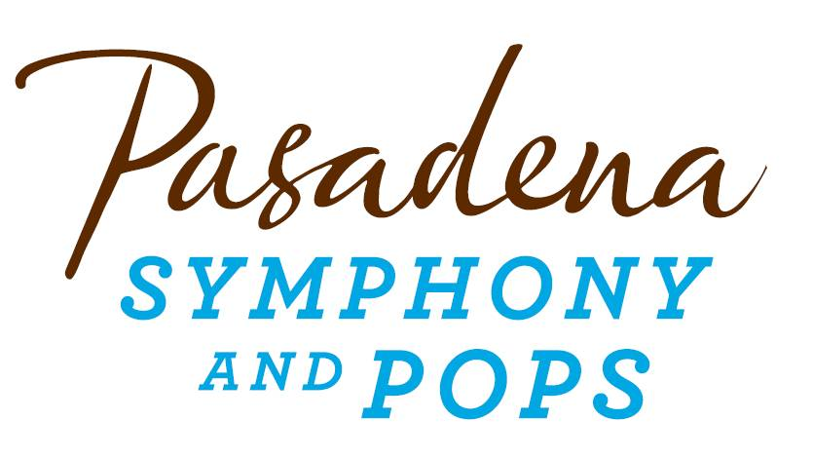
FOR IMMEDIATE RELEASE

Pasadena Symphony Association
Pasadena Symphony & POPS
Contact: Marisa McCarthy
mmccarthy@PasadenaSymphony-Pops.org
(626) 793-7172 ext. 13

For artist bios and images, please visit: http://www.pasadenasymphony-pops.org/press-release-a-night-at-the-movies/

August 20, 2015

MICHAEL FEINSTEIN & THE PASADENA POPS PRESENT
SUMMER FINALE WITH JEREMY JORDAN AND SHELÉA FRAZIER IN
A NIGHT AT THE MOVIES!

Pasadena, CA – Michael Feinstein and the Pasadena POPS close their popular outdoor summer concert series at the Los Angeles County Arboretum on September 12 with the quintessential Feinstein experience - a special tribute to the Academy Awards. A Night at the Movies! brings the glitz and glamour of the Academy Awards to the Arboretum with Oscar-nominated music from Hollywood classics Singing in the Rain, Meet Me in St. Louis, The Wizard of Oz, Lullaby of Broadway and many more. “This will be an evening that salutes great film composers, classical film scores and a lot of songs that you will know and love,” says Feinstein, who has curated an evening of what he considers “the best and most representative of Hollywood.”
The songs of Hollywood’s Golden Age will be sung by two fresh talents, Sheléa Frazier and Jeremy Jordan. A versatile rising star, Frazier has performed with such legends as Stevie Wonder and Brian McKnight. She will be joined on stage by the fabulous Jeremy Jordan. A Tony and Grammy award nominee, this singular talent is best known for his starring role in the Broadway production of Newsies and his series regular role on the NBC hit series Smash.
Feinstein has put together a sensational season closer jam-packed with surprises. The evening promises not to disappoint, with tap dancers and a chorus complementing a few select pieces, and a parade of authentic Hollywood costumes topping off the spectacle. Don’t miss Michael Feinstein and the Pasadena POPS in their final concert of the 2015 season as they remember Oscar winners and losers in this evening of Hollywood favorites that will leave everyone saying, “You should have been there.”
It’s the last chance for the best outdoor dinner party in town with spacious circular table seating with fine linens, or lawn seating for those who want to bring a blanket – each option carries on the tradition of picnic-dining with family and friends. Among many venue amenities, audiences can enjoy pre-ordered gourmet dining packages for on-site pickup just steps from your table from Julienne, Marston’s, and Claud & Co. The food court also host mouth-watering food trucks plus specialty ice creams by Choctál and two full beverage centers serving fine wines, beer, coffee and soft drinks. Audiences get the ultimate outdoor concert experience: large LED video screens to see the artists and orchestra up close, superior sound quality and the high-quality production value that is a signature of the Pasadena POPS. Patrons may also visit the Pasadena Humane Society's Mobile Adoption Unit, which will be on-site prior to the concert with deserving animals in need of a forever home as part of the Pups for POPS program.
All concerts are held at the Los Angeles County Arboretum and Botanic Garden. Grounds open for picnicking and dining at 5:30 p.m. and performances begin at 7:30 p.m. All concertgoers enjoy free parking at the adjacent Westfield Santa Anita shopping center with complimentary non-stop shuttle service to the Arboretum’s main entrance.
The Arboretum is located at 301 North Baldwin Ave., Arcadia, CA. Single tickets and season subscriptions are now on sale and are available by calling the box office at (626)-793-7172, online at PasadenaSymphony-Pops.org or at the Arboretum on the day of the concerts.

IF YOU GO:
- What: Michael Feinstein and The Pasadena POPS present A Night at the Movies!
- When: Saturday, September 12; Gates open at 5:30pm, Concert starts at 7:30 p.m.
- Where: The LA County Arboretum | 301 N Baldwin Ave., Arcadia, CA 91007
- Cost: Tickets start at $25.00
- Dining: Gates open at 5:30pm. Guests are welcome to bring their own food and drink or visit one of the many onsite gourmet food vendors.
- Parking: Subscribers have the opportunity to purchase onsite Arboretum parking. Single ticket holders may park for free at the Westfield Santa Anita shopping center with free non-stop shuttles to the main gate.

###
ABOUT THE PASADENA SYMPHONY ASSOCIATION
Recent Acclaim for the Pasadena Symphony and POPS
“The Pasadena Symphony signals a new direction…teeming with vitality...dripping with opulent, sexy emotion.” Los Angeles Times.
“...full of pulsating energy from first note to last... the strings were lushly resonant, the wind principals were at the top of their games, and the brass rang out with gleaming vigor.” –Pasadena Star News.
Formed in 1928, the Pasadena Symphony and POPS is an ensemble of Hollywood’s most talented, sought after musicians. With extensive credits in the film, television, recording and orchestral industry, the artists of Pasadena Symphony and POPS are the most heard in the world.
The Pasadena Symphony and POPS performs in two of the most extraordinary venues in the United States: Ambassador Auditorium, known as the Carnegie Hall of the West, and the luxuriant Los Angeles Arboretum & Botanic Garden. Internationally recognized, Grammy-nominated conductor, David Lockington, serves as the Pasadena Symphony Association’s Music Director, with performance-practice specialist Nicholas McGegan serving as Principal Guest Conductor. The multi-platinum-selling, two-time Emmy and five-time Grammy Award-nominated entertainer dubbed “The Ambassador of the Great American Songbook,” Michael Feinstein, is the Principal Pops Conductor, who succeeded Marvin Hamlisch in the newly created Marvin Hamlisch Chair.
A hallmark of its robust education programs, the Pasadena Symphony Association has served the youth of the region for over five decades through the Pasadena Youth Symphony Orchestras (PYSO) comprised of five performing ensembles, with over 250 gifted 4th-12th grade students from more than 50 schools all over the Southern California region. The PYSO Symphony often performs on the popular television show GLEE.
The PSA provides people from all walks of life with powerful access points to the world of symphonic music.
-end-

