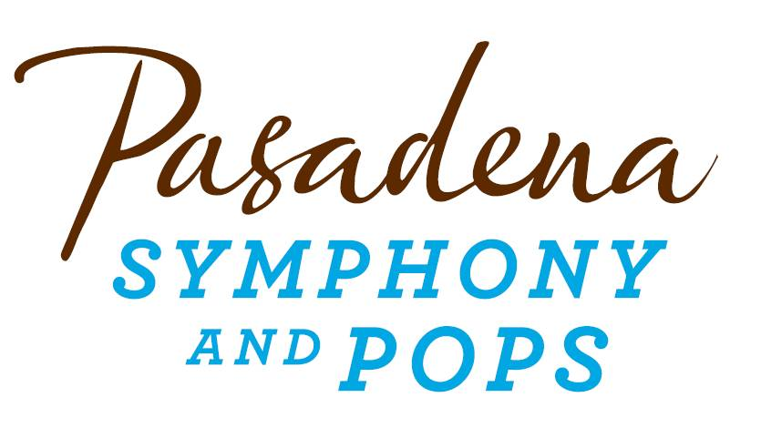
FOR IMMEDIATE RELEASE

Pasadena Symphony Association
Pasadena Symphony & POPS
Contact: Marisa McCarthy
MMccarthy@PasadenaSymphony-Pops.org
(626) 793-7172 ext. 13

For artist bios and images, please visit: http://www.pasadenasymphony-pops.org/press-release-to-ella-and-nat-with-love/

July 28, 2015
MICHAEL FEINSTEIN & THE PASADENA POPS PAY TRIBUTE
TO ELLA FITGERALD AND NAT KING COLE

Pasadena, CA –Michael Feinstein and the Pasadena POPS continue their one of a kind, popular outdoor summer concert series at the Los Angeles Arboretum with To Ella and Nat with Love on August 22. The evening pays tribute to two of the most iconic American singers, bringing the songbooks of Ella Fitzgerald and Nat King Cole to life. “These two singers epitomize what is great about American popular music,” states Feinstein, who has put together a sensational program of standards that have stood the test of time. Concertgoers will enjoy “Mona Lisa,” ‘Unforgettable,” “I Only Have Eyes for You,” “How High the Moon,” “Lady Be Good” and more.
Two amazing vocalists will complement Feinstein and the POPS orchestra in this not to be missed performance. The silky-smooth vocals of Denzal Sinclaire will set the mood. Canada Magazine’s four year consecutive winner of Male Jazz Vocalist, Sinclaire has earned accolades by Natalie Cole herself, for his subtle and sophisticated tribute to her father. Tony nominee, platinum-selling songwriter and Theater World Award winner Ann Hampton Callaway will round out the evening. The jazz/cabaret diva has been paying tribute to Ella Fitzgerald for many years and “is one of the great contemporary interpreters of scat singing,” says Feinstein, “something that is a very specialized art.”
All concerts are held at the Los Angeles County Arboretum and Botanic Garden. Grounds open for picnicking and dining at 5:30 p.m. and performances begin at 7:30 p.m. Among many venue amenities, audiences can enjoy pre-ordered gourmet dining packages for on-site pickup just steps from your table from Julienne, Marston’s, and Claud & Co.; the food court will host mouth-watering food trucks plus specialty ice creams by Choctál. The experience is now even more convenient with two full beverage centers serving fine wines, beer, coffee and soft drinks plus exclusive hotel packages for POPS patrons at Pasadena’s landmark Hotel Constance. Patrons may also visit the Pasadena Humane Society's Mobile Adoption Unit, which will be on-site prior to each concert with deserving animals in need of a forever home as part of the Pups for POPS program.
Subscribers may pre-purchase parking on-site at the Arboretum, and all concertgoers enjoy free parking at the adjacent Westfield Santa Anita shopping center with complimentary non-stop shuttle service to the Arboretum’s main entrance. Audiences get the ultimate outdoor concert experience: large LED video screens to see the artists and orchestra up close, superior sound quality and the high-quality production value that is a signature of the Pasadena POPS.
Don’t miss the best outdoor dinner party in town with spacious circular table seating with fine linens, or lawn seating for those who want to bring a blanket – each option carries on the tradition of picnic-dining with your family and friends with Michael Feinstein and Pasadena’s premier POPS orchestra! The Arboretum is located at 301 North Baldwin Ave., Arcadia, CA. Single tickets are now on sale starting at $25, and are available by calling the box office at (626)-793-7172, online at PasadenaSymphony-Pops.org or at the Arboretum on the day of the concerts.

IF YOU GO:
- What: The Pasadena POPS presents To Ella and Nat with Love
- When: August 22 at 7:30 pm; gates open at 5:30pm for picnicking.
- Where: The LA County Arboretum | 301 N Baldwin Ave., Arcadia, CA 91007
- Cost: Tickets start at $25.00
- Dining: Gates open at 5:30pm. Guests are welcome to bring their own food and drink or visit one of the many onsite gourmet food vendors.
- Parking: Subscribers have the opportunity to purchase onsite Arboretum parking. Single ticket holders may park for free at the Westfield Santa Anita shopping center with free non-stop shuttles to the main gate.
###
ABOUT THE PASADENA SYMPHONY ASSOCIATION
Recent Acclaim for the Pasadena Symphony and POPS
“The Pasadena Symphony signals a new direction…teeming with vitality...dripping with opulent, sexy emotion.” Los Angeles Times.
“...full of pulsating energy from first note to last... the strings were lushly resonant, the wind principals were at the top of their games, and the brass rang out with gleaming vigor.” –Pasadena Star News.
Formed in 1928, the Pasadena Symphony and POPS is an ensemble of Hollywood’s most talented, sought after musicians. With extensive credits in the film, television, recording and orchestral industry, the artists of Pasadena Symphony and POPS are the most heard in the world.
The Pasadena Symphony and POPS performs in two of the most extraordinary venues in the United States: Ambassador Auditorium, known as the Carnegie Hall of the West, and the luxuriant Los Angeles Arboretum & Botanic Garden. Internationally recognized, Grammy-nominated conductor, David Lockington, serves as the Pasadena Symphony Association’s Music Director, with performance-practice specialist Nicholas McGegan serving as Principal Guest Conductor. The multi-platinum-selling, two-time Emmy and five-time Grammy Award-nominated entertainer dubbed “The Ambassador of the Great American Songbook,” Michael Feinstein, is the Principal Pops Conductor, who succeeded Marvin Hamlisch in the newly created Marvin Hamlisch Chair.
A hallmark of its robust education programs, the Pasadena Symphony Association has served the youth of the region for over five decades through the Pasadena Youth Symphony Orchestras (PYSO) comprised of five performing ensembles, with over 250 gifted 4th-12th grade students from more than 50 schools all over the Southern California region. The PYSO Symphony often performs on the popular television show GLEE.
The PSA provides people from all walks of life with powerful access points to the world of symphonic music.
-end-

