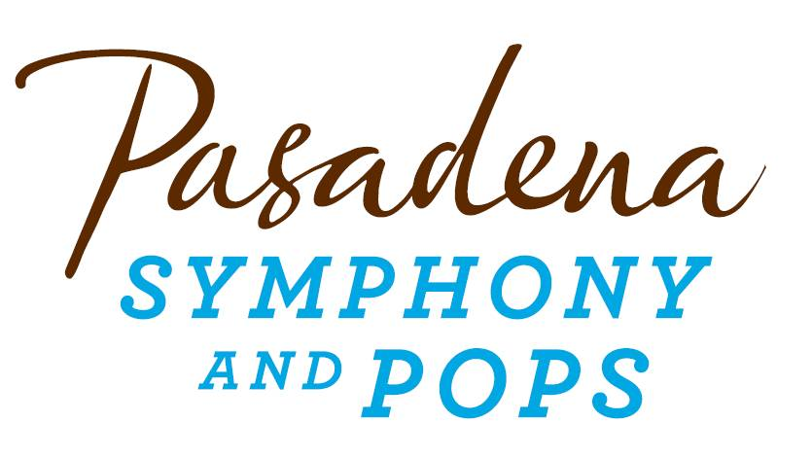
FOR IMMEDIATE RELEASE

Pasadena Symphony Association
Pasadena Symphony & POPS
Contact: Marisa McCarthy
mmccarthy@PasadenaSymphony-Pops.org
(626) 793-7172 ext. 13

June 17, 2015

RELIVE THE BEATLES’ GREATEST HITS WITH CLASSICAL MYSTERY TOUR AND THE PASADENA POPS AS PART OF THE 2015 SIERRA AUTO SUMMER CONCERT SERIES

Pasadena, CA – The Pasadena POPS celebrates the best of the music of The Beatles with Classical Mystery Tour on Saturday, July 11 at the Los Angeles Arboretum. Back by Popular demand, Classical Mystery Tour brings the timeless hits of The Beatles to life with a fresh set list of favorites from the early years to Sgt. Pepper’s Lonely Hearts Club Band through their solo careers. Spanning The Beatles’ vast catalog, tracks include “Yesterday”, “Lucy in the Sky with Diamonds”, “A Day in the Life”, “Strawberry Fields Forever,” “Penny Lane,” and “Let It Be” plus many more.
The Fabulous Four performers include Jim Owen (John Lennon), Tony Kishman (Paul McCartney), Joe Bithorn (George Harrison) and Chris Camilleri (Ringo Starr). The quartet looks and sounds just like The Beatles, with unforgettable music and costumes, but Classical Mystery Tour is more than just a rock concert. The show presents more than two dozen Beatles tunes transcribed note-for-note and performed with a full orchestra – like you've never heard them before. Many have called it “the best show the Beatles never did!”
“The orchestral score is exact, right down to every note and instrument that was on the original recording,” explains Jim Owens, one of the founders and performers of Classical Mystery Tour. “It’s always been our goal to play Beatles music as closely to the way they did it, because really, they did it the best.” The Los Angeles Times raved that Classical Mystery Tour was “more than just an incredible simulation......the crowd stood and bellowed for more."
Since its initial performance at the Orange County Performing Arts Center in 1996, Classical Mystery Tour has performed hundreds of concerts with orchestras across the United States and around the world and has received countless accolades from fans as well as media.

Tickets to Classical Mystery Tour start at $25 and are on sale now along with all other concerts in the Pasadena POPS Sierra Auto Summer Series. All concerts are held at the Los Angeles Arboretum and Botanic Garden. Grounds open for picnicking and dining at 5:30 p.m. and performances begin at 7:30 p.m. Among many venue amenities, audiences can enjoy pre-ordered gourmet dining packages for on-site pickup just steps from your table from Julienne, Marston’s and Claud & Co. The food court will host mouth-watering food trucks plus specialty ice creams by Choctál. The concert experience is effortless with two full beverage centers serving fine wines, beer, coffee and soft drinks plus exclusive hotel packages for POPS patrons at Pasadena’s landmark Hotel Constance. Patrons may also visit the Pasadena Humane Society's Mobile Adoption Unit, which will be on-site prior to each concert with deserving animals in need of a forever home as part of the Pups for POPS program.
All concertgoers enjoy free parking at the adjacent Westfield Santa Anita shopping center with complimentary non-stop shuttle service to the Arboretum’s main entrance. Audiences get the ultimate outdoor concert experience: large LED video screens to see the artists and orchestra up close, superior sound quality and the high-quality production value that is a signature of the Pasadena POPS.
Don’t miss the best outdoor dinner party in town with spacious circular table seating with fine linens or lawn seating for those who want to bring a blanket – each option carries on the summer tradition of picnic-dining with your family and friends with Pasadena’s premier POPS orchestra! The Arboretum is located at 301 North Baldwin Ave., Arcadia, CA. Single tickets and season subscriptions are now on sale and are available by calling the box office at (626)-793-7172, online at PasadenaSymphony-Pops.org or at the Arboretum on the day of the concerts.

IF YOU GO:
- What: The Pasadena Symphony presents the 2015 Pasadena POPS with Principal Pops Conductor Michael Feinstein
- When: Saturday, July 11 at 7:30 p.m.
- Where: The LA County Arboretum | 301 N Baldwin Ave., Arcadia, CA 91007
- Cost: Tickets start at $25.00
- Dining: Gates open at 5:30pm. Guests are welcome to bring their own food and drink or visit one of the many onsite gourmet food vendors.
- Parking: Subscribers have the opportunity to purchase onsite Arboretum parking. Single ticket holders may park for free at the Westfield Santa Anita shopping center with free non-stop shuttles to the main gate.

###
ABOUT THE PASADENA SYMPHONY ASSOCIATION
Recent Acclaim for the Pasadena Symphony and POPS
“The Pasadena Symphony signals a new direction…teeming with vitality...dripping with opulent, sexy emotion.” Los Angeles Times.
“...full of pulsating energy from first note to last... the strings were lushly resonant, the wind principals were at the top of their games, and the brass rang out with gleaming vigor.” –Pasadena Star News.
Formed in 1928, the Pasadena Symphony and POPS is an ensemble of Hollywood’s most talented, sought after musicians. With extensive credits in the film, television, recording and orchestral industry, the artists of Pasadena Symphony and POPS are the most heard in the world.
The Pasadena Symphony and POPS performs in two of the most extraordinary venues in the United States: Ambassador Auditorium, known as the Carnegie Hall of the West, and the luxuriant Los Angeles Arboretum & Botanic Garden. Internationally recognized, Grammy-nominated conductor, David Lockington, serves as the Pasadena Symphony Association’s Music Director, with performance-practice specialist Nicholas McGegan serving as Principal Guest Conductor. The multi-platinum-selling, two-time Emmy and five-time Grammy Award-nominated entertainer dubbed “The Ambassador of the Great American Songbook,” Michael Feinstein, is the Principal Pops Conductor, who succeeded Marvin Hamlisch in the newly created Marvin Hamlisch Chair.
A hallmark of its robust education programs, the Pasadena Symphony Association has served the youth of the region for over five decades through the Pasadena Youth Symphony Orchestras (PYSO) comprised of five performing ensembles, with over 250 gifted 4th-12th grade students from more than 50 schools all over the Southern California region. The PYSO Symphony often performs on the popular television show GLEE.
The PSA provides people from all walks of life with powerful access points to the world of symphonic music.
-end-

