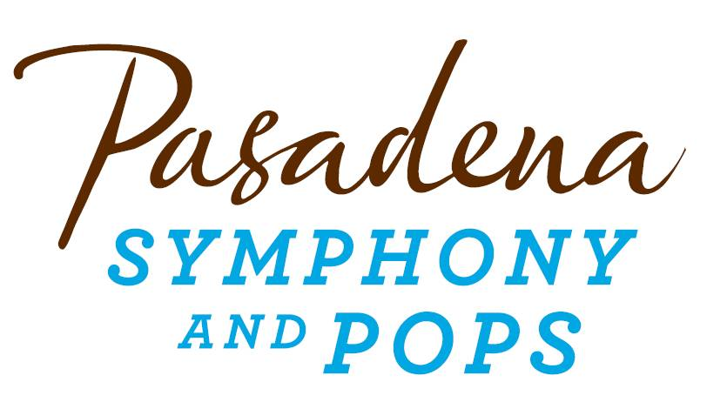
FOR IMMEDIATE RELEASE

Pasadena Symphony Association
Pasadena Symphony & POPS
Contact: Lora Unger
Lunger@PasadenaSymphony-Pops.org
(626) 793-7172 ext. 12

For artist images and biographies, please visit: http://www.pasadenasymphony-pops.org/big-band-swing-2/
May 26, 2015

MICHAEL FEINSTEIN & THE PASADENA POPS OPEN THE SIERRA AUTO SUMMER CONCERT SERIES WITH BIG BAND SWING
Pasadena, CA –Michael Feinstein and the Pasadena POPS open their one of a kind, popular outdoor summer concert series with vocalists Marilyn Maye and Michael Andrew in BIG BAND SWING on Saturday June 20th in a show sure to get all ages dancing in the aisles at the Los Angeles Arboretum.
In quintessential Feinstein fashion, the show will feature the sizzling and sultry big brass sounds that defined feel of the era with hits such as Glenn Miller’s Pennsylvania 6-500, Benny Goodman’s Sing Sing Sing, Duke Ellington's Harlem Nocturne and Sophisticated Ladies along with rare gems made fresh like Jimmy Dorsey’s Green Eyes, Les Brown’s Leap Frog and Harry James’ Trumpet Blues and Cantabile.
The timeless and moving songs of the era spring to life with Marilyn Maye who brings over 80-years of talent to the Pops stage [Ella Fitzgerald proclaimed her as the “greatest white female singer in the world”] and award-winning vocalist, Michael Andrew [praised by Larry King Live “as one of the great singers of all time."] This collaboration will mesmerize audiences with “Mack the Knife,” “As Time Goes By,” “That Old Black Magic,” “Too Late Now” “Over the Rainbow” and so much more.
“At the POPS, you’ll enjoy definitive performances of music that personify the Great American Songbook in so many ways,” says Feinstein adding “ I’ve chosen the guest artists because they are master entertainers who will add exciting panache to the show – it’s a rare chance to experience music performed this way at one of the most beautiful outdoor venues anywhere.”
“When the Pasadena Pops signed Michael Feinstein to be its conductor in 2013, it looked like a coup and a gamble. The concept that he established in his first concert— exploring the highlights, nooks and crannies of American popular music — is proving to be infinitely flexible…his showbiz savvy made the cascade of data entertaining, never overwhelming...the gamble looks to be a roaring success.” – The Los Angeles Times
All concerts are held at the Los Angeles Arboretum and Botanic Garden. Grounds open for picnicking and dining at 5:30 p.m. and performances begin at 7:30 p.m. Among many venue amenities, audiences can enjoy per-ordered gourmet dining packages for on-site pickup just steps from your table from Julienne, Marston’s, and Claud & Co.; the food court will host mouth-watering food trucks plus specialty ice creams by Choctál. The concert experience is effortless with two full beverage centers serving fine wines, beer, coffee and soft drinks plus exclusive hotel packages for POPS patrons at Pasadena’s landmark Hotel Constance. Patrons may also visit the Pasadena Humane Society's Mobile Adoption Unit, which will be on-site prior to each concert with deserving animals in need of a forever home as part of the Pups for POPS program.
All concertgoers enjoy free parking at the adjacent Westfield Santa Anita shopping center with complimentary non-stop shuttle service to the Arboretum’s main entrance. Audiences get the ultimate outdoor concert experience: large LED video screens to see the artists and orchestra up close, superior sound quality and the high-quality production value that is a signature of the Pasadena POPS.
Don’t miss the best outdoor dinner party in town with spacious circular table seating with fine linens, or lawn seating for those who want to bring a blanket – each option carries on the tradition of picnic-dining with your family and friends with Michael Feinstein and Pasadena’s premier POPS orchestra! The Arboretum is located at 301 North Baldwin Ave., Arcadia, CA. Single tickets and season subscriptions are now on sale and are available by calling the box office at (626)-793-7172, online at PasadenaSymphony-Pops.org or at the Arboretum on the day of the concerts.
IF YOU GO:
- What: BIG BAND SWING with the Pasadena POPS and Michael Feinstein
- When: June 20, 2015. Doors open at 5:30 p.m. for picnic dining, concert starts at 7:30 p.m.
- Where: The LA Arboretum | 301 N Baldwin Ave., Arcadia, CA 91007
- Cost: Tickets start at $20.00
- Dining: Gates open at 5:30pm. Guests are welcome to bring their own food and drink or visit one of the many onsite gourmet food vendors.
- Parking: Free at the adjacent Westfield Santa Anita shopping center with free non-stop shuttles to the main gate.
####
ABOUT THE PASADENA SYMPHONY ASSOCIATION
Recent Acclaim for the Pasadena Symphony and POPS
“The Pasadena Symphony signals a new direction…teeming with vitality...dripping with opulent, sexy emotion.” Los Angeles Times.
“...full of pulsating energy from first note to last... the strings were lushly resonant, the wind principals were at the top of their games, and the brass rang out with gleaming vigor.” –Pasadena Star News.
Formed in 1928, the Pasadena Symphony and POPS is an ensemble of Hollywood’s most talented, sought after musicians. With extensive credits in the film, television, recording and orchestral industry, the artists of Pasadena Symphony and POPS are the most heard in the world.
The Pasadena Symphony and POPS performs in two of the most extraordinary venues in the United States: Ambassador Auditorium, known as the Carnegie Hall of the West, and the luxuriant Los Angeles Arboretum & Botanic Garden. Internationally recognized, Grammy-nominated conductor, David Lockington, serves as the Pasadena Symphony Association’s Music Director, with performance-practice specialist Nicholas McGegan serving as Principal Guest Conductor. The multi-platinum-selling, two-time Emmy and five-time Grammy Award-nominated entertainer dubbed “The Ambassador of the Great American Songbook,” Michael Feinstein, is the Principal Pops Conductor, who succeeded Marvin Hamlisch in the newly created Marvin Hamlisch Chair.
A hallmark of its robust education programs, the Pasadena Symphony Association has served the youth of the region for over five decades through the Pasadena Youth Symphony Orchestras (PYSO) comprised of five performing ensembles, with over 250 gifted 4th-12th grade students from more than 50 schools all over the Southern California region. The PYSO Symphony often performs on the popular television show GLEE.
The PSA provides people from all walks of life with powerful access points to the world of symphonic music.

