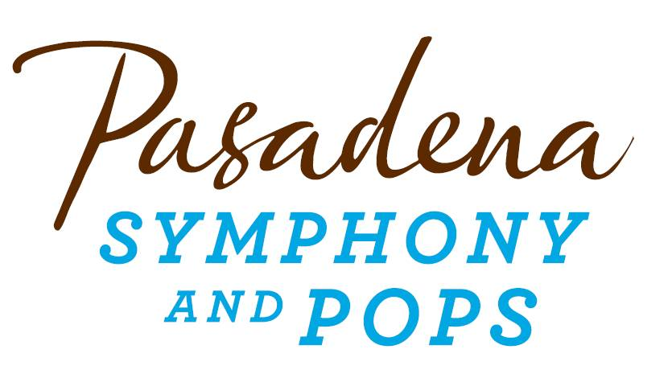
FOR IMMEDIATE RELEASE

Pasadena Symphony Association
Pasadena Symphony & POPS
Contact: Lani Shotlow-Rincon
Lshotlow-rincon@PasadenaSymphony-Pops.org
(626) 793-7172 ext. 13

For artist images, please visit: http://www.pasadenasymphony-pops.org/2015-pops-press-release/
For bios, please visit: http://www.pasadenasymphony-pops.org/wp-content/uploads/2015/03/2015-POPS-Artist-Bios.doc

March 4, 2015
MICHAEL FEINSTEIN & THE PASADENA POPS ANNOUNCE
2015 SIERRA ACURA SUMMER CONCERT SERIES
Tickets on sale now for Michael Feinstein’s Sinatra Project, Marilyn Maye, Jeremy Jordan, Anne Hampton Callaway, music of the Beatles and more at the Los Angeles Arboretum
Pasadena, CA –Principal Pops Conductor Michael Feinstein and the Pasadena POPS announce their one of a kind, popular outdoor summer concert series at the Los Angeles Arboretum with five events sure to make your summer sizzle. Swing into Summer on June 20 with Big Band Swing; celebrate the best of the music of the Beatles with the Classical Mystery Tour on July 11; the multi-platinum-selling, two-time Emmy and five-time Grammy Award-nominated entertainer Michael Feinstein brings his luxurious vocals in his Sinatra Project on August 1; hear definitive performances in To Ella and Nat with Love on August 22 paying tribute to two of the most iconic American Singers; and close the summer with the quintessential Feinstein experience with a special tribute to the glamour of the Academy Awards with A Night at the Oscars! on September 12. The 2015 Sierra Acura Summer Pops season is jam-packed with vibrant talent spanning the ages!
“When the Pasadena Pops signed Michael Feinstein to be its conductor in 2013, it looked like a coup and a gamble. The concept that he established in his first concert— exploring the highlights, nooks and crannies of American popular music — is proving to be infinitely flexible…his showbiz savvy made the cascade of data entertaining, never overwhelming...the gamble looks to be a roaring success.” – The Los Angeles Times
“At the POPS, you’ll enjoy definitive performances of music that personify the Great American Songbook in so many ways,” says Feinstein adding “ I’ve chosen the guest artists because they are master entertainers who will add exciting panache to each show – it’s a rare chance to experience music performed this way at one of the most beautiful outdoor venues anywhere.”
June 20, 2015
Big Band Swing
Audiences will swing to the big-band sounds of the 1930’s and 40’s with American cabaret singer, Marilyn Maye who brings over 80-years of talent to the Pops stage. Ella Fitzgerald proclaimed her as the “greatest white female singer in the world.” With award-winning vocalist, Michael Andrew, praised by Larry King Live “as one of the great singers of all time” this collaboration will mesmerize with hits such as “Moonglow,” “Stardust,” “Minnie the Moocher,” “Serenade in Blue,” “Night and Day,” “Misty,” “On the Street Where You Live” and “Get Happy.”
July 11, 2015
Classical Mystery Tour
The renowned artists of Classical Mystery Tour is back by popular demand, with a fresh set list of Beatles favorites, featuring hits from Sgt. Pepper’s Lonely Hearts Club Band – with “Let it Be,” “Yesterday,” “Strawberry Fields Forever,” “Penny Lake,” “Lucy in the Sky with Diamonds,” “A Day in the Life” and so much more, performed with a full orchestra.
August 1, 2015
The Sinatra Project
Michael Feinstein puts the conducting baton down for one night only to sing his Sinatra Project, an evening entirely devoted to celebrate the brilliance of “The Voice” as only Feinstein can. Curating an evening solely dedicated to Ol’ Blue Eyes’ biggest hits, Feinstein sings “Luck Be A Lady,” “Fly Me to The Moon,” “The Way You Look Tonight,” “The Lady Is A Tramp,” “For Once In My Life” and more.
To Ella and Nat with Love
August 22, 2015
The POPS pays tribute to Ella Fitzgerald and Nat King Cole, two of the most iconic American singers, with definitive performances by vocalists Denzal Sinclaire and Ann Hampton Callaway. Tony nominee, platinum selling songwriter and Theater World Award winner, Jazz/Cabaret diva Ann Hampton Callaway joins the Pops alongside Denzal Sinclaire, a singer of subtle skill and with a relaxed and sophisticated approach to songs, was Canada Magazine’s four year consecutive winner of Male Jazz Vocalist for a magical night featuring “Mona Lisa,” ‘Unforgettable,” “When I Fall in Love,” “Lady Be Good,” “How High the Moon,” “Body and Soul,” “Mr. Paganini,” “In A Sentimental Mood” and more.
A Night at the Oscars!
September 12, 2015
The Pasadena Pops closes the summer concert season with the quintessential Feinstein experience – bringing the glitz and glamour of the Academy Awards to the Arboretum with a special tribute to the glamour of the Academy Awards with vocalists Sheléa Frazier and Jeremy Jordan. Frazier, a versatile rising star joins Jeremy Jordan, Tony and Grammy award nominee, recently seen in the film adaptation of “The Last 5 Years,” will remember the winners, the loser and everything in between with an evening of Hollywood favorites!
All concerts are held at the Los Angeles County Arboretum and Botanic Garden. Grounds open for picnicking and dining at 5:30 p.m. and performances begin at 7:30 p.m. Among many venue amenities, audiences can enjoy pre-ordered gourmet dining packages for on-site pickup just steps from your table from Julienne, Marston’s, and Claud & Co.; the food court will host mouth-watering food trucks plus specialty ice creams by Choctal. The experience is now even more convenient with two full beverage centers serving fine wines, beer, coffee and soft drinks plus exclusive hotel packages for POPS patrons at Pasadena’s landmark Hotel Constance. Patrons may also visit the Pasadena Humane Society's Mobile Adoption Unit, which will be on-site prior to each concert with deserving animals in need of a forever home as part of the Pups for POPS program.
Subscribers may pre-purchase parking on-site at the Arboretum, and all concertgoers enjoy free parking at the adjacent Westfield Santa Anita shopping center with complimentary non-stop shuttle service to the Arboretum’s main entrance. Audiences get the ultimate outdoor concert experience: large LED video screens to see the artists and orchestra up close, superior sound quality and the high-quality production value that is a signature of the Pasadena POPS.
Don’t miss the best outdoor dinner party in town with spacious circular table seating with fine linens, or lawn seating for those who want to bring a blanket – each option carries on the tradition of picnic-dining with your family and friends with Michael Feinstein and Pasadena’s premier POPS orchestra! The Arboretum is located at 301 North Baldwin Ave., Arcadia, CA. Single tickets and season subscriptions are now on sale and are available by calling the box office at (626)-793-7172, online at PasadenaSymphony-Pops.org or at the Arboretum on the day of the concerts.
2015 Sierra Acura Summer Concert Series Calendar

June 20, 2015
Big Band Swing
Michael Feinstein, conductor
Marilyn Maye, vocalist
Michael Andrew, vocalist

July 11, 2015
Classical Mystery Tour
Music of the Beatles
Martin Herman, conductor
Jim Owen, Tony Kishman, David John, & Chris Camilleri, vocalists
August 1, 2015
The Sinatra Project
Michael Feinstein, vocalist
Larry Blank, conductor

To Ella and Nat with Love
August 22, 2015
Ann Hampton Callaway, vocalist
Denzal Sinclaire, vocalist
Michael Feinstein, conductor

A Night at the Oscars!
September 12, 2015
Sheléa Frazier, vocalist
Jeremy Jordan, vocalist
Michael Feinstein, conductor

IF YOU GO:
- What: The Pasadena Symphony presents the 2015 Pasadena POPS with Principal Pops Conductor Michael Feinstein
- When: June 20, July 11, August 1, August 22, September 12 at 7:30 p.m.
- Where: The LA County Arboretum | 301 N Baldwin Ave., Arcadia, CA 91007
- Cost: Tickets start at $20.00
- Dining: Gates open at 5:30pm. Guests are welcome to bring their own food and drink or visit one of the many onsite gourmet food vendors.
- Parking: Subscribers have the opportunity to purchase onsite Arboretum parking. Single ticket holders may park for free at the Westfield Santa Anita shopping center with free non-stop shuttles to the main gate.

###
ABOUT THE PASADENA SYMPHONY ASSOCIATION
Recent Acclaim for the Pasadena Symphony and POPS
“The Pasadena Symphony signals a new direction…teeming with vitality...dripping with opulent, sexy emotion.” Los Angeles Times.
“...full of pulsating energy from first note to last... the strings were lushly resonant, the wind principals were at the top of their games, and the brass rang out with gleaming vigor.” –Pasadena Star News.
Formed in 1928, the Pasadena Symphony and POPS is an ensemble of Hollywood’s most talented, sought after musicians. With extensive credits in the film, television, recording and orchestral industry, the artists of Pasadena Symphony and POPS are the most heard in the world.
The Pasadena Symphony and POPS performs in two of the most extraordinary venues in the United States: Ambassador Auditorium, known as the Carnegie Hall of the West, and the luxuriant Los Angeles Arboretum & Botanic Garden. Internationally recognized, Grammy-nominated conductor, David Lockington, serves as the Pasadena Symphony Association’s Music Director, with performance-practice specialist Nicholas McGegan serving as Principal Guest Conductor. The multi-platinum-selling, two-time Emmy and five-time Grammy Award-nominated entertainer dubbed “The Ambassador of the Great American Songbook,” Michael Feinstein, is the Principal Pops Conductor, who succeeded Marvin Hamlisch in the newly created Marvin Hamlisch Chair.
A hallmark of its robust education programs, the Pasadena Symphony Association has served the youth of the region for over five decades through the Pasadena Youth Symphony Orchestras (PYSO) comprised of five performing ensembles, with over 250 gifted 4th-12th grade students from more than 50 schools all over the Southern California region. The PYSO Symphony often performs on the popular television show GLEE.
The PSA provides people from all walks of life with powerful access points to the world of symphonic music.
-end-

